Computer Networks 1

Samenvatting door Gilles De Praeter

Inhoud

1. Networking today 5

a. Network components 5

b. Network representations and topologies 6

c. Common types of networks 7

d. Internet connections 9

e. Reliable Networks 10

f. Network Trends 12

g. Network security 13

h. The IT professional 14

2. Basic switch and end device configuration 14

a. Cisco IOS Access 14

b. IOS Navigation 15

c. The Command Structure 16

d. Basic Device Configuration 18

e. Save Configurations 19

f. Ports and Addresses 20

g. Configure IP Addressing 21

3. Protocols and models 22

a. Introduction 22

b. The Rules 22

c. Protocols 23

d. Protocol Suites 24

e. Standards Organisations 26

f. Reference Models 27

g. Data Encapsulation 28

h. Data Access 29

4. Physical layer 30

a. Purpose of the Physical Layer 30

b. Physical Layer Characteristics 31

c. Copper Cabling 32

d. UTP Cabling 34

e. Fiber-Optic Cabling 36

f. Wireless Media 38

5. Number systems 39

6. Data link layer 39

a. Purpose of the Data Link Layer 39

b. Topologies 40

c. Data Link Frame 42

7. Ethernet switching 44

a. Ethernet Frame 44

b. Ethernet MAC Address 45

c. The MAC Address Table 46

d. Switch Speeds and Forwarding Methods 47

8. Network layer 50

a. Network Layer Characteristics 50

b. IPv4 Packet 51

c. IPv6 Packet 53

d. How a Host Routes 55

e. Introduction to Routing 56

9. Address resolution 57

a. MAC and IP 57

b. ARP 58

c. IPv6 Neighbor Discovery 59

10. Basic router configuration 61

a. Configure Initial Router Settings 61

b. Configure Interfaces 61

c. Configure the Default Gateway 62

11. IPv4 addressing 62

a. IPv4 Address Structure 62

b. IPv4 Unicast, Broadcast and Multicast 64

c. Types of IPv4 Addresses 65

d. Network Segmentation 68

e. Subnet an IPv4 Network 69

f. Subnet A Slash 16 and a Slash 8 Prefix 71

g. Subnet to Meet Requirements 73

h. VLSM 74

i. Structured Design 75

12. IPv6 addressing 76

a. IPv4 Issues 76

b. IPv6 Address Representation 77

c. IPv6 Address Types 77

d. GUA and LLA Static Configuration 81

e. Dynamic Addressing for IPv6 GUAs 82

f. Dynamic Addressing for IPv6 LLAs 87

g. IPv6 Multicast Addresses 89

h. Subnet an IPv6 Network 90

13. ICMP 91

a. ICMP Messages 91

b. Ping and Traceroute Tests 94

14. Transport layer 96

a. Transportation of Data 96

b. TCP Overview 98

c. UDP Overview 99

d. Port Numbers 101

e. TCP Communication Process 102

f. Reliability and Flow Control 104

g. UDP Communication 109

15. Application layer 109

a. Application, Presentation and Session 109

b. Peer-To-Peer 111

c. Web and Email Protocols 113

d. IP Addressing Services 116

e. File Sharing Services 120

16. Network security fundamentals 121

a. Security Threats and Vulnerabilities 121

b. Network Attacks 122

c. Network Attack Mitigations 123

d. Device Security 125

17. Build a small network 128

a. Devices in a Small Network 128

b. Small Network Applications and Protocols 129

c. Scale to Larger Networks 131

d. Verify Connectivity 132

e. Host and IOS Commands 135

f. Troubleshooting Methodologies 137

g. Troubleshooting Scenarios 139

# Networking today

## Network components

* Host of end device: all computers that are connected to a network.
* Servers:
  + Computers that provide information to end devices.
  + Email server: this server runs email server software. Clients use mail client software, such as Microsoft Outlook, to access email on the server.
  + Web server: this server runs web server software. Clients use browser software, such as Windows Internet Explorer, to access web pages on the server.
  + File server: this server stores corporate and user files in a central location. The client devices access these files with client software such as the Windows File Explorer.
* Clients:
  + Computers that send requests to servers to retrieve information.
  + A web page from a web server, email from email server, …

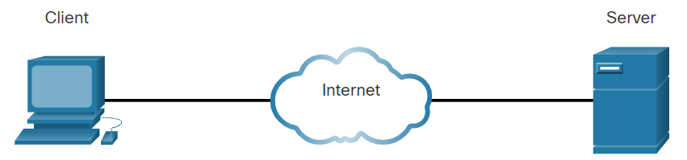

* Peer-to-peer network: a network where one computer function as a client and a server.
  + Advantages:
    - Easy to set up
    - Less complex
    - Lower cost
    - Can be used for simple tasks such as transferring files and sharing printers.
  + Disadvantages:
    - No centralized administration
    - Not as secure
    - Not scalable
    - All devices may act as both clients and servers which can slow their performance.
* End devices are either the source or the destination of a message transmitted over the network.
* Intermediary devices:
  + They connect the individual end devices to the network.
  + Examples: wireless router, LAN switch, router, multilayer switch, firewall appliance
  + Functions:
    - Regenerate and retransmit communication signals.
    - Maintain information about what pathways exist through the network and internetwork.
    - Notify other devices of errors and communication failures.
    - Direct data along alternate pathways when there is a link failure.
    - Classify and direct messages according to priorities.
    - Permit or deny the flow of data, based on security settings.
* Network media:
  + Communication across a network is carried through a medium which allows a message to travel from source to destination.
  + Metal wires within cables: Data is encoded into electrical impulses.
  + Glass or plastic fibers within cables (fiber-optic cable): Data is encoded into pulses of light.
  + Wireless transmission: Data is encoded via modulation of specific frequencies of electromagnetic waves.

## Network representations and topologies

* Topology diagrams = network diagrams:
  + Use symbols to represent devices within the network for visualisation.

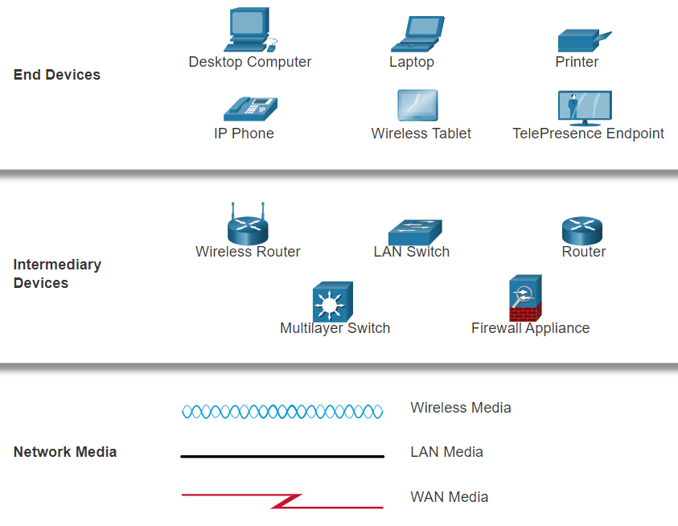

* + Network Interface Card (NIC): a NIC physically connects the end device to the network.
  + Physical Port: a connector or outlet on a networking device where the media connects to an end device or another networking device.
  + Interface: specialized ports on a networking device that connect to individual networks. Because routers connect networks, the ports on a router are referred to as network interfaces.
  + Physical Topology Diagrams: illustrate the physical location of intermediary devices and cable installation.

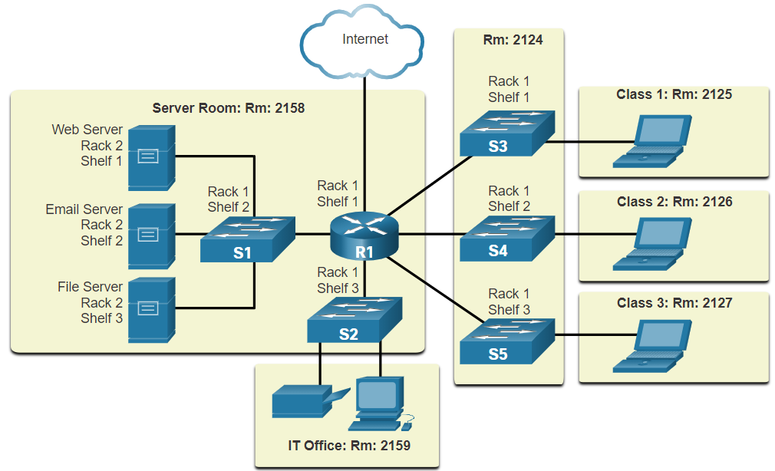

* + Logical Topology Diagrams: illustrate devices, ports, and the addressing scheme of the network.

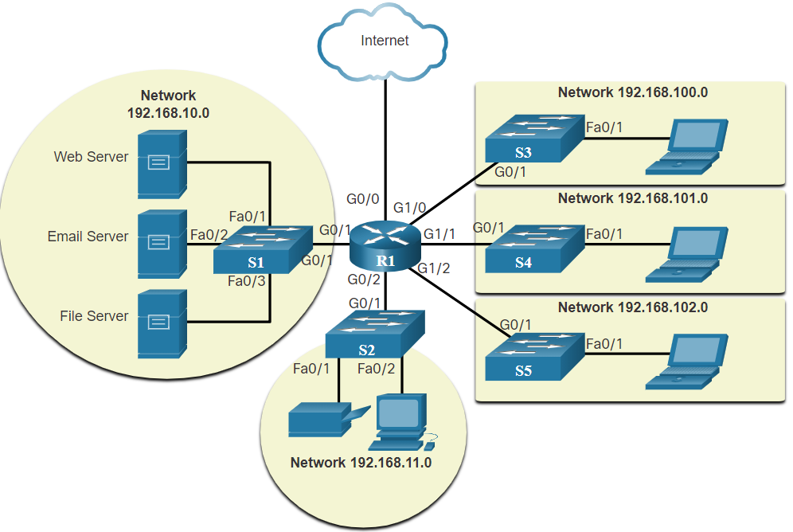

## Common types of networks

* Small home networks: connect a few computers to each other and to the internet.
* Small office and home office networks (SOHO network): allows computers in a home office or a remote office to connect to a corporate network, or access centralized, shared resources.
* Medium to large networks (like those used by corporations and schools): they can have many locations with hundreds or thousands of interconnected hosts.
* World wide networks: The internet is a network of networks that connects hundreds of millions of computers world-wide.
* Network infrastructures vary greatly in terms of:
  + Size of the area covered
  + Number of users connected
  + Number and types of services available
  + Area of responsibility
* Local Area Network (LAN):
  + Is a network infrastructure that provides access to users and end devices in a small geographical area.
  + Characteristics:
    - LANs interconnect end devices in a limited area such as a home, school, office building, or campus.
    - A LAN is usually administered by a single organization or individual. Administrative control is enforced at the network level and governs the security and access control policies.
    - LANs provide high-speed bandwidth to internal end devices and intermediary devices.
* Wide Area Network (WAN):
  + is a network infrastructure that provides access to other networks over a wide geographical area, which is typically managed by service providers (SPs) or Internet Service Providers (ISPs).
  + Characteristics:
    - WANs interconnect LANs over wide geographical areas such as between cities, states, provinces, countries, or continents.
    - WANs are usually administered by multiple service providers.
    - WANs typically provide slower speed links between LANs

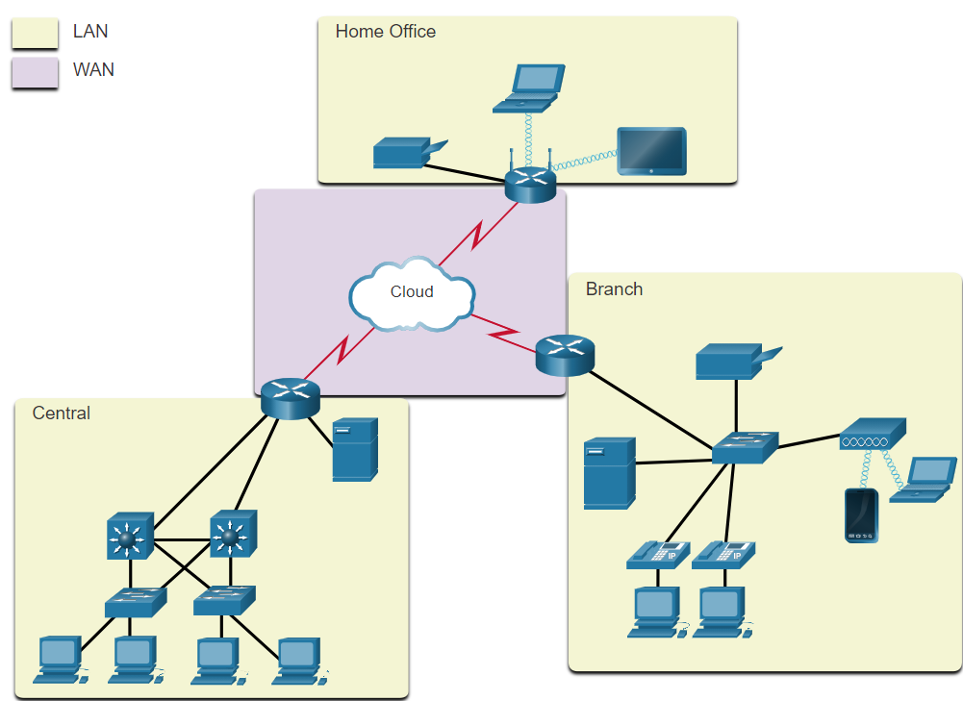

* The internet:
  + is a worldwide collection of interconnected networks (internetworks, or internet for short).
  + LANs are connected to each other using WANs
  + WANs may use copper wires, fiber-optic cables and wireless transmission.
  + There are organizations that were developed to help maintain the structure and standardization of internet protocols and processes:
    - Internet Engineering Task Force (IETF)
    - Internet Corporation for Assigned Names and Numbers (ICANN)
    - Internet Architecture Board (IAB)
* Intranet: a private connection of LANs and WANs that belongs to an organization. It is designed to be accessible only by the organization's members, employees, or others with authorization.
* Extranet: may be used by an organisation to provide secure and safe access to individuals who work for a different organization but require access to the organization’s data.

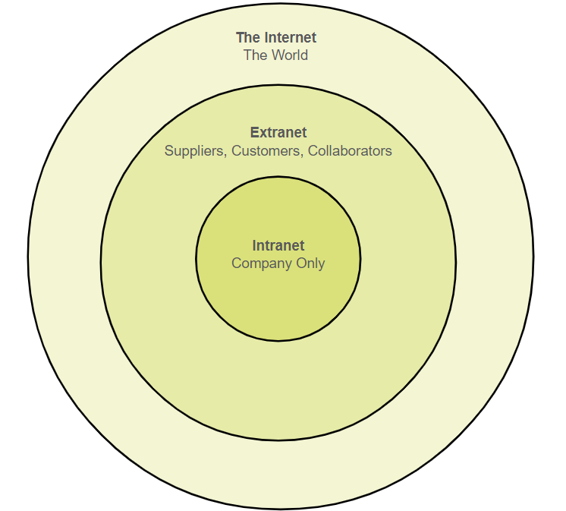

## Internet connections

* Home and small office internet connections:
  + Cable: high bandwidth, always on, internet offered by cable television service providers.
  + Digital Subscriber Lines (DSL): high bandwidth, always on, internet connection that runs over a telephone line. Mostly SOHO users connect using Asymmetrical DSL (ADSL), which means that the download speed is faster than the upload.
  + Cellular: uses a cell phone network to connect to the internet, performance limited by the phone and cell tower it is connected to.
  + Satellite: major benefit for rural areas, the satellite dish requires a clear line of sight to the satellite.
  + Dial-up Telephone: an inexpensive, low bandwidth option using a phone line and a modem.
* Businesses internet connections:
  + may require higher bandwidth, dedicated bandwidth, and managed services.
  + Dedicated Leased Lines: these are reversed circuits within the service provider’s network that connect geographically separated offices for private voice and or data networking.
  + Metro Ethernet (= Ethernet WAN): extends LAN access technology into WAN.
  + Business DSL: available in various formats. A popular choice is Symmetric DSL (SDSL). This provides uploads and downloads at the same high speeds.
  + Satellite: this is an option when a wired connection isn’t an option.
* Converged networks:
  + Before converged networks, an organization would have been separately cabled for telephone, video, and data. Each of these networks would use different technologies to carry the signal. Each of these technologies would use a different set of rules and standards.
  + Converged data networks carry multiple services on one link including: data, voice and video.
  + The network infrastructure uses the same set of rules and standards.

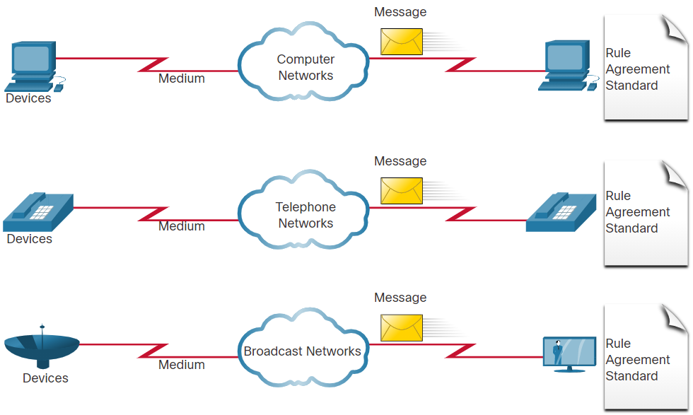 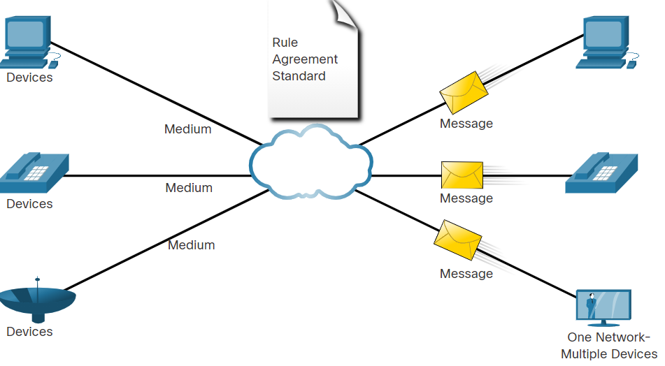

## Reliable Networks

* Network Architecture refers to the technologies that support the infrastructure that moves data across the network.
* There are four basic characteristics that the underlying architectures need to address to meet user expectations:
  + Fault Tolerance:
    - A fault tolerant network is one that limits the number of affected devices during a failure. It is built to allow quick recovery when such a failure occurs. These networks depend on multiple paths between the source and destination of a message.
    - Reliable networks provide redundancy by implementing a packet switched network: Packet switching splits traffic into packets that are routed over a network. Each packet could theoretically take a different path to the destination.

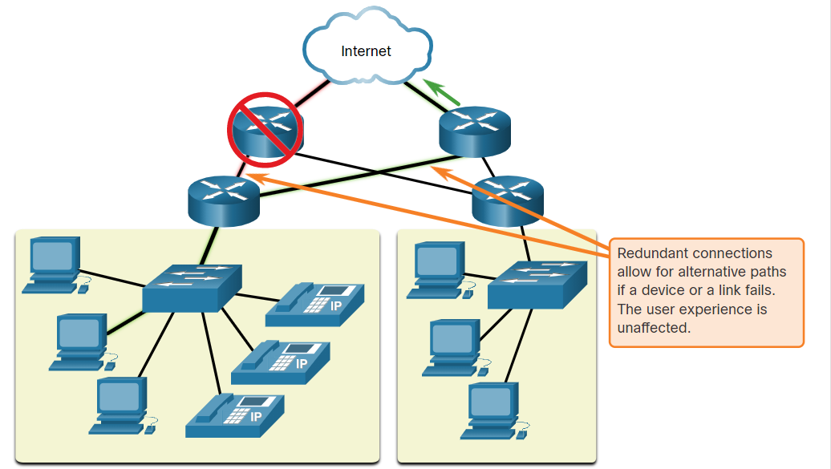

* + Scalability:
    - A scalable network can expand quickly and easily to support new users and applications without impacting the performance of services to existing users.
    - Network designers follow accepted standards and protocols to make the networks scalable.

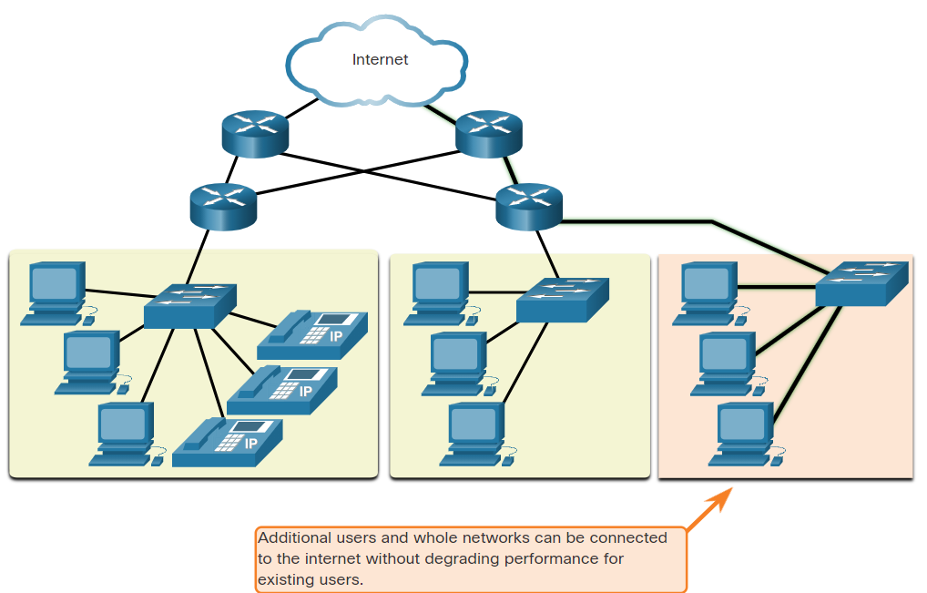

* + Quality of Service (QoS):
    - Voice and live video transmissions require higher expectations for those services being delivered. -> watching a video with constant breaks is not fun.
    - Congestion: this occurs when the demand for bandwidth (measured in bits per second) exceeds the amount available.
    - When the volume of traffic is greater than what can be transported across the network, devices will hold the packets in memory until resources become available to transmit them.
    - QoS becomes a primary mechanism for managing congestion and ensuring reliable delivery of content to all users.

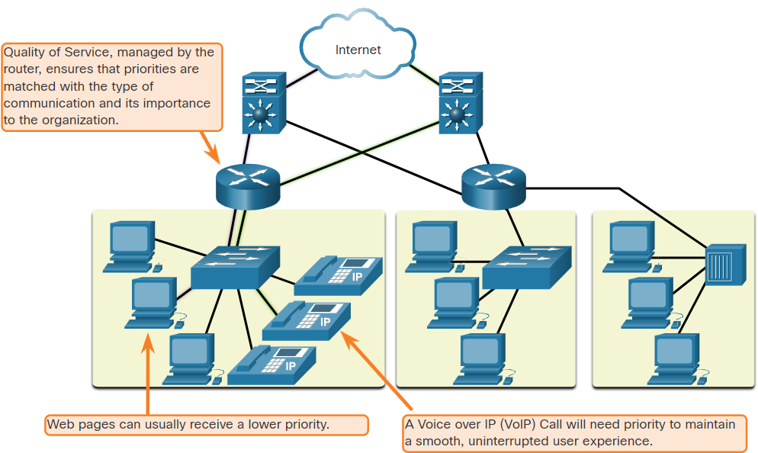

* + Security:
    - Network administrators must address two types of network security concerns:
      * network infrastructure security: this includes physical security of network devices and preventing unauthorized access to the devices.
      * Information Security: protection of the information or data transmitted over the network and the information stored on network attached devices.
    - Three goals of network security:
      * Confidentiality: only intended recipients can read the data
      * Integrity: assurance that the data has not be altered with during transmission
      * Availability: assurance of timely and reliable access to data for authorized users

## Network Trends

* Bring Your Own Device (BYOD):
  + means any device, with any ownership, used anywhere.
  + enables end users the freedom to use personal tools to access information and communicate across a business or campus network.
* Online Collaboration:
  + Collaborate and work with others over the network on joint projects.
  + Collaboration is a very high priority for businesses and in education.
  + Cisco Webex Teams is a multifunctional collaboration tool that lets you send instant messages, post images, and post videos and links.
* Video communication:
  + Video calls are made to anyone, regardless of where they are located.
  + It is a powerful tool for communicating with others and it is becoming a critical requirement for effective collaboration.
  + Cisco TelePresence powers is one way of working where everyone, everywhere.
* Cloud Computing:
  + allows us to store personal files or backup our data on servers over the internet.
  + Applications can also be accessed using the Cloud.
  + Allows businesses to deliver to any device anywhere in the world.
  + is made possible by data centers. Data centers are facilities used to house computer systems and associated components.
  + For security, reliability, and fault tolerance, cloud providers often store data in distributed data centers.
  + 4 primary types of clouds:
    - Public Clouds:
      * Available to the public through a pay-per-use model or for free.
    - Private Clouds:
      * Intended for a specific organization or entity such as the government.
    - Hybrid Clouds:
      * Made up of two or more Cloud types, for example, part custom and part public.
      * Each part remains a distinctive object, but both are connected using the same architecture.
    - Custom Clouds:
      * Built to meet the needs of a specific industry, such as healthcare or media.
      * Can be private or public.
* Smart home technology:
  + Integrates technology into every-day appliances, which can then connect with other devices to make the appliances more ‘smart’ or automated.
  + Ovens might know what time to cook a meal for you by communicating with your calendar on what time you are scheduled to be home.
  + Currently being developed for all rooms within a house.
* Powerline networking:
  + Uses existing electrical wiring to connect devices. Using a standard powerline adapter, devices can connect to the LAN wherever there is an electrical outlet by sending data on certain frequencies.
  + Powerline networking can allow devices to connect to a LAN where data network cables or wireless communications are not a viable option.
* Wireless broadband:
  + A Wireless Internet Service Provider (WISP) is an ISP that connects subscribers to a designated access point or hot spot using similar wireless technologies found in home wireless local area networks (WLANs). It uses the same cellular technology as a smart phone
  + More commonly found in rural environments where DSL or cable services are not available.
  + An antenna is installed outside the house providing wireless or wired connectivity for devices in the home.

## Network security

* Network security:
  + Is an integral part of networking regardless of the size of the network.
  + The network security that is implemented must consider the environment while securing the data, but still allowing for quality of service that is expected of the network.
* Security threats:
  + Threat vectors might be external or internal.
  + External threats:
    - Viruses, worms, and Trojan horses: These contain malicious software or code running on a user device.
    - Spyware and adware: These are types of software which are installed on a user’s device. The software then secretly collects information about the user.
    - Zero-day attacks: Also called zero-hour attacks, these occur on the first day that a vulnerability becomes known.
    - Threat actor attacks: A malicious person attacks user devices or network resources.
    - Denial of service attacks: These attacks slow or crash applications and processes on a network device.
    - Data interception and theft: This attack captures private information from an organization’s network.
    - Identity theft: This attack steals the login credentials of a user in order to access private data.
  + Internal Threats:
    - lost or stolen devices
    - accidental misuse by employees
    - malicious employees
    - BYOD
* Security solutions:
  + security should be implemented in multiple layers, using more than one security solution. If one security component fails to identify and protect the network, others may succeed.
  + Home network security implementation:
    - Antivirus and antispyware: protection from malware
    - Firewall filtering: blocks unauthorized access into and out of the network
  + Corporate network security implementation:
    - Dedicated firewall systems: more advanced firewall capabilities that can filter large amounts of traffic with more granularity.
    - Access control lists (ACL): These further filter access and traffic forwarding based on IP addresses and applications.
    - Intrusion prevention systems (IPS): These identify fast-spreading threats, such as zero-day or zero-hour attacks.
    - Virtual private networks (VPN): These provide secure access into an organization for remote workers.

## The IT professional

* The Cisco Certified Network Associate (CCNA) certification demonstrates that you have a knowledge of foundational technologies and ensures you stay relevant with skill sets needed for the adoption of next-generation technologies.
* The new CCNA focuses on IP foundation and security topics along with wireless, virtualization, automation, and network programmability.
* There are new DevNet certifications at the associate, specialist and professional levels, to validate your software development skills.

# Basic switch and end device configuration

## Cisco IOS Access

* Operating Systems (OS):
  + The portion of the OS that interacts directly with computer hardware is known as the kernel.
  + The portion that interfaces with applications and the user is known as the shell.
  + The user can interact with the shell using a command-line interface (CLI) or a graphical user interface (GUI).

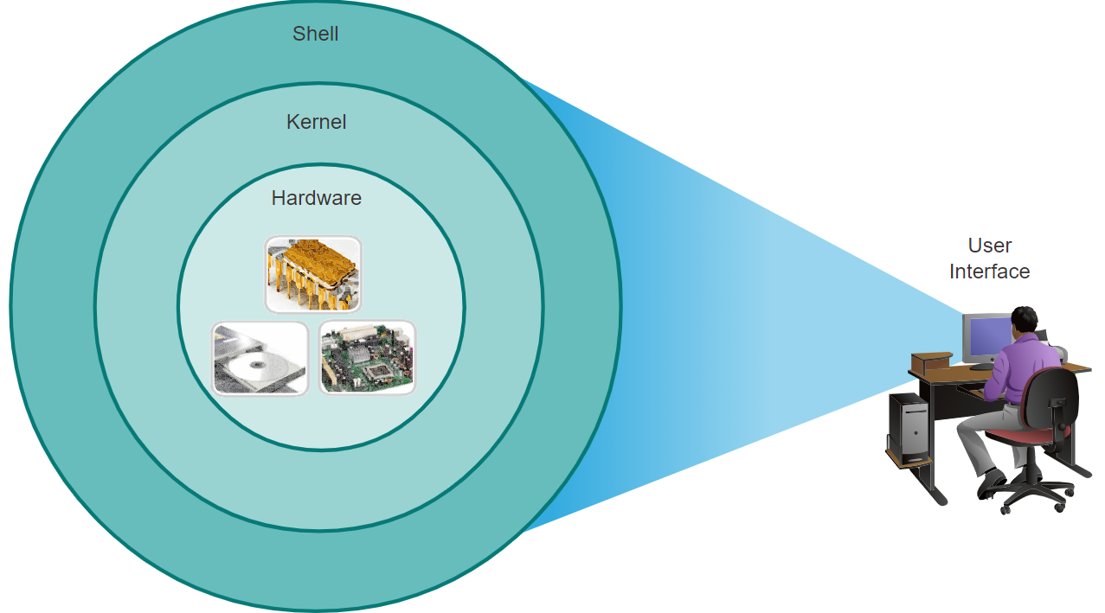

* + However, GUIs may not always be able to provide all the features available with the CLI. GUIs can also fail, crash, or simply not operate as specified. For these reasons, network devices are typically accessed through a CLI. The CLI is less resource intensive and very stable when compared to a GUI.
  + The family of network operating systems used on many Cisco devices is called the Cisco Internetwork Operating System (IOS)
  + Purpose of a PC OS:
    - Use a mouse to make selections and run programs
    - Enter text and text-based commands
    - View output on a monitor
  + Purpose of a CLI-based network operating system:
    - Use a keyboard to run CLI-based network programs
    - Use a keyboard to enter text and text-based commands
    - View output on a monitor
* Access methods for networking devices:
  + Console: A physical management port used to access a device in order to provide maintenance, such as performing the initial configurations. The advantage of using a console port is that the device is accessible even if no networking services are configured, such as performing the initial configuration. A computer running terminal emulation software and a special console cable to connect to the device are required for a console connection.
  + Secure Shell (SSH): an in-band and recommended method for remotely establishing a secure CLI connection, through a virtual interface, over a network. Unlike a console connection, SSH connections require active networking services on the device, including an active interface configured with an address.
  + Telnet (use SSH instead of Telnet!!): is an insecure, in-band method of remotely establishing a CLI session, through a virtual interface, over a network. Unlike SSH, Telnet does not provide a secure, encrypted connection and should only be used in a lab environment. User authentication, passwords, and commands are sent over the network in plaintext.
  + AUX: Some devices, such as routers, may also support a legacy auxiliary port that was used to establish a CLI session remotely over a telephone connection using a modem. Like a console connection, the AUX port is out-of-band and does not require networking services to be configured or available.
  + Terminal emulation programs are used to connect to a network device by either a console port or by an SSH/Telnet connection.
    - There are several terminal emulation programs to choose from such as PuTTY, Tera Term and SecureCRT.

## IOS Navigation

* Primary command modes:
  + User EXEC Mode: it allows only a limited number of basic monitoring commands but does not allow the execution of any commands that might change the configuration of the device. The user EXEC mode is identified by the CLI prompt that ends with the > symbol. 🡪 Router> or switch>
  + Privileged EXEC Mode: To execute configuration commands, a network administrator must access privileged EXEC mode. Higher configuration modes, like global configuration mode, can only be reached from privileged EXEC mode. The privileged EXEC mode can be identified by the prompt ending with the # symbol. -> Router# or switch#
  + Global config mode: from here, CLI configuration changes are made that affect the operation of the device. Global configuration mode is identified by a prompt that ends with (config)# after the device name, such as Switch(config)#
  + Line Configuration Mode: Used to configure console, SSH, Telnet, or AUX access. -> Switch(config-line)
  + Interface Configuration Mode: Used to configure a switch port or router network interface. -> Switch(config-if)
  + **enable** command to move from user EXEC mode to privileged EXEC mode.
    - **disable** privileged EXEC mode command to return to user EXEC mode.
  + **configure terminal** privileged EXEC mode command to move in the global configuration mode.
    - **exit** global config mode command to return to the privileged EXEC mode.
  + **line** command followed by the management line type and number you wish to access.
    - **exit** command to exit a sub configuration mode and return to global configuration mode.
  + the **end** command or enter the key combination ‘Ctrl+Z’ to move from any sub configuration mode to the privileged EXEC mode.
  + You can also move directly from one subconfiguration mode to another

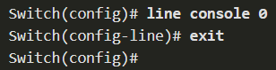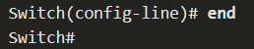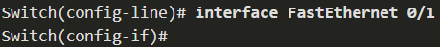

## The Command Structure

* Basic IOS command structure:

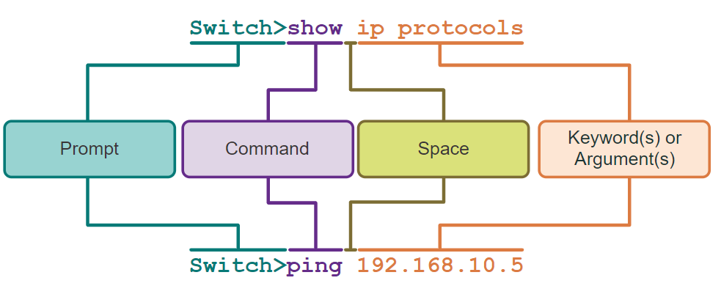

* + Keyword: This is a specific parameter defined in the operating system (in the figure, ip protocols).
  + Argument: This is not predefined; it is a value or variable defined by the user (in the figure, 192.168.10.5).
* IOS command syntax:
  + **Boldface:** indicates commands and keywords that you enter literally as shown.
  + *Italics*: indicates arguments for which you supply values.
  + [x]: indicate an optional element (keyword or argument).
  + {x}: indicate a required element (keyword or argument).
  + [x{y | z}]: indicate a required choice within an optional element. Spaces are used to clearly delineate parts of the command.
* IOS help features:
  + Context-sensitive help enables you to quickly find answers to these questions:
    - Which commands are available in each command mode?
    - Which commands start with specific characters or group of characters?
    - Which arguments and keywords are available to particular commands?
  + Enter a **?** at the CLI to access context-sensitive help:

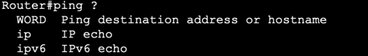

* + Command syntax check verifies that a valid command was entered by the user.
    - If the interpreter cannot understand the command being entered, it will provide feedback describing what is wrong with the command.

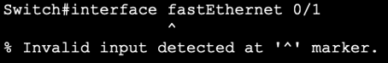

* Hot keys and shortcuts:
  + Commands and keywords can be shortened to the minimum number of characters that identify a unique selection. For example, the **configure** command can be shortened to **conf** because **configure** is the only command that begins with **conf**.
  + Tab: Completes a partial command name entry.
  + Backspace: Erases the character to the left of the cursor.
  + Ctrl+D: Erases the character at the cursor.
  + Ctrl+K: Erases all characters from the cursor to the end of the command line.
  + Esc D: Erases all characters from the cursor to the end of the word.
  + Ctrl+U or Ctrl+X: Erases all characters from the cursor back to the beginning of the command line.
  + Ctrl+W: Erases the word to the left of the cursor.
  + Ctrl+A: Moves the cursor to the beginning of the line.
  + Left Arrowor Ctrl+B: Moves the cursor one character to the left.
  + Esc B: Moves the cursor back one word to the left.
  + Esc F: Moves the cursor forward one word to the right.
  + Right Arrowor Ctrl+F: Moves the cursor one character to the right.
  + Ctrl+E: Moves the cursor to the end of command line.
  + Up Arrowor Ctrl+P: Recalls the previous command in the history buffer, beginning with the most recent command.
  + Down Arrowor Ctrl+N: Goes to the next line in the the history buffer.
  + Ctrl+R or Ctrl+I or Ctrl+L: Redisplays the system prompt and command line after a console message is received.
  + When a command output produces more text than can be displayed in a terminal window, the IOS will display a “--More--” prompt.
    - Enter Key: Displays the next line.
    - Space Bar: Displays the next screen.
    - Any other key: Ends the display string, returning to previous prompt. Except "y", which answers "yes" to the --More-- prompt, and acts like the Space bar
  + Commands used to exit out of an operation:
    - Ctrl-C: When in any configuration mode, ends the configuration mode and returns to privileged EXEC mode. When in setup mode, aborts back to the command prompt.
    - Ctrl-Z: When in any configuration mode, ends the configuration mode and returns to privileged EXEC mode.
    - Ctrl-Shift-6: All-purpose break sequence used to abort DNS lookups, traceroutes, pings, etc.

## Basic Device Configuration

* Device names:
  + The first configuration command on any device should be to give it a unique hostname.
  + By default, all devices are assigned a factory default name. For example, a Cisco IOS switch is "Switch.”
  + Guideline for naming devices:
    - Start with a letter
    - Contain no spaces
    - End with a letter or digit
    - Use only letters, digits, and dashes
    - Be less than 64 characters in length
  + **hostname** command to change the hostname:

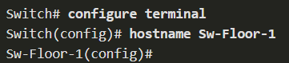

* + **no hostname** to return to the default prompt
  + Make sure to update the documentation each time a device is added or modified
* Password guidelines:
  + All networking devices should limit administrative access by securing privileged EXEC, user EXEC, and remote Telnet access with passwords. In addition, all passwords should be encrypted and legal notifications provided.
  + Guidelines:
    - Use passwords that are more than eight characters in length.
    - Use a combination of upper and lowercase letters, numbers, special characters, and/or numeric sequences.
    - Avoid using the same password for all devices.
    - Do not use common words because they are easily guessed.
* Configure passwords:
  + Securing user EXEC mode access:
    - First enter line console configuration mode using the **line console 0** command in global configuration mode.
    - Next, specify the user EXEC mode password using the **password** *password* command.
    - Finally, enable user EXEC access using the **login** command.

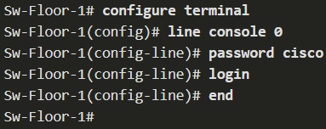

* + Securing privileged EXEC mode access:
    - First enter global configuration mode.
    - Next, use the **enable secret** *password* command.

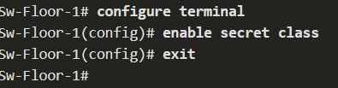

* + Virtual terminal (VTY) lines enable remote access using Telnet or SSH to the device. Many Cisco switches support up to 16 VTY lines that are numbered 0 to 15.
  + Securing VTY line access:
    - First enter line VTY configuration mode using the **line vty 0 15** command in global configuration mode.
    - Next, specify the VTY password using the **password** *password* command.
    - Finally, enable VTY access using the **login** command.

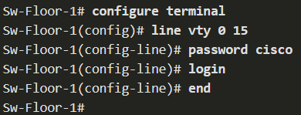

* Encrypt passwords:
  + The startup-config and running-config files display most passwords in plaintext.
  + To encrypt all plaintext passwords, use the **service password-encryption** global config command.

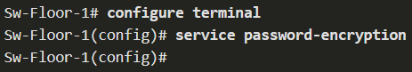

* + Use the **show running-config** command to verify that the passwords on the device are now encrypted.

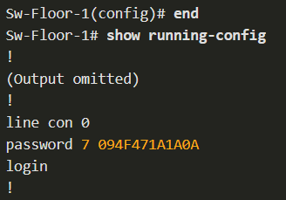

* Banner messages:
  + A banner message is important to warn unauthorized personnel from attempting to access the device.
  + To create a banner on a network device, use the **banner motd #** *message* **#** global config command.



## Save Configurations

* There are two system files that store the device configuration:
  + **startup-config:** This is the saved configuration file that is stored in NVRAM. It contains all the commands that will be used by the device upon startup or reboot. Flash does not lose its contents when the device is powered off.
    - **show running-config** privileged EXEC mode command is used to view the running config.
  + **running-config:** This is stored in Random Access Memory (RAM). It reflects the current configuration. Modifying a running configuration affects the operation of a Cisco device immediately. RAM is volatile memory. It loses all of its content when the device is powered off or restarted.
    - The **show startup-config** privileged EXEC command to view the startup configuration file.
  + the **copy running-config startup-config** privileged EXEC mode command to save changes made to the running configuration to the startup configuration file.
  + **Reload** command to reload the device
  + **Erase startup-config**privileged EXEC mode commandto remove the startup config
* Capture configuration to a Text file:
  1. Open terminal emulation software, such as PuTTY or Tera Term, that is already connected to a switch.
  2. Enable logging in to the terminal software and assign a name and file location to save the log file. The figure displays that All session output will be captured to the file specified (i.e., MySwitchLogs).
  3. Execute the show running-config or show startup-config command at the privileged EXEC prompt. Text displayed in the terminal window will be placed into the chosen file.
  4. Disable logging in the terminal software. The figure shows how to disable logging by choosing the None session logging option

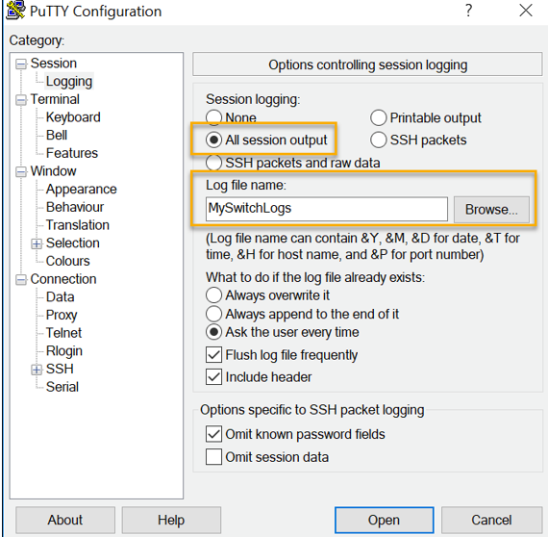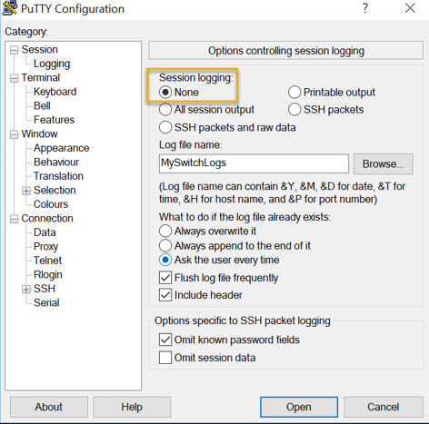

* + The text file created can be used as a record of how the device is currently implemented. The file could require editing before being used to restore a saved configuration to a device.
  + To restore a configuration file to a device:
    1. Enter global configuration mode on the device.
    2. Copy andpaste the text file into the terminal window connected to the switch.

## Ports and Addresses

* IP addresses:
  + The use of IP addresses is the primary means of enabling devices to locate one another and establish end-to-end communication on the internet.
  + The structure of an IPv4 address is called dotted decimal notation and is represented by four decimal numbers between 0 and 255.
  + An IPv4 subnet mask is a 32-bit value that differentiates the network portion of the address from the host portion. Coupled with the IPv4 address, the subnet mask determines to which subnet the device is a member.
  + The default gateway address is the IP address of the router that the host will use to access remote networks, including the internet.
  + IPv6 addresses are 128 bits in length and written as a string of hexadecimal values. Every four bits is represented by a single hexadecimal digit; for a total of 32 hexadecimal values. Groups of four hexadecimal digits are separated by a colon “:”.
  + IPv6 addresses are not case-sensitive and can be written in either lowercase or uppercase.

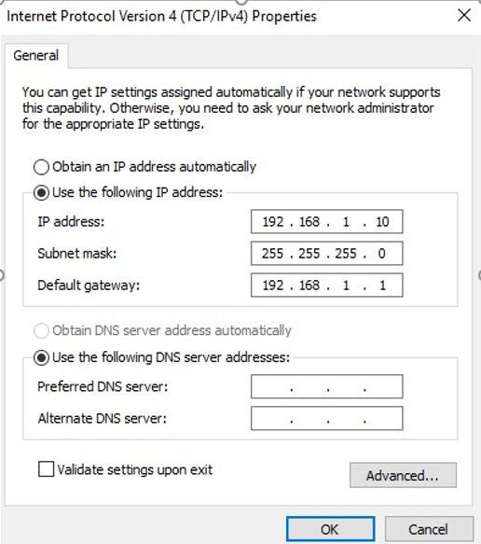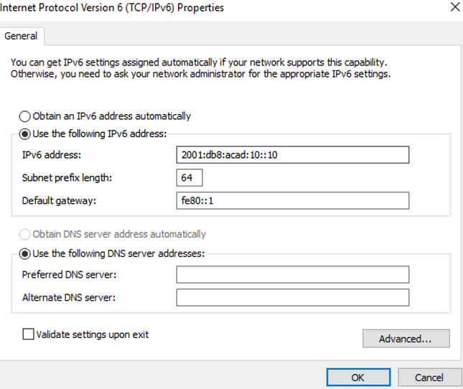

* Interfaces and ports:
  + Network communications depend on end user device interfaces, networking device interfaces, and the cables that connect them. Each physical interface has specifications, or standards, that define it.
  + Types of network media include twisted-pair copper cables, fiber-optic cables, coaxial cables, or wireless.
  + Different types of network media have different features and benefits. Some of the differences between various types of media include:
    - Distance the media can successfully carry a signal
    - Environment in which the media is to be installed
    - Amount of data and the speed at which it must be transmitted
    - Cost of the media and installation

## Configure IP Addressing

* Manual IP address configuration for end devices:
  + IPv4 address information can be entered into end devices manually, or automatically using Dynamic Host Configuration Protocol (DHCP).
  + IPv6 addressing and configuration options are similar to IPv4.
* Automatic IP address configuration for end devices:
  + DHCP enables automatic IPv4 address configuration for every end device that is DHCP-enabled.
  + End devices are typically by default using DHCP for automatic IPv4 address configuration.
  + IPv6 uses DHCPv6 and SLAAC (Stateless Address Autoconfiguration) for dynamic address allocation.
* Show IP configuration on windows: use the command **ipconfig**.
  + Use the command **show ip interface brief** for switches and routers
* Use the **ping** *ip address* command to test connectivity to another device on the network or a website on the internet.

# Protocols and models

## Introduction

* Protocols are sets of agreed upon rules that have been created by standards organizations.
* Models give you a way to visualize the rules and their place in your network.

## The Rules

* All communication methods have 3 elements in common:
  + Message source (sender)
  + Message destination (receiver)
  + Channel
* Protocols must account for the following requirements to successfully deliver a message that is understood by the receiver:
  + An identified sender and receiver
  + Common language and grammar
  + Speed and timing of delivery
  + Confirmation or acknowledgment requirements
* Common computer protocols include the following requirements:
  + Message encoding:
    - Encoding is the process of converting information into another acceptable form, for transmission. Decoding reverses this process to interpret the information.
  + Message formatting and encapsulation:
    - When a message is sent from source to destination, it must use a specific format or structure. Message formats depend on the type of message and the channel that is used to deliver the message.
    - The process of placing one message format (the letter) inside another message format (the envelope) is called encapsulation. De-encapsulation occurs when the process is reversed by the recipient and the letter is removed from the envelope.
  + Message size:
    - Encoding between hosts must be in an appropriate format for the medium.
      * Messages sent across the network are converted to bits
      * The bits are encoded into a pattern of light, sound, or electrical impulses.
      * The destination host must decode the signals to interpret the message.
  + Message timing:
    - Flow Control: Manages the rate of data transmission and defines how much information can be sent and the speed at which it can be delivered.
    - Response Timeout: Manages how long a device waits when it does not hear a reply from the destination.
    - Access method: Determines when someone can send a message.
      * There may be various rules governing issues like “collisions”. This is when more than one device sends traffic at the same time and the messages become corrupt.
      * Some protocols are proactive and attempt to prevent collisions; other protocols are reactive and establish a recovery method after the collision occurs.
  + Message delivery options:
    - Unicast: Information is being transmitted to a single end device.
    - Multicast: Information is being transmitted to a one or more end devices.
    - Broadcast: Information is being transmitted to all end devices.

## Protocols

* Network protocols define a common set of rules.
  + Can be implemented on devices in:
    - Software
    - Hardware
    - Both
  + Protocols have their own:
    - Function
    - Format
    - Rules
* Network Communications Protocols: Protocols enable two or more devices to communicate over one or more networks.
  + IP, Transmission Control Protocol (TCP), HyperText Transfer Protocol (HTTP), and many more.
* Network Security Protocols: Protocols secure data to provide authentication, data integrity, and data encryption.
  + Secure Shell (SSH), Secure Sockets Layer (SSL), and Transport Layer Security (TLS).
* Routing Protocols: Protocols enable routers to exchange route information, compare path information, and then to select the best path to the destination network.
  + Open Shortest Path First (OSPF) and Border Gateway Protocol (BGP).
* Service Discovery Protocols: Protocols are used for the automatic detection of devices or services.
  + Dynamic Host Configuration Protocol (DHCP) which discovers services for IP address allocation, and Domain Name System (DNS) which is used to perform name-to-IP address translation.
* Network protocol functions:
  + Addressing: This identifies the sender and the intended receiver of the message using a defined addressing scheme. Examples of protocols that provide addressing include Ethernet, IPv4, and IPv6.
  + Reliability: This function provides guaranteed delivery mechanisms in case messages are lost or corrupted in transit. TCP provides guaranteed delivery.
  + Flow control: This function ensures that data flows at an efficient rate between two communicating devices. TCP provides flow control services.
  + Sequencing: This function uniquely labels each transmitted segment of data. The receiving device uses the sequencing information to reassemble the information correctly. This is useful if the data segments are lost, delayed or received out-of-order. TCP provides sequencing services.
  + Error Detection : This function is used to determine if data became corrupted during transmission. Various protocols that provide error detection include Ethernet, IPv4, IPv6, and TCP.
  + Application Interface: This function contains information used for process-to-process communications between network applications. For example, when accessing a web page, HTTP or HTTPS protocols are used to communicate between the client and server web processes.
* Networks require the use of several protocols.
  + Each protocol has its own function and format.
* some common network protocols used when accessing websites:
  + Hypertext Transfer Protocol (HTTP):
    - Governs the way a web server and a web client interact
    - Defines content and format
  + Transmission Control Protocol (TCP):
    - Manages the individual conversations
    - Provides guaranteed delivery
    - Manages flow control
  + Internet Protocol (IP): Delivers messages globally from the sender to the receiver
  + Ethernet: Delivers messages from one NIC to another NIC on the same Ethernet Local Area Network (LAN)

## Protocol Suites

* A protocol suite:
  + a group of inter-related protocols necessary to perform a communication function.
  + Sets of rules that work together to help solve a problem.
* One of the best ways to visualize how the protocols within a suite interact is to view the interaction as a stack. A protocol stack shows how the individual protocols within a suite are implemented. The protocols are viewed in terms of layers, with each higher-level service depending on the functionality defined by the protocols shown in the lower levels. The lower layers of the stack are concerned with moving data over the network and providing services to the upper layers, which are focused on the content of the message being sent.

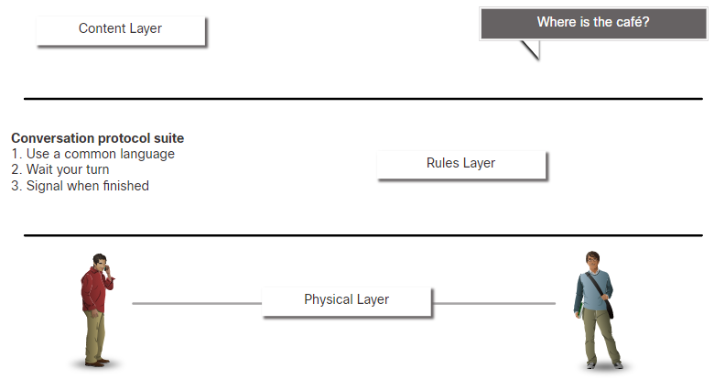

* There are several protocol suites:
  + Internet Protocol Suite or TCP/IP -Themost common protocol suite and maintained by the Internet Engineering Task Force (IETF)
  + Open Systems Interconnection (OSI) protocols -Developedby the International Organization for Standardization (ISO) and the International Telecommunications Union (ITU)
  + AppleTalk -Proprietary suite release by Apple Inc.
  + Novell NetWare -Proprietary suite developed by Novell Inc.
* TCP/IP protocols operate at the application, transport, and internet layers.
* The most common network access layer LAN protocols are Ethernet and WLAN (wireless LAN).

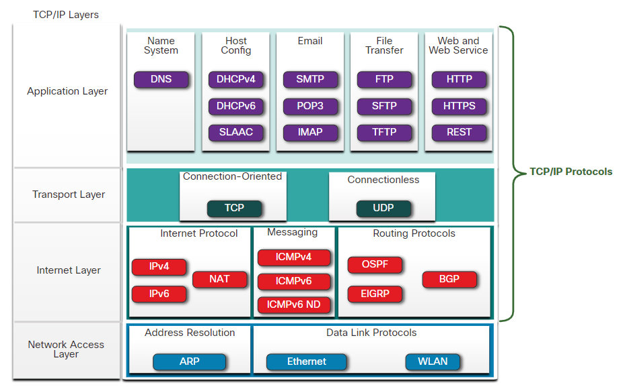

* TCP/IP is the protocol suite used by the internet and the networks of today. TCP/IP has two important aspects for vendors and manufacturers:
  + Open standard protocol suite - This means it is freely available to the public and can be used by any vendor on their hardware or in their software.
  + Standards-based protocol suite - This means it has been endorsed by the networking industry and approved by a standards organization. This ensures that products from different manufacturers can interoperate successfully.

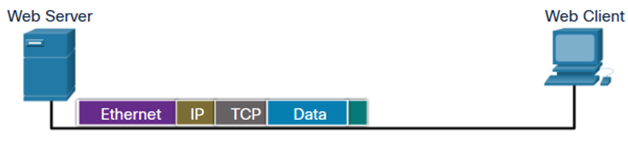

## Standards Organisations

* Open standards encourage interoperability, competition, and innovation. They also guarantee that the product of no single company can monopolize the market or have an unfair advantage over its competition.
* Standards organizations are usually vendor-neutral, non-profit organizations established to develop and promote the concept of open standards.
* standards organizations involved with the development and support of the internet:
  + Internet Society (ISOC) - Promotes the open development and evolution of internet
  + Internet Architecture Board (IAB) - Responsible for management and development of internet standards
  + Internet Engineering Task Force (IETF) - Develops, updates, and maintains internet and TCP/IP technologies
  + Internet Research Task Force (IRTF) - Focused on long-term research related to internet and TCP/IP protocols
* standards organizations involved with the development and support of TCP/IP
  + Internet Corporation for Assigned Names and Numbers (ICANN) - Coordinates IP address allocation, the management of domain names, and assignment of other information
  + Internet Assigned Numbers Authority (IANA) - Oversees and manages IP address allocation, domain name management, and protocol identifiers for ICANN
* Standards organisations responsible for promoting and creating the electronic and communication standards used to deliver the IP packets as electronic signals over a wired or wireless medium:
  + Institute of Electrical and Electronics Engineers (IEEE, pronounced “I-triple-E”) - dedicated to creating standards in power and energy, healthcare, telecommunications, and networking
  + Electronic Industries Alliance (EIA) - develops standards relating to electrical wiring, connectors, and the 19-inch racks used to mount networking equipment
  + Telecommunications Industry Association (TIA) - develops communication standards in radio equipment, cellular towers, Voice over IP (VoIP) devices, satellite communications, and more
  + International Telecommunications Union-Telecommunication Standardization Sector (ITU-T) - defines standards for video compression, Internet Protocol Television (IPTV), and broadband communications, such as a digital subscriber line (DSL)

## Reference Models

* Complex concepts such as how a network operates can be difficult to explain and understand. For this reason, a layered model is used to modularize the operations of a network into manageable layers.
* These are the benefits of using a layered model:
  + Assist in protocol design because protocols that operate at a specific layer have defined information that they act upon and a defined interface to the layers above and below
  + Foster competition because products from different vendors can work together
  + Prevent technology or capability changes in one layer from affecting other layers above and below
  + Provide a common language to describe networking functions and capabilities
* There are two layered models that are used to describe network operations:
  + Open System Interconnection (OSI) Reference Model
  + TCP/IP Reference Model

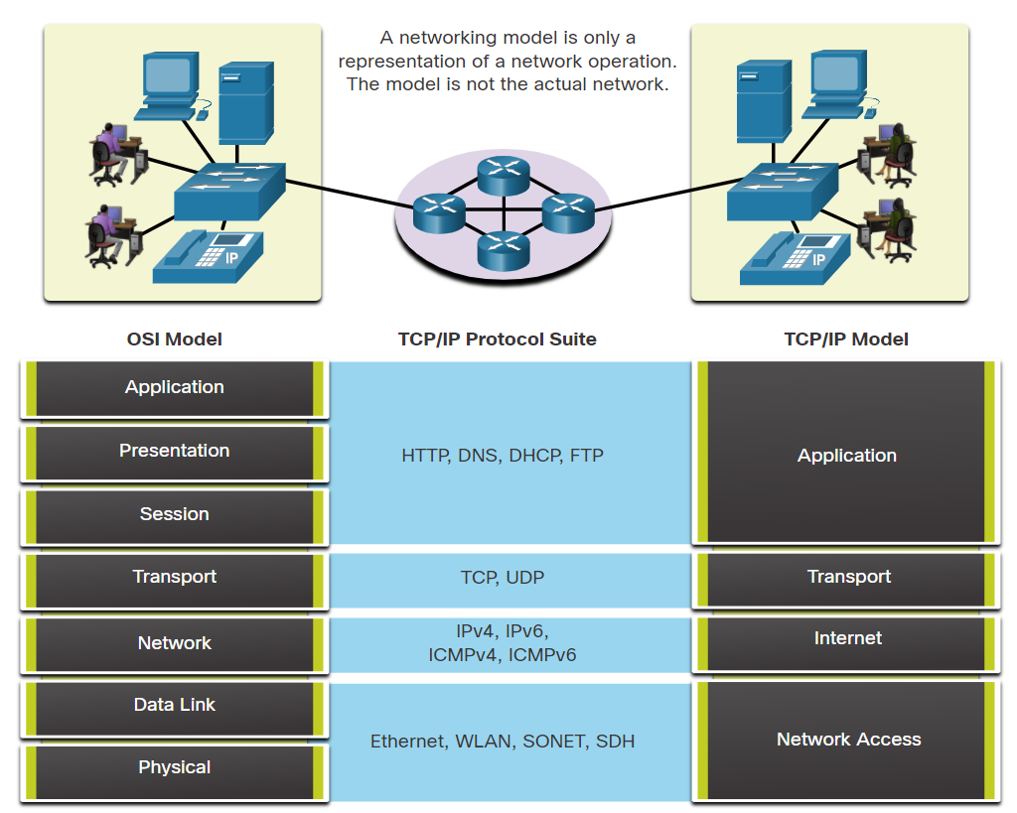

* 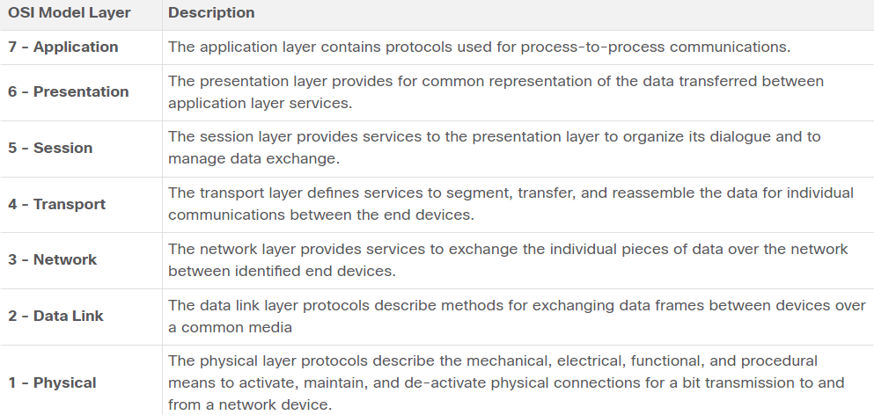The OSI Reference Model:
* 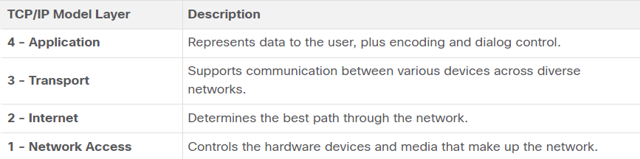The TCP/IP Reference Model:

## Data Encapsulation

* Segmentation is the process of dividing a stream of data into smaller units for transmissions over the network.
* Segmenting messages has two primary benefits:
  + Increases speed - Because a large data stream is segmented into packets, large amounts of data can be sent over the network without tying up a communications link.
  + Increases efficiency -If a single segment is fails to reach its destination due to a failure in the network or network congestion, only that segment needs to be retransmitted instead of resending the entire data stream.
* Multiplexing is the processes of taking multiple streams of segmented data and interleaving them together. This allows many different conversations to be interleaved on the network
* Sequencing messages is the process of numbering the segments so that the message may be reassembled at the destination.
  + TCP is responsible for sequencing the individual segments.
* Encapsulation is the process where protocols add their information to the data.
  + At each stage of the process, a PDU has a different name to reflect its new functions.
  + There is no universal naming convention for PDUs, in this course, the PDUs are named according to the protocols of the TCP/IP suite.
  + PDUs passing down the stack are as follows:
    - Data - The general term for the PDU used at the application layer
    - Segment - Transport layer PDU
    - Packet - Network layer PDU
    - Frame - Data Link layer PDU
    - Bits - Physical layer PDU used when physically transmitting data over the medium
* Encapsulation is a top-down process.
  + The level above does its process and then passes it down to the next level of the model. This process is repeated by each layer until it is sent out as a bit stream.

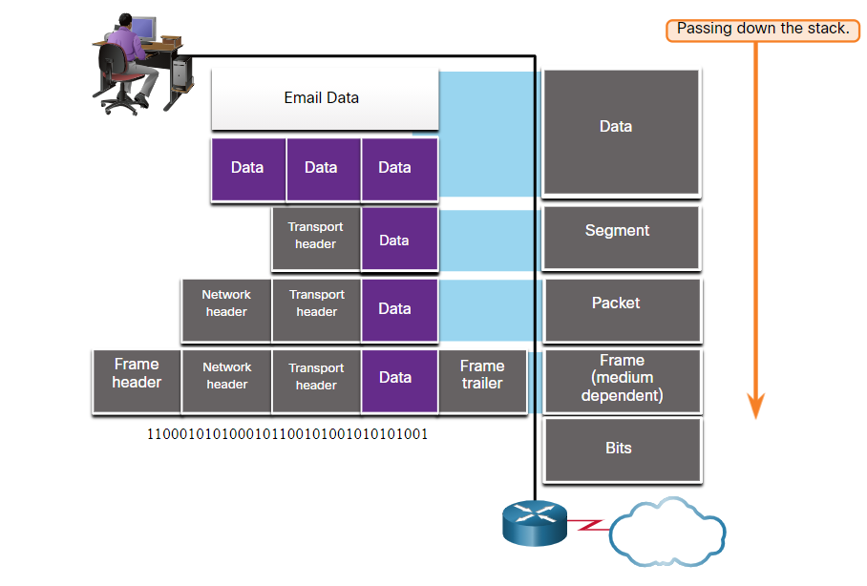

* De-encapsulation is the process used by a receiving device to remove one or more of the protocol headers.
  + It moves up the stack toward the end-user application.
  + When a layer completes its process, that layer strips off its header and passes it up to the next level to be processed.

## Data Access

* Both the data link and network layers use addressing to deliver data from source to destination.
  + Network layer source and destination addresses - Responsible for delivering the IP packet from the original source to the final destination, which may be on the same network or a remote network.
  + Data link layer source and destination addresses - Responsible for delivering the data link frame from one network interface card (NIC) to another NIC on the same network.

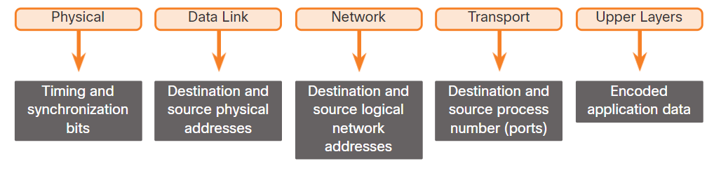

* An IP address is the network layer, or Layer 3, logical address used to deliver the IP packet from the original source to the final destination, as shown in the figure.
* The IP packet contains two IP addresses:
  + Source IP address - The IP address of the sending device, which is the original source of the packet.
  + Destination IP address - The IP address of the receiving device, which is the final destination of the packet.
* An IP address contains two parts:
  + Network portion (IPv4) or Prefix (IPv6) - The left-most part of the address that indicates the network in which the IP address is a member. All devices on the same network will have the same network portion of the address.
  + Host portion (IPv4) or Interface ID (IPv6) - The remaining part of the address that identifies a specific device on the network. This portion is unique for each device or interface on the network.
* On an Ethernet network, the data link addresses are known as Ethernet Media Access Control (MAC) addresses
* The IP packet is encapsulated in a data link frame that contains the following data link information:
  + Source data link address - The physical address of the NIC that is sending the data link frame.
  + Destination data link address - The physical address of the NIC that is receiving the data link frame. This address is either the next hop router or the address of the final destination device.
* The purpose of the data link address is to deliver the data link frame from one network interface to another network interface on the same network. Before an IP packet can be sent over a wired or wireless network, it must be encapsulated in a data link frame, so it can be transmitted over the physical medium. The router removes the Layer 2 information as it is received on one NIC and adds new data link information before forwarding out the exit NIC on its way towards the final destination.

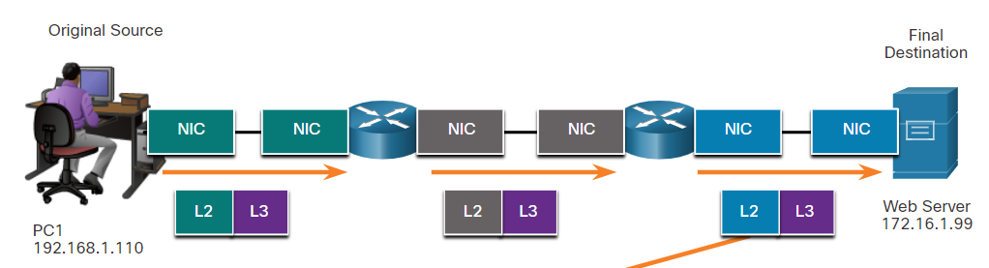

# Physical layer

## Purpose of the Physical Layer

* Before any network communications can occur, a physical connection to a local network must be established.
  + A physical connection can be a wired connection using a cable or a wireless connection using radio waves.
* Network interface cards (NICs) connect a device to the network.
  + Ethernet NICs are used for a wired connection.
  + Wireless local area network (WLAN) NICs are used for wireless.
  + An end-user device may include one or both types of NICs.
* The OSI physical layer provides the means to transport the bits that make up a data link layer frame across the network media. This layer accepts a complete frame from the data link layer and encodes it as a series of signals that are transmitted to the local media. The encoded bits that comprise a frame are received by either an end device or an intermediate device.
* The physical layer encodes the frames and creates the electrical, optical, or radio wave signals that represent the bits in each frame. These signals are then sent over the media, one at a time.

## Physical Layer Characteristics

* The physical layer consists of electronic circuitry, media, and connectors developed by engineers. Therefore, it is appropriate that the standards governing this hardware are defined by the relevant electrical and communications engineering organizations.

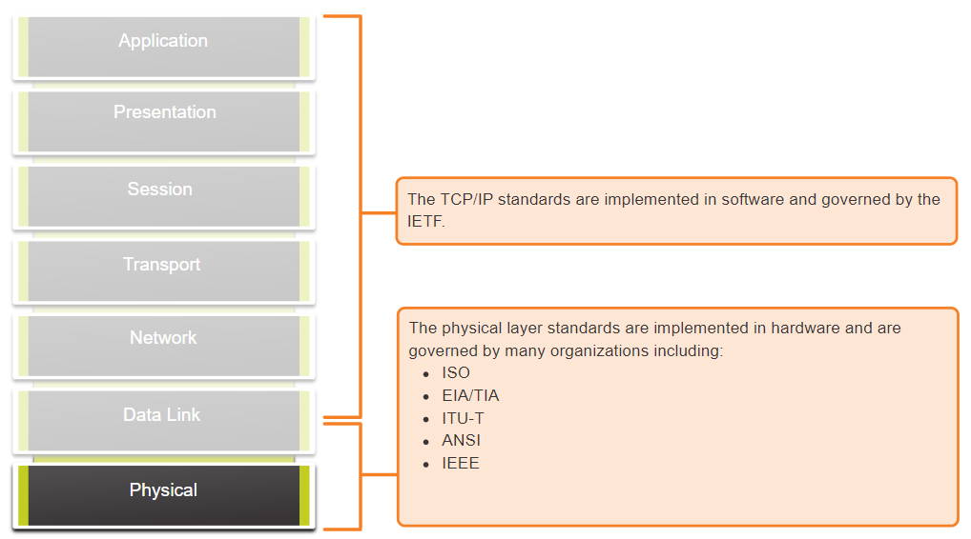

* The physical layer standards address three functional areas:
  + Physical Components:
    - the electronic hardware devices, media, and other connectors that transmit the signals that represent the bits. Hardware components such as NICs, interfaces and connectors, cable materials, the various ports and interfaces on a Cisco 1941 router, and cable designs are all specified in standards associated with the physical layer.
  + Encoding:
    - Encoding converts the stream of bits into a format recognizable by the next device in the network path.
    - This ‘coding’ provides predictable patterns that can be recognized by the next device.
    - For example, Manchester encoding represents a 0 bit by a high to low voltage transition, and a 1 bit is represented as a low to high voltage transition. Figure below.
  + Signaling:
    - The signaling method is how the bit values, “1” and “0” are represented on the physical medium.
    - The method of signaling will vary based on the type of medium being used.

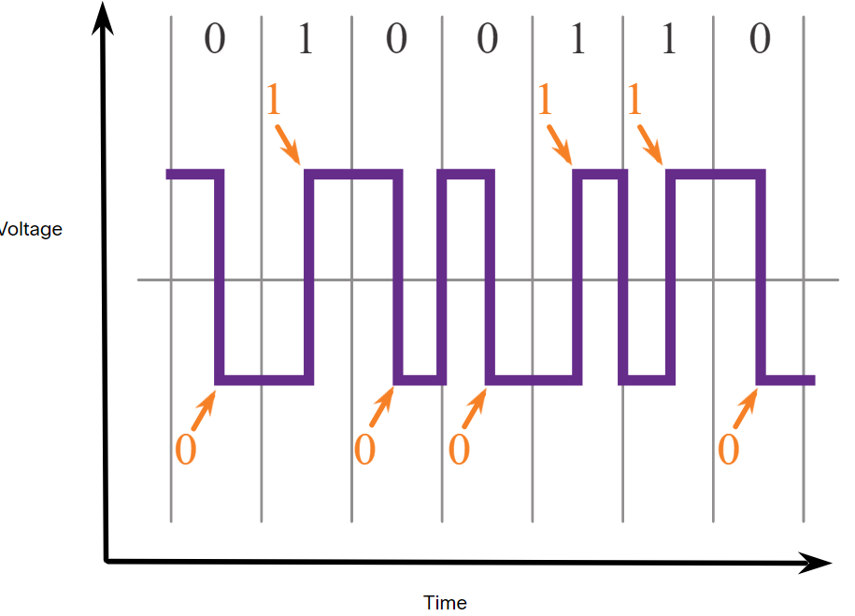

* Bandwidth is the capacity at which a medium can carry data. Digital bandwidth measures the amount of data that can flow from one place to another in a given amount of time. Bandwidth is typically measured in kilobits per second (kbps), megabits per second (Mbps), or gigabits per second (Gbps).
* Physical media properties, current technologies, and the laws of physics all play a role in determining the available bandwidth.

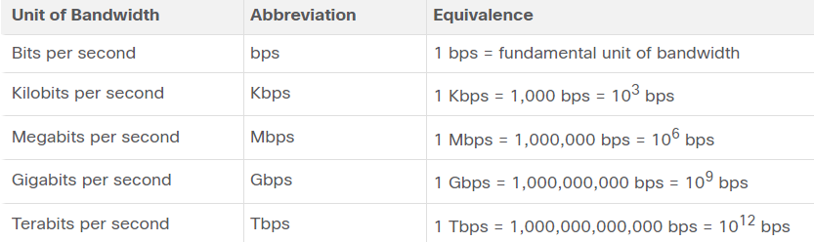

* Latency:
  + Amount of time, including delays, for data to travel from one given point to another
* Throughput:
  + The measure of the transfer of bits across the media over a given period of time
* Goodput:
  + The measure of usable data transferred over a given period of time
  + Goodput = Throughput - traffic overhead

## Copper Cabling

* Networks use copper media because it is inexpensive, easy to install, and has low resistance to electrical current. However, copper media is limited by distance and signal interfere
* Copper cabling is the most common type of cabling used in networks today. It is inexpensive, easy to install, and has low resistance to electrical current flow.
* Limitations:
  + Attenuation – the longer the electrical signals have to travel, the weaker they get.
  + The electrical signal is susceptible to interference from two sources, which can distort and corrupt the data signals (Electromagnetic Interference (EMI) and Radio Frequency Interference (RFI) and Crosstalk).
* Mitigation (the reduction of something harmful or the reduction of its harmful effects):
  + Strict adherence to cable length limits will mitigate attenuation.
  + Some kinds of copper cable mitigate EMI and RFI by using metallic shielding and grounding.
  + Some kinds of copper cable mitigate crosstalk by twisting opposing circuit pair wires together.
* Electromagnetic interference (EMI) or radio frequency interference (RFI) - EMI and RFI signals can distort and corrupt the data signals being carried by copper media. Potential sources of EMI and RFI include radio waves and electromagnetic devices, such as fluorescent lights or electric motors.
* Crosstalk - Crosstalk is a disturbance caused by the electric or magnetic fields of a signal on one wire to the signal in an adjacent (aangrenzend) wire. Specifically, when an electrical current flows through a wire, it creates a small, circular magnetic field around the wire, which can be picked up by an adjacent wire.
* Unshielded twisted-pair (UTP) cabling is the most common networking media. UTP cabling, terminated with RJ-45 connectors, is used for interconnecting network hosts with intermediary networking devices, such as switches and routers.
* Key Characteristics of UTP:
  1. The outer jacket protects the copper wires from physical damage.
  2. Twisted pairs protect the signal from interference.
  3. Color-coded plastic insulation electrically isolates the wires from each other and identifies each pair.

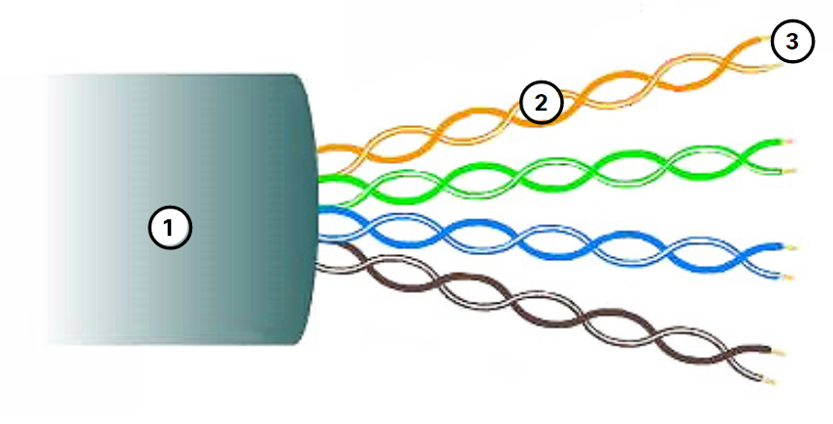

* Shielded twisted-pair (STP):
  + Better noise protection than UTP
  + More expensive than UTP
  + Harder to install than UTP
  + Terminated with RJ-45 connectors
  + Interconnects hosts with intermediary network devices
* Key Characteristics of STP
  1. The outer jacket protects the copper wires from physical damage
  2. Braided or foil shield provides EMI/RFI protection
  3. Foil shield for each pair of wires provides EMI/RFI protection
  4. Color-coded plastic insulation electrically isolates the wires from each other and identifies each pair

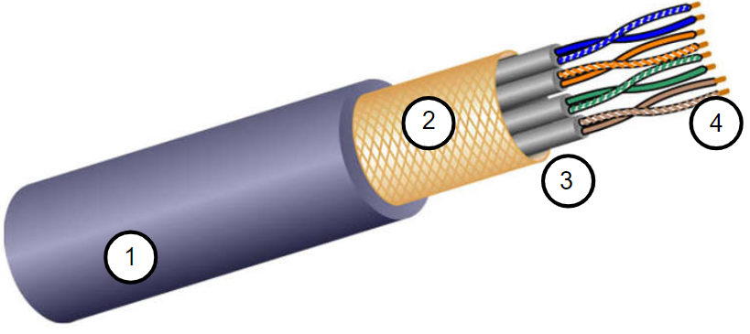

* Coaxial Cable (coax) consists of the following:
  1. Outer cable jacket to prevent minor physical damage
  2. A woven copper braid, or metallic foil, acts as the second wire in the circuit and as a shield that reduces the amount of outside electromagnetic interference for the inner conductor.
  3. A layer of flexible plastic insulation
  4. A copper conductor is used to transmit the electronic signals.



* There are different types of connectors used with coax cable.
* Coax is commonly used in the following situations:
  + Wireless installations **-** Coaxial cables attach antennas to wireless devices.
  + Cable internet installations **-** customer premises wiring

## UTP Cabling

* UTP has four pairs of color-coded copper wires twisted together and encased in a flexible plastic sheath. No shielding is used. UTP relies on the following properties to limit crosstalk:
  + Cancellation - Each wire in a pair of wires uses opposite polarity. One wire is negative, the other wire is positive. They are twisted together and the magnetic fields effectively cancel each other and outside EMI/RFI.
  + Variation in twists per meter in each wire - Each wire is twisted a different amount of times, which helps prevent crosstalk amongst the wires in the cable.
* Standards for UTP are established by the TIA/EIA. TIA/EIA-568 standardizes elements like:
  + Cable Types
  + Cable Lengths
  + Connectors
  + Cable Termination
  + Testing Methods
* Electrical standards for copper cabling are established by the IEEE, which rates cable according to its performance. Examples include:
  + Category 3
  + Category 5 and 5e
  + Category 6 and 6a
  + 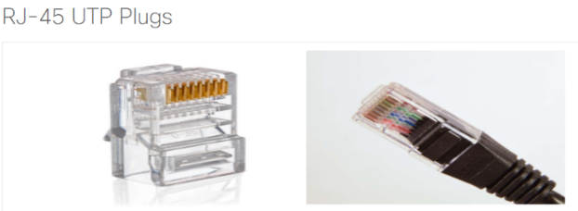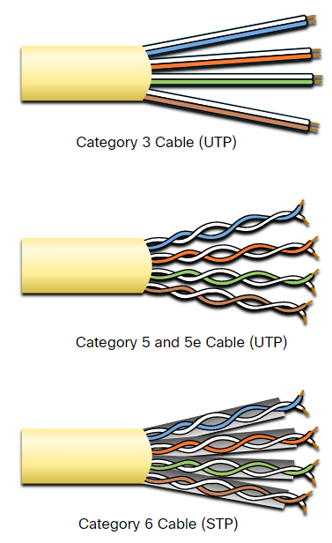Higher category -> higher data rates (bandwith)

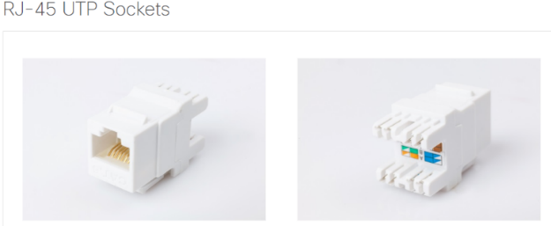

* UTP cable is usually terminated with an RJ-45 connector (the male component).
  + The socket is the female component of a network device, wall, cubicle partition outlet, or patch panel.
  + When terminated improperly, each cable is a potential source of physical layer performance degradation.

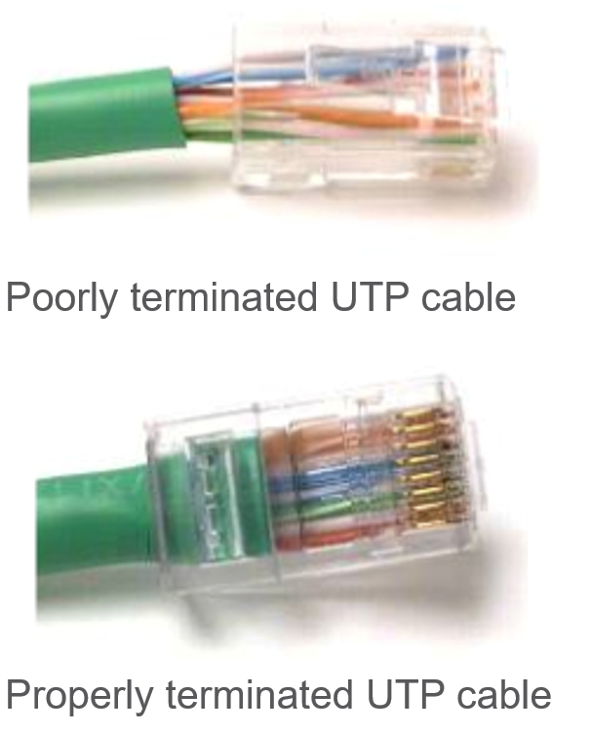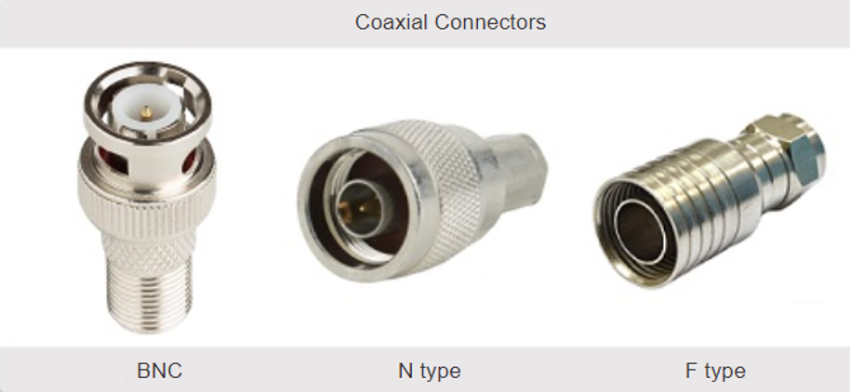

* Different situations may require UTP cables to be wired according to different wiring conventions. This means that the individual wires in the cable have to be connected in different orders to different sets of pins in the RJ-45 connectors.
* The following are the main cable types that are obtained by using specific wiring conventions:
  + Ethernet Straight-through - The most common type of networking cable. It is commonly used to interconnect a host to a switch and a switch to a router.
  + Ethernet Crossover - A cable used to interconnect similar devices. For example, to connect a switch to a switch, a host to a host, or a router to a router. However, crossover cables are now considered legacy as NICs use medium-dependent interface crossover (auto-MDIX) to automatically detect the cable type and make the internal connection.
  + Rollover cable, which is Cisco proprietary. It is used to connect a workstation to a router or switch console port.

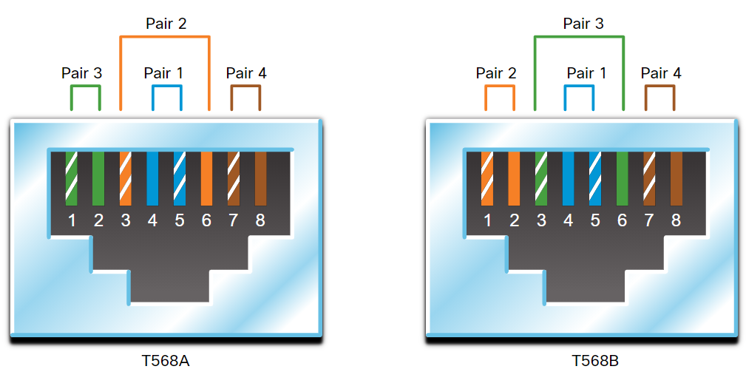

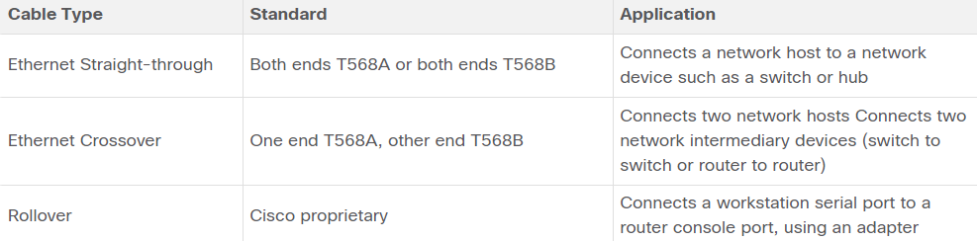

## Fiber-Optic Cabling

* Fiber-Optic Cabling:
  + Not as common as UTP because of the expense involved
  + Ideal for some networking scenarios
  + Transmits data over longer distances at higher bandwidth than any other networking media
  + Less susceptible to attenuation, and completely immune to EMI/RFI
  + Made of flexible, extremely thin strands of very pure glass
  + Uses a laser or LED to encode bits as pulses of light
  + The fiber-optic cable acts as a wave guide to transmit light between the two ends with minimal signal loss
* Single-Mode Fiber:
  + Very small core
  + Uses expensive lasers
  + Long-distance applications

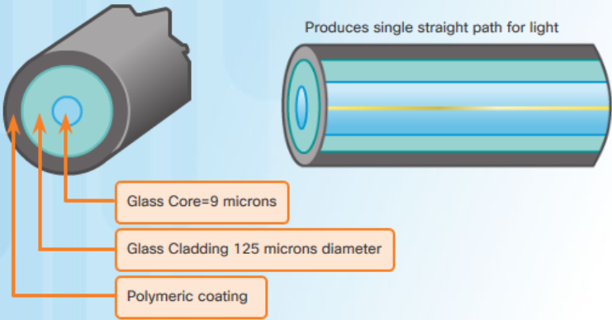

* Multimode Fiber:
  + Larger core
  + Uses less expensive LEDs
  + LEDs transmit at different angles
  + Up to 10 Gbps over 550 meters

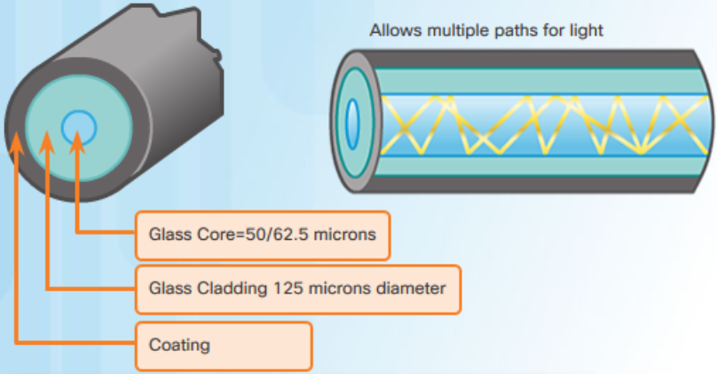

* One of the highlighted differences between MMF and SMF is the amount of dispersion. Dispersion refers to the spreading out of a light pulse over time. Increased dispersion means increased loss of signal strength. MMF has a greater dispersion than SMF. That is why MMF can only travel up to 500 meters before signal loss.
* Fiber-optic cabling is now being used in four types of industry:
  + Enterprise Networks - Used for backbone cabling applications and interconnecting infrastructure devices
  + Fiber-to-the-Home (FTTH) - Used to provide always-on broadband services to homes and small businesses
  + Long-Haul Networks - Used by service providers to connect countries and cities
  + Submarine Cable Networks - Used to provide reliable high-speed, high-capacity solutions capable of surviving in harsh undersea environments at up to transoceanic distances.
* An optical-fiber connector terminates the end of an optical fiber. A variety of optical-fiber connectors are available. The main differences among the types of connectors are dimensions and methods of coupling. Businesses decide on the types of connectors that will be used, based on their equipment.
* Until recently, light could only travel in one direction over optical fiber. Two fibers were required to support the full duplex operation. Therefore, fiber-optic patch cables bundle together two optical fiber cables and terminate them with a pair of standard, single-fiber connectors. Some fiber connectors accept both the transmitting and receiving fibers in a single connector known as a duplex connector. BX standards such as 100BASE-BX use different wavelengths for sending and receiving over a single fiber.

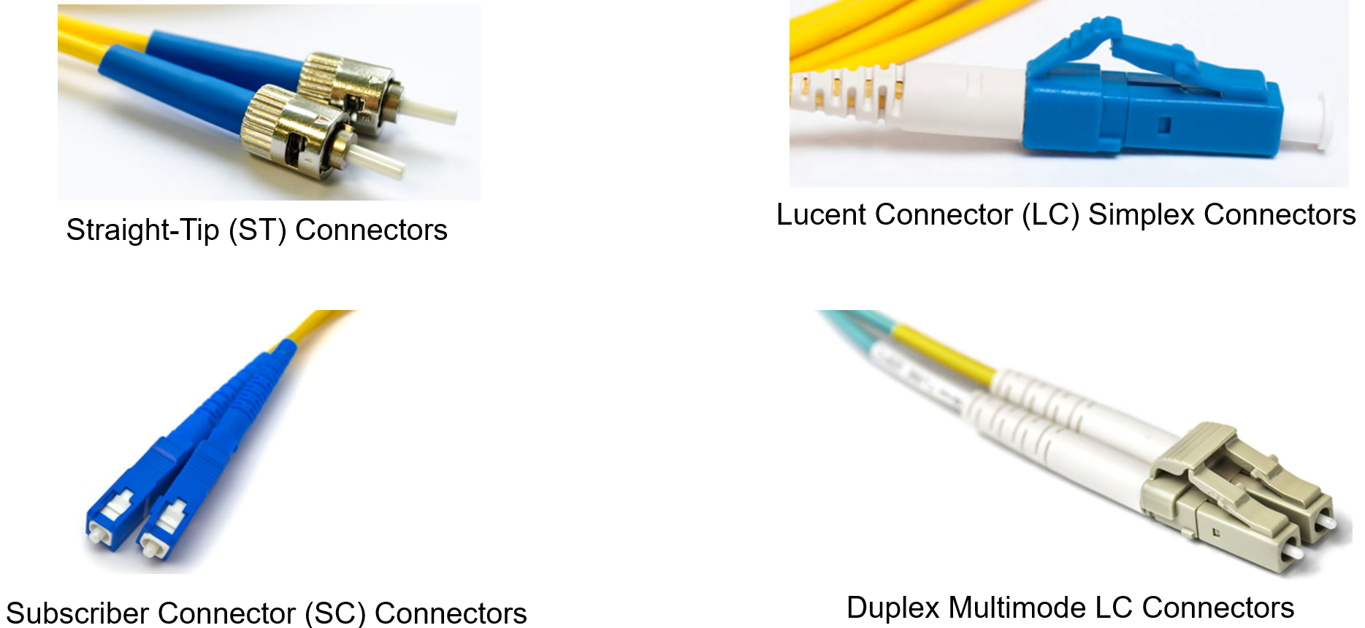

* Fiber patch cords are required for interconnecting infrastructure devices. The use of color distinguishes between single-mode and multimode patch cords. A yellow jacket is for single-mode fiber cables and orange (or aqua) for multimode fiber cables.

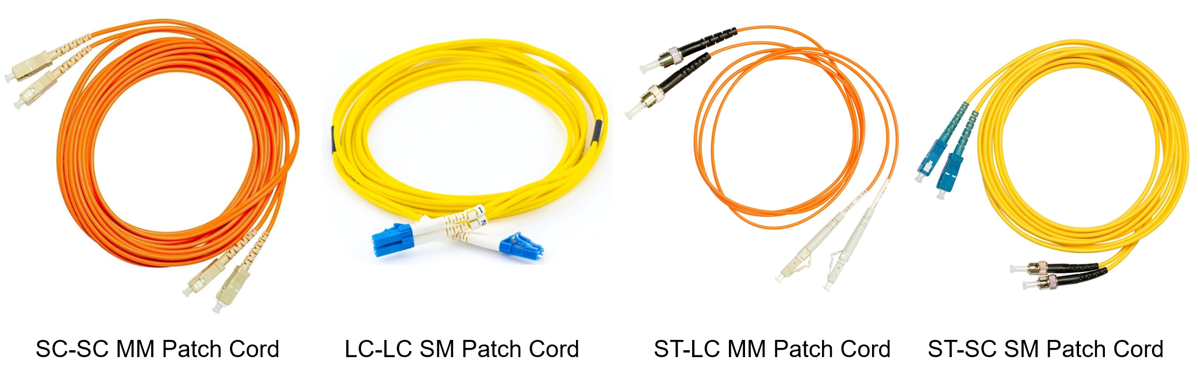

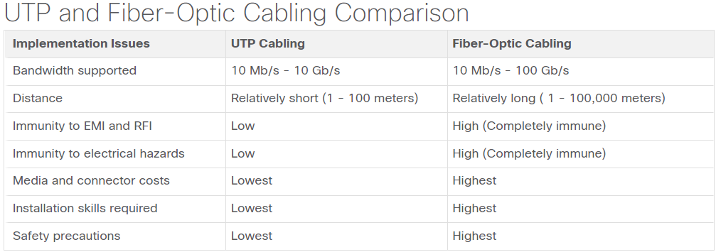

## Wireless Media

* It carries electromagnetic signals representing binary digits using radio or microwave frequencies. This provides the greatest mobility option.
* These are some of the limitations of wireless:
  + Coverage area - Wireless data communication technologies work well in open environments. However, certain construction materials used in buildings and structures, and the local terrain, will limit the effective coverage.
  + Interference - Wireless is susceptible to interference and can be disrupted by such common devices as household cordless phones, some types of fluorescent lights, microwave ovens, and other wireless communications.
  + Security - Wireless communication coverage requires no access to a physical strand of media. Therefore, devices and users, not authorized for access to the network, can gain access to the transmission. Network security is a major component of wireless network administration.
  + Shared medium - WLANs operate in half-duplex, which means only one device can send or receive at a time. The wireless medium is shared amongst all wireless users. Many users accessing the WLAN simultaneously results in reduced bandwidth for each user.
* The IEEE and telecommunications industry standards for wireless data communications

cover both the data link and physical layers. In each of these standards, physical layer

specifications dictate:

* + Data to radio signal encoding methods
  + Frequency and power of transmission
  + Signal reception and decoding requirements
  + Antenna design and construction
* Wireless Standards:
  + Wi-Fi (IEEE 802.11) - Wireless LAN (WLAN) technology
  + Bluetooth (IEEE 802.15) - Wireless Personal Area network (WPAN) standard
  + WiMAX (IEEE 802.16) - Uses a point-to-multipoint topology to provide broadband wireless access
  + Zigbee (IEEE 802.15.4) - Low data-rate, low power-consumption communications, primarily for Internet of Things (IoT) applications
* In general, a Wireless LAN (WLAN) requires the following devices:
  + Wireless Access Point (AP) - Concentrate wireless signals from users and connect to the existing copper-based network infrastructure
  + Wireless NIC Adapters - Provide wireless communications capability to network hosts

# Number systems

# Data link layer

## Purpose of the Data Link Layer

* The data link layer is responsible for network interface card (NIC) to network interface card communications. The data link layer does the following:
  + Enables upper layers to access the media. The upper layer protocol is completely unaware of the type of media that is used to forward the data.
  + Encapsulates Layer 3 packets (IPv4 and IPv6) into Layer 2 Frames.
  + It also performs error detection and rejects corrupts frames.
  + Controls how data is placed and received on the media.
* In computer networks, a node is a device that can receive, create, store, or forward data along a communications path. A node can be either an end device such as a laptop or mobile phone, or an intermediary device such as an Ethernet switch.
* IEEE 802 LAN/MAN standards are specific to the type of network (Ethernet, WLAN, WPAN, etc).
* The IEEE 802 LAN/MAN data link layer consists of two sublayers. Logical Link Control (LLC) and Media Access Control (MAC).
  + The LLC sublayer communicates between the networking software at the upper layers and the device hardware at the lower layers. It places information in the frame that identifies which network layer protocol is being used for the frame. This information allows multiple Layer 3 protocols, such as IPv4 and IPv6, to use the same network interface and media.
  + The MAC sublayer is responsible for data encapsulation and media access control.

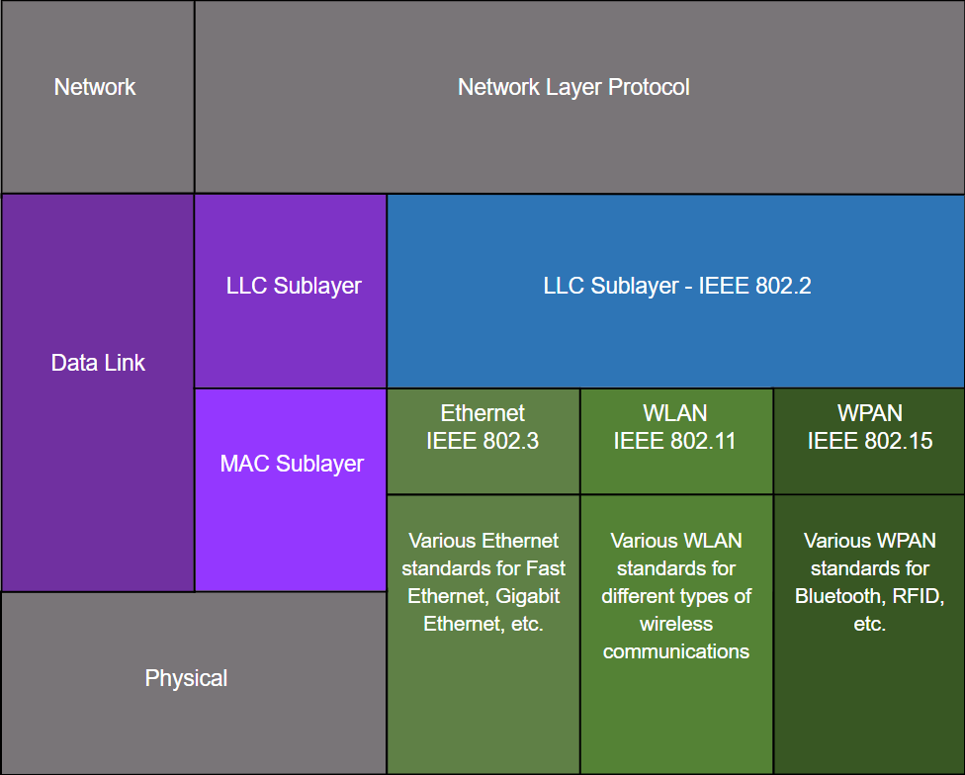

* The LLC sublayer takes the network protocol data, which is typically an IPv4 or IPv6 packet, and adds Layer 2 control information to help deliver the packet to the destination node.
* The MAC sublayer controls the NIC and other hardware that is responsible for sending and receiving data on the wired or wireless LAN/MAN medium.
  + provides data encapsulation:
    - Frame delimiting - The framing process provides important delimiters to identify fields within a frame. These delimiting bits provide synchronization between the transmitting and receiving nodes.
    - Addressing - Provides source and destination addressing for transporting the Layer 2 frame between devices on the same shared medium.
    - Error detection - Includes a trailer used to detect transmission errors.
  + provides media access control, allowing multiple devices to communicate over a shared (half-duplex) medium. Full-duplex communications do not require access control.
* Packets exchanged between nodes may experience numerous data link layers and media transitions.
* At each hop along the path, a router performs four basic Layer 2 functions:
  + Accepts a frame from the network medium.
  + De-encapsulates the frame to expose the encapsulated packet.
  + Re-encapsulates the packet into a new frame.
  + Forwards the new frame on the medium of the next network segment.
* Data link layer protocols are defined by engineering organizations:
  + Institute for Electrical and Electronic Engineers (IEEE).
  + International Telecommunications Union (ITU).
  + International Organizations for Standardization (ISO).
  + American National Standards Institute (ANSI).

## Topologies

* There are three common physical WAN topologies:
  + Point-to-point – the simplest and most common WAN topology. Consists of a permanent link between two endpoints.
  + Hub and spoke – similar to a star topology where a central site interconnects branch sites through point-to-point links.
  + Mesh – provides high availability but requires every end system to be connected to every other end system.
  + A hybrid is a variation or combination of any topologies.
* Point-to-Point WAN Topology:
  + Physical point-to-point topologies directly connect two nodes.
  + The nodes may not share the media with other hosts.
  + Because all frames on the media can only travel to or from the two nodes, Point-to-Point WAN protocols can be very simple.

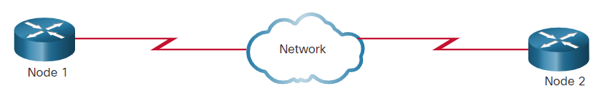

* End devices on LANs are typically interconnected using a star or extended star topology. Star and extended star topologies are easy to install, very scalable and easy to troubleshoot.
* Early Ethernet and Legacy Token Ring technologies provide two additional topologies:
  + Bus – All end systems chained together and terminated on each end.
  + Ring – Each end system is connected to its respective neighbors to form a ring.

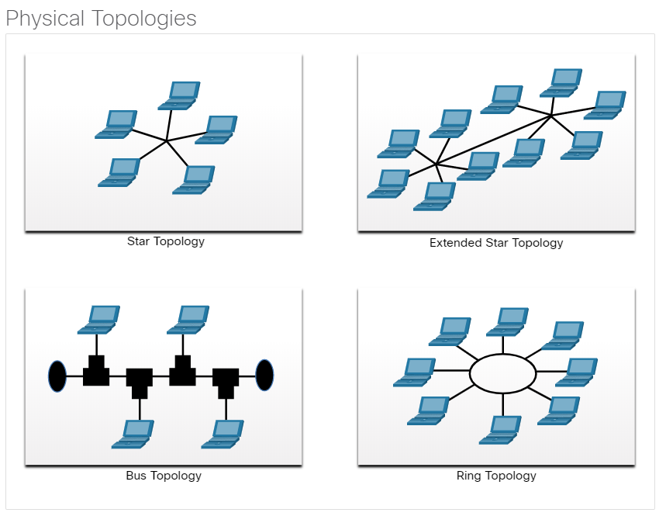

* Half-duplex communication
  + Only allows one device to send or receive at a time on a shared medium.
  + Used on WLANs and legacy bus topologies with Ethernet hubs.
* Full-duplex communication
  + Allows both devices to simultaneously transmit and receive on a shared medium.
  + Ethernet switches operate in full-duplex mode.
* It is important that two interconnected interfaces, such as a host NIC and an interface on an Ethernet switch, operate using the same duplex mode. Otherwise, there will be a duplex mismatch creating inefficiency and latency on the link.
* A multiaccess network is a network that can have two or more end devices attempting to access the network simultaneously.
  + For example, Ethernet LANs and WLANs
* Some multiaccess networks require rules to govern how devices share the physical media. There are two basic access control methods for shared media:
* Contention-based access:
  + In contention-based multiaccess networks, all nodes are operating in half-duplex, competing for the use of the medium. However, only one device can send at a time.
  + Examples of contention-based access methods include the following:
    - Carrier sense multiple access with collision detection (CSMA/CD) used on legacy bus-topology Ethernet LANs
    - Carrier sense multiple access with collision avoidance (CSMA/CA) used on Wireless LANs
* Controlled access:
  + In a controlled-based multiaccess network, each node has its own time to use the medium. These deterministic types of legacy networks are inefficient because a device must wait its turn to access the medium. Examples of multiaccess networks that use controlled access include the following:
    - Legacy Token Ring
    - Legacy ARCNET
* Today, Ethernet networks operate in full-duplex and do not require an access method.
* CSMA/CD (carrier sense multiple access/collision detection):
  + Used by legacy Ethernet LANs.
  + Operates in half-duplex mode where only one device sends or receives at a time.
  + If two devices transmit at the same time, a collision will occur. For legacy Ethernet LANs, both devices will detect the collision on the network. The NIC compares data transmitted with data received, or by recognizing that the signal amplitude is higher than normal on the media. The data sent by both devices will be corrupted and will need to be resent.
* CSMA/CA (carrier sense multiple access/collision avoidance):
  + CMSA/CA uses a method similar to CSMA/CD to detect if the media is clear. CMSA/CA uses additional techniques. In wireless environments it may not be possible for a device to detect a collision. CMSA/CA does not detect collisions but attempts to avoid them by waiting before transmitting. Each device that transmits includes the time duration that it needs for the transmission. All other wireless devices receive this information and know how long the medium will be unavailable.
  + After a wireless device sends an 802.11 frame, the receiver returns an acknowledgment so that the sender knows the frame arrived.
* Contention-based systems do not scale well under heavy media use.

## Data Link Frame

* Data is encapsulated by the data link layer with a header and a trailer to form a frame.
* A data link frame has three parts:
  + Header
  + Data
  + Trailer
* The fields of the header and trailer vary according to data link layer protocol.
* All data link layer protocols encapsulate the data within the data field of the frame. However, the structure of the frame and the fields contained in the header and trailer vary according to the protocol.
  + Depending on the environment, the amount of control information needed in the frame varies to match the access control requirements of the media and logical topology. (For example, WLAN frame needs more control info then Ethernet frame)
* Framing breaks the stream into decipherable groupings, with control information inserted in the header and trailer as values in different fields.
  + The standards for a specific data link protocol define the actual frame format.
* Frame fields include the following:
  + Frame start and stop indicator flags - Used to identify the beginning and end limits of the frame.
  + Addressing - Indicates the source and destination nodes on the media.
  + Type - Identifies the Layer 3 protocol in the data field.
  + Control - Identifies special flow control services such as quality of service (QoS). QoS gives forwarding priority to certain types of messages.
  + Data - Contains the frame payload (i.e., packet header, segment header, and the data).
  + Error Detection - Included after the data to form the trailer. The trailer field is called the frame check sequence (FCS). The trailer determines if the frame arrived without error using a cyclic redundancy check (CRC). It places a logical or mathematical summary of the bits that comprise the frame in the trailer.

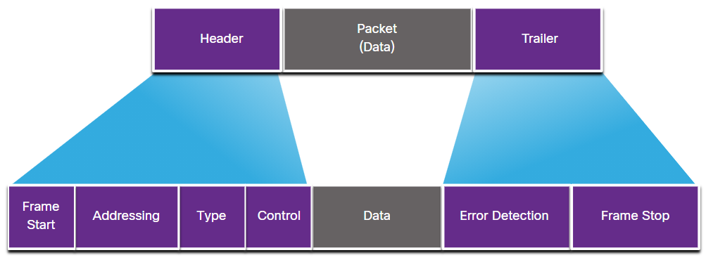

* Layer 2 address:
  + Also referred to as a physical address or MAC address.
  + Contained in the frame header. It is typically at the beginning of the frame, so the NIC can quickly determine if it matches its own Layer 2 address before accepting the rest of the frame.
  + Used only for local delivery (on the same network) of a frame on the link.
  + Updated by each device that forwards the frame.
* If the data must pass onto another network segment, an intermediary device, such as a router, is necessary. The router must accept the frame based on the physical address and de-encapsulate the frame in order to examine the hierarchical address, which is the IP address. Using the IP address, the router can determine the network location of the destination device and the best path to reach it. When it knows where to forward the packet, the router then creates a new frame for the packet, and the new frame is sent on to the next network segment toward its final destination.
* The Layer 2 protocol used depends on the logical topology and the physical media.
* The Layer 2 protocol that is used for a particular network topology is determined by the technology used to implement that topology. The technology used is determined by the size of the network, in terms of the number of hosts and the geographic scope, and the services to be provided over the network.
* Each protocol performs media access control for specified logical topologies.
* The difference in bandwidth normally results in the use of different protocols for LANs and WANs.
* Data link layer protocols include:
  + Ethernet
  + 802.11 Wireless
  + Point-to-Point Protocol (PPP)
  + High-Level Data Link Control (HDLC)
  + Frame Relay

# Ethernet switching

## Ethernet Frame

* Ethernet is one of two LAN technologies used today, with the other being wireless LANs (WLANs). Ethernet uses wired communications, including twisted pair, fiber-optic links, and coaxial cables.
* Ethernet operates in the data link layer and the physical layer. It is a family of networking technologies defined in the IEEE 802.2 and 802.3 standards. It supports bandwiths of 10 Mbps – 100 Gbps
* The minimum Ethernet frame size is 64 bytes and the maximum is 1518 bytes. The preamble field is not included when describing the size of the frame.
  + Any frame less than 64 bytes in length is considered a “collision fragment” or “runt frame” and is automatically discarded by receiving stations. Frames with more than 1500 bytes of data are considered “jumbo” or “baby giant frames”.
  + If the size of a transmitted frame is less than the minimum, or greater than the maximum, the receiving device drops the frame. Dropped frames are likely to be the result of collisions or other unwanted signals. They are considered invalid. Jumbo frames are usually supported by most Fast Ethernet and Gigabit Ethernet switches and NICs.

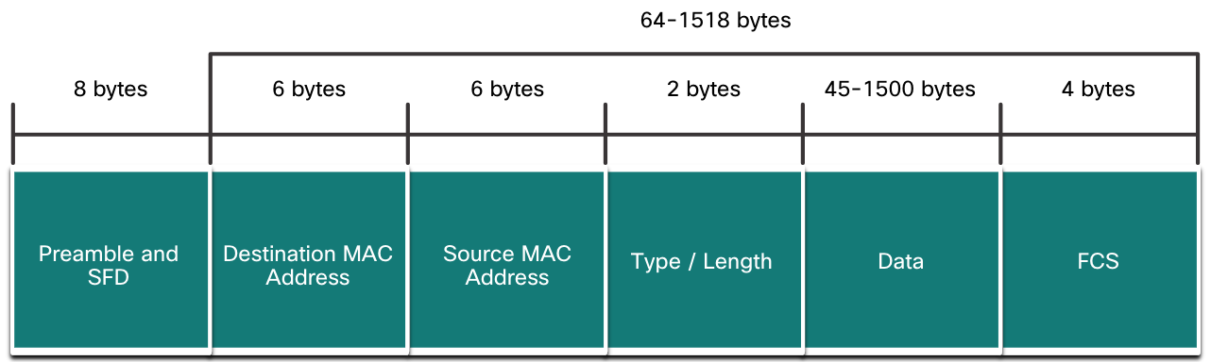

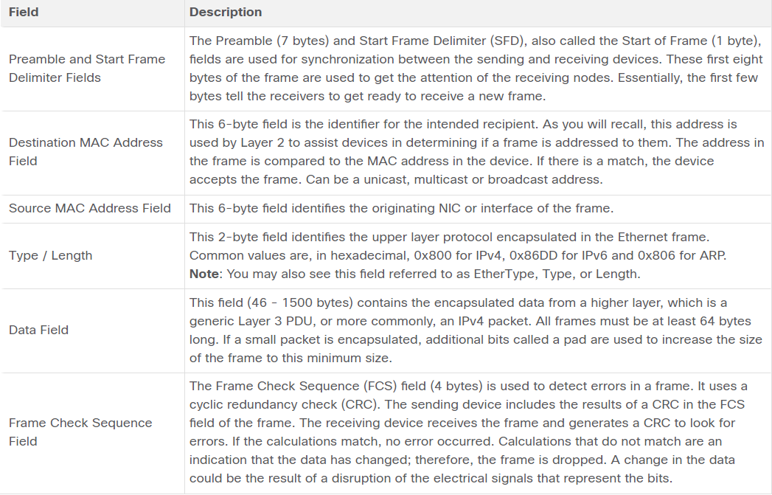

## Ethernet MAC Address

* In an Ethernet LAN, every network device is connected to the same, shared media. The MAC address is used to identify the physical source and destination devices (NICs) on the local network segment. MAC addressing provides a method for device identification at the data link layer of the OSI model
* An Ethernet MAC address is a 48-bit address expressed using 12 hexadecimal digits and or 6 bytes in length
* All MAC addresses must be unique to the Ethernet device or Ethernet interface. To ensure this, all vendors that sell Ethernet devices must register with the IEEE to obtain a unique 6 hexadecimal (i.e., 24-bit or 3-byte) code called the organizationally unique identifier (OUI).
* Therefore, an Ethernet MAC address consists of a 6 hexadecimal vendor OUI code followed by a 6 hexadecimal vendor-assigned value.
  + It is the responsibility of the vendor to ensure that none of its devices be assigned the same MAC address.

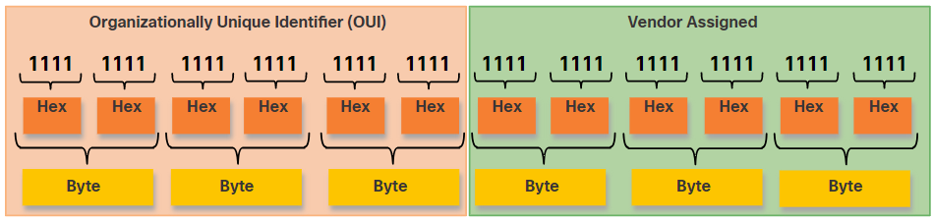

* It is possible for duplicate MAC addresses to exist because of mistakes made during manufacturing, mistakes made in some virtual machine implementation methods, or modifications made using one of several software tools. In any case, it will be necessary to modify the MAC address with a new NIC or make modifications via software.
* Sometimes the MAC address is referred to as a burned-in address (BIA) because the address is hard coded into read-only memory (ROM) on the NIC. This means that the address is encoded into the ROM chip permanently.
  + On modern PC operating systems and NICs, it is possible to change the MAC address in software. This is useful when attempting to gain access to a network that filters based on BIA. Consequently, filtering or controlling traffic based on the MAC address is no longer as secure.
* When a device is forwarding a message to an Ethernet network, the Ethernet header include a Source MAC address and a Destination MAC address.
  + When a NIC receives an Ethernet frame, it examines the destination MAC address to see if it matches the physical MAC address that is stored in RAM. If there is no match, the device discards the frame. If there is a match, it passes the frame up the OSI layers, where the de-encapsulation process takes place.
* In Ethernet, different MAC addresses are used for Layer 2 unicast, broadcast, and multicast communications.
  + The source MAC address must always be a unicast.
* A unicast MAC address is the unique address that is used when a frame is sent from a single transmitting device to a single destination device.
  + For a unicast packet to be sent and received, a destination IP address must be in the IP packet header. A corresponding destination MAC address must also be present in the Ethernet frame header. The IP address and MAC address combine to deliver data to one specific destination host.
* Address Resolution Protocol (ARP): The process that a source host uses to determine the destination MAC address associated with an IPv4 address.
* The process that a source host uses to determine the destination MAC address associated with an IPv6 address is known as Neighbour Discovery (ND).
* An Ethernet broadcast frame is received and processed by every device on the Ethernet LAN. The features of an Ethernet broadcast are as follows:
  + It has a destination MAC address of FF-FF-FF-FF-FF-FF in hexadecimal (48 ones in binary).
  + It is flooded out all Ethernet switch ports except the incoming port.
  + It is not forwarded by a router.
  + If the encapsulated data is an IPv4 broadcast packet, this means the packet contains a destination IPv4 address that has all ones (1s) in the host portion. This numbering in the address means that all hosts on that local network (broadcast domain) will receive and process the packet.
* An Ethernet multicast frame is received and processed by a group of devices on the Ethernet LAN that belong to the same multicast group. The features of an Ethernet multicast are as follows:
  + There is a destination MAC address of 01-00-5E when the encapsulated data is an IPv4 multicast packet and a destination MAC address of 33-33 when the encapsulated data is an IPv6 multicast packet.
  + There are other reserved multicast destination MAC addresses for when the encapsulated data is not IP, such as Spanning Tree Protocol (STP) and Link Layer Discovery Protocol (LLDP).
  + It is flooded out all Ethernet switch ports except the incoming port, unless the switch is configured for multicast snooping.
  + It is not forwarded by a router, unless the router is configured to route multicast packets.
  + If the encapsulated data is an IP multicast packet, the devices that belong to a multicast group are assigned a multicast group IP address. The range of IPv4 multicast addresses is 224.0.0.0 to 239.255.255.255. The range of IPv6 multicast addresses begins with ff00::/8. Because multicast addresses represent a group of addresses (sometimes called a host group), they can only be used as the destination of a packet.
  + As with the unicast and broadcast addresses, the multicast IP address requires a corresponding multicast MAC address.

## The MAC Address Table

* A Layer 2 Ethernet switch uses Layer 2 MAC addresses to make forwarding decisions. It is completely unaware of the data (protocol) being carried in the data portion of the frame, such as an IPv4 packet, an ARP message, or an IPv6 ND packet. The switch makes its forwarding decisions based solely on the Layer 2 Ethernet MAC addresses.
* An Ethernet switch examines its MAC address table to make a forwarding decision for each frame, unlike legacy Ethernet hubs that repeat bits out all ports except the incoming port.
  + When a switch is turned on, the MAC address table is empty
  + The MAC address table is sometimes referred to as a content addressable memory (CAM) table.
* Every frame that enters a switch is checked for new information to learn. It does this by examining the source MAC address of the frame and the port number where the frame entered the switch. If the source MAC address does not exist, it is added to the table along with the incoming port number. If the source MAC address does exist, the switch updates the refresh timer for that entry in the table. By default, most Ethernet switches keep an entry in the table for 5 minutes.
  + If the source MAC address does exist in the table but on a different port, the switch treats this as a new entry. The entry is replaced using the same MAC address but with the more current port number.
  + The destination MAC is not in the table.
* If the destination MAC address is a unicast address, the switch will look for a match between the destination MAC address of the frame and an entry in its MAC address table. If the destination MAC address is in the table, it will forward the frame out the specified port. If the destination MAC address is not in the table, the switch will forward the frame out all ports except the incoming port. This is called an unknown unicast.
* A switch can have multiple MAC addresses associated with a single port. This is common when the switch is connected to another switch. The switch will have a separate MAC address table entry for each frame received with a different source MAC address.

## Switch Speeds and Forwarding Methods

* Switches use one of the following forwarding methods for switching data between network ports:
  + Store-and-forward switching - This frame forwarding method receives the entire frame and computes the CRC. CRC uses a mathematical formula, based on the number of bits (1s) in the frame, to determine whether the received frame has an error. If the CRC is valid, the switch looks up the destination address, which determines the outgoing interface. Then the frame is forwarded out of the correct port.
  + Cut-through switching - This frame forwarding method forwards the frame before it is entirely received. At a minimum, the destination address of the frame must be read before the frame can be forwarded. The switch looks up the destination MAC address in its switching table, determines the outgoing interface port, and forwards the frame onto its destination through the designated switch port. The switch does not perform any error checking on the frame.
* A big advantage of store-and-forward switching is that it determines if a frame has errors before propagating the frame. When an error is detected in a frame, the switch discards the frame. Discarding frames with errors reduces the amount of bandwidth consumed by corrupt data. Store-and-forward switching is required for quality of service (QoS) analysis on converged networks where frame classification for traffic prioritization is necessary
* There are two variants of cut-through switching:
  + Fast-forward switching - Fast-forward switching offers the lowest level of latency. Fast-forward switching immediately forwards a packet after reading the destination address. Because fast-forward switching starts forwarding before the entire packet has been received, there may be times when packets are relayed with errors. This occurs infrequently, and the destination NIC discards the faulty packet upon receipt. In fast-forward mode, latency is measured from the first bit received to the first bit transmitted. Fast-forward switching is the typical cut-through method of switching.
  + Fragment-free switching - In fragment-free switching, the switch stores the first 64 bytes of the frame before forwarding. Fragment-free switching can be viewed as a compromise between store-and-forward switching and fast-forward switching. The reason fragment-free switching stores only the first 64 bytes of the frame is that most network errors and collisions occur during the first 64 bytes. Fragment-free switching tries to enhance fast-forward switching by performing a small error check on the first 64 bytes of the frame to ensure that a collision has not occurred before forwarding the frame. Fragment-free switching is a compromise between the high latency and high integrity of store-and-forward switching, and the low latency and reduced integrity of fast-forward switching.
  + Some switches are configured to perform cut-through switching on a per-port basis until a user-defined error threshold is reached, and then they automatically change to store-and-forward. When the error rate falls below the threshold, the port automatically changes back to cut-through switching.
* An Ethernet switch may use a buffering technique to store frames before forwarding them. Buffering may also be used when the destination port is busy because of congestion. The switch stores the frame until it can be transmitted.

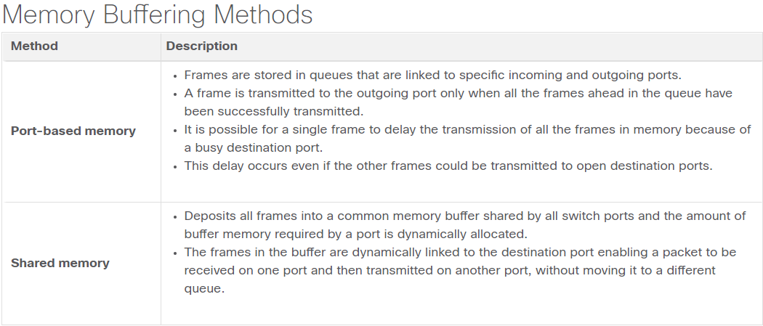

* Shared memory buffering also results in the ability to store larger frames with potentially fewer dropped frames. This is important with asymmetric switching which allows for different data rates on different ports such as when connecting a server to a 10 Gbps switch port and PCs to 1 Gbps ports.
* Two of the most basic settings on a switch are the bandwidth (sometimes referred to as “speed”) and duplex settings for each individual switch port. It is critical that the duplex and bandwidth settings match between the switch port and the connected devices, such as a computer or another switch.
  + Auto-negotiation is an optional function found on most Ethernet switches and NICs. It enables two devices to automatically negotiate the best speed and duplex capabilities. Full-duplex is chosen if both devices have the capability along with their highest common bandwidth.
  + Gigabit Ethernet ports only operate in full-duplex.

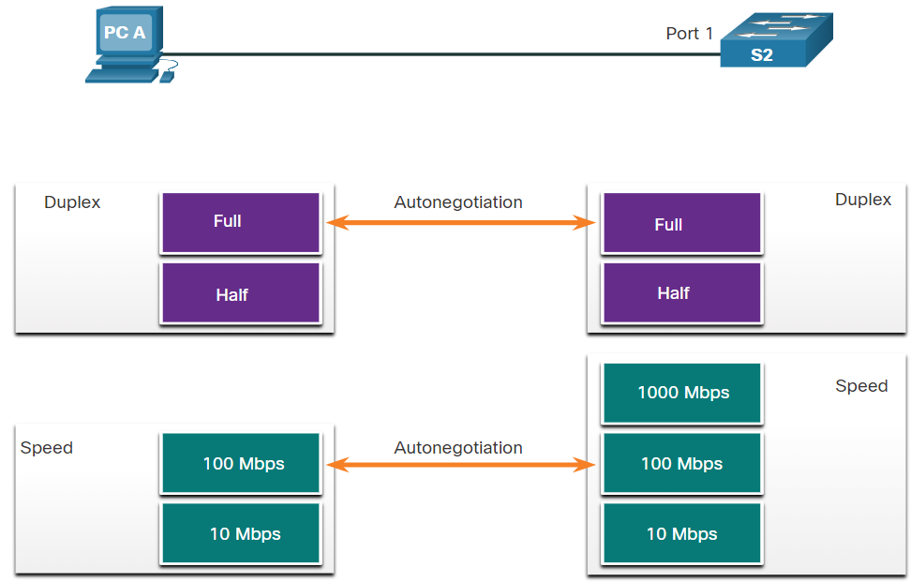

* Duplex mismatch is one of the most common causes of performance issues on 10/100 Mbps Ethernet links. It occurs when one port on the link operates at half-duplex while the other port operates at full-duplex. (S2, half-duplex, will continually experience collisions because S1, full-duplex, keeps sending frames any time it has something to send.)
* Duplex mismatch occurs when one or both ports on a link are reset, and the autonegotiation process does not result in both link partners having the same configuration. It also can occur when users reconfigure one side of a link and forget to reconfigure the other. Both sides of a link should have autonegotiation on, or both sides should have it off. Best practice is to configure both Ethernet switch ports as full-duplex.
* Connections between devices once required the use of either a crossover or straight-through cable. The type of cable required depended on the type of interconnecting devices.
  + A crossover cable is used when connecting like devices, and a straight-through cable is used for connecting unlike devices.
  + A direct connection between a router and a host requires a cross-over connection.

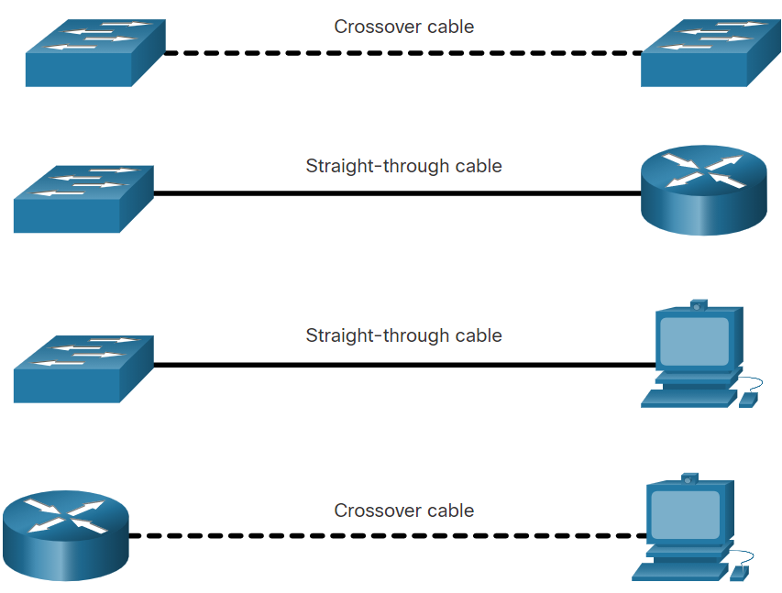

* Most switch devices now support the automatic medium-dependent interface crossover (auto-MDIX) feature. When enabled, the switch automatically detects the type of cable attached to the port and configures the interfaces accordingly. Therefore, you can use either a crossover or a straight-through cable for connections to a copper 10/100/1000 port on the switch, regardless of the type of device on the other end of the connection.
* The auto-MDIX feature is enabled by default on switches running Cisco IOS Release 12.2(18)SE or later. However, the feature could be disabled. For this reason, you should always use the correct cable type and not rely on the auto-MDIX feature. Auto-MDIX can be re-enabled using the mdix auto interface configuration command.

# Network layer

## Network Layer Characteristics

* The network layer:
  + Provides services to allow end devices to exchange data
  + IP version 4 (IPv4) and IP version 6 (IPv6) are the principle network layer communication protocols.
  + Other network layer protocols include routing protocols such as Open Shortest Path First (OSPF) and messaging protocols such as Internet Control Message Protocol (ICMP).
* The network layer performs four basic operations:
  + Addressing end devices
  + Encapsulation
  + Routing
  + De-encapsulation
* IP encapsulation:
  + IP encapsulates the transport layer segment.
  + IP can use either an IPv4 or IPv6 packet and not impact the layer 4 segment.
  + IP packet will be examined by all layer 3 devices (routers and level 3 switches) as it traverses the network.
  + The IP addressing does not change from source to destination.
  + Note: NAT will change addressing, but will be discussed in a later module.

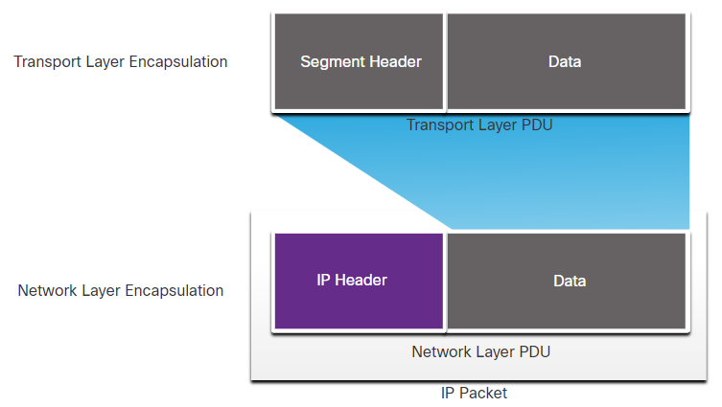

* IP was designed as a protocol with low overhead. It provides only the functions that are necessary to deliver a packet from a source to a destination over an interconnected system of networks. The protocol was not designed to track and manage the flow of packets. These functions, if required, are performed by other protocols at other layers, primarily TCP at Layer 4.
* These are the basic characteristics of IP:
  + Connectionless:
    - IP does not establish a connection with the destination before sending the packet.
    - There is no control information needed (synchronizations, acknowledgments, etc.).
    - The destination will receive the packet when it arrives, but no pre-notifications are sent by IP.
  + Best Effort:
    - IP does not require additional fields in the header to maintain an established connection. This process greatly reduces the overhead of IP.
    - With no pre-established end-to-end connection, senders are unaware whether destination devices are present and functional when sending packets, nor are they aware if the destination receives the packet, or if the destination device is able to access and read the packet.
    - The IP protocol does not guarantee that all packets that are delivered are, in fact, received.
  + IP is unreliable:
    - It cannot manage or fix undelivered or corrupt packets.
    - IP cannot retransmit after an error.
    - IP cannot realign out of sequence packets.
    - IP must rely on other protocols for these functions.
  + IP is media Independent:
    - IP does not concern itself with the type of frame required at the data link layer or the media type at the physical layer.
    - IP can be sent over any media type: copper, fiber, or wireless.
* There is, however, one major characteristic of the media that the network layer considers: the maximum size of the PDU that each medium can transport. This characteristic is referred to as the maximum transmission unit (MTU). Part of the control communication between the data link layer and the network layer is the establishment of a maximum size for the packet. The data link layer passes the MTU value up to the network layer. The network layer then determines how large packets can be.
  + In some cases, an intermediate device, usually a router, must split up an IPv4 packet when forwarding it from one medium to another medium with a smaller MTU. This process is called fragmenting the packet, or fragmentation. Fragmentation causes latency. IPv6 packets cannot be fragmented by the router.

## IPv4 Packet

* IPv4 is the primary communication protocol for the network layer.
* The network header has many purposes:
  + It ensures the packet is sent in the correct direction (to the destination).
  + It contains information for network layer processing in various fields.
  + The information in the header is used by all layer 3 devices that handle the packet
* The IPv4 network header characteristics:
  + It is in binary.
  + Contains several fields of information
  + Diagram is read from left to right, 4 bytes per line, and top down.
  + The two most important fields are the source and destination.

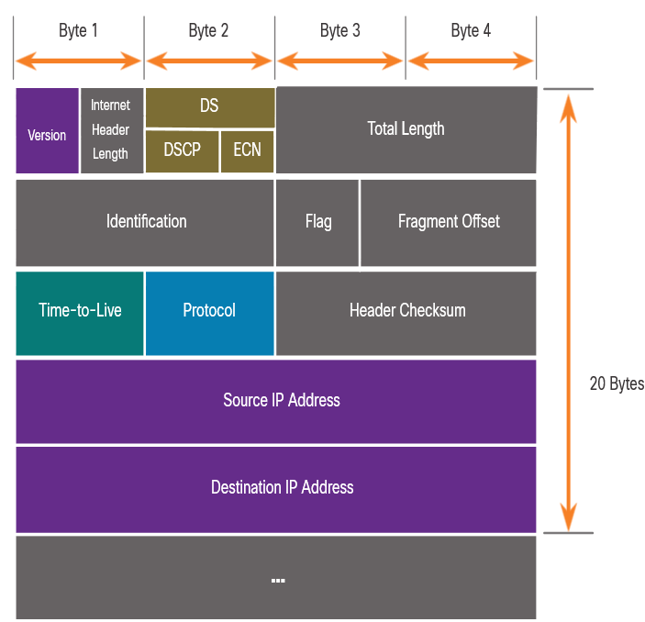

* Significant fields in the IPv4 header include the following:
  + Version - Contains a 4-bit binary value set to 0100 that identifies this as an IPv4 packet.
  + The Internet Header Length (IHL) - Total Length
  + Differentiated Services or DiffServ (DS) - Formerly called the type of service (ToS) field, the DS field is an 8-bit field used to determine the priority of each packet. The six most significant bits of the DiffServ field are the differentiated services code point (DSCP) bits and the last two bits are the explicit congestion notification (ECN) bits.
  + Header Checksum – This is used to detect corruption in the IPv4 header.
  + Time to Live (TTL) – TTL contains an 8-bit binary value that is used to limit the lifetime of a packet. The source device of the IPv4 packet sets the initial TTL value. It is decreased by one each time the packet is processed by a router. If the TTL field decrements to zero, the router discards the packet and sends an Internet Control Message Protocol (ICMP) Time Exceeded message to the source IP address. Because the router decrements the TTL of each packet, the router must also recalculate the Header Checksum.
  + Protocol – This field is used to identify the next level protocol. This 8-bit binary value indicates the data payload type that the packet is carrying, which enables the network layer to pass the data to the appropriate upper-layer protocol. Common values include ICMP (1), TCP (6), and UDP (17).
  + Source IPv4 Address – This contains a 32-bit binary value that represents the source IPv4 address of the packet. The source IPv4 address is always a unicast address.
  + Destination IPv4 Address – This contains a 32-bit binary value that represents the destination IPv4 address of the packet. The destination IPv4 address is a unicast, multicast, or broadcast address.
  + Other fields are used to reorder a fragmented packet. Specifically, the IPv4 packet uses Identification, Flags, and Fragment Offset fields to keep track of the fragments. A router may have to fragment an IPv4 packet when forwarding it from one medium to another with a smaller MTU.

## IPv6 Packet

* IPv4 still has three major issues:
  + IPv4 address depletion - IPv4 has a limited number of unique public addresses available. Although there are approximately 4 billion IPv4 addresses, the increasing number of new IP-enabled devices, always-on connections, and the potential growth of less-developed regions have increased the need for more addresses.
  + Lack of end-to-end connectivity - Network Address Translation (NAT) is a technology commonly implemented within IPv4 networks. NAT provides a way for multiple devices to share a single public IPv4 address. However, because the public IPv4 address is shared, the IPv4 address of an internal network host is hidden. This can be problematic for technologies that require end-to-end connectivity.
  + Increased network complexity – While NAT has extended the lifespan of IPv4 it was only meant as a transition mechanism to IPv6. NAT in its various implementation creates additional complexity in the network, creating latency and making troubleshooting more difficult.
* Improvements that IPv6 provides include the following:
  + Increased address space - IPv6 addresses are based on 128-bit hierarchical addressing as opposed to IPv4 with 32 bits.
  + Improved packet handling - The IPv6 header has been simplified with fewer fields.
  + Eliminates the need for NAT - With such a large number of public IPv6 addresses, NAT between a private IPv4 address and a public IPv4 is not needed. This avoids some of the NAT-induced problems experienced by applications that require end-to-end connectivity.
* IPv4 Packet Header Fields in the IPv6 Packet Header:
  + The IPv6 header is simplified, but not smaller.
  + The header is fixed at 40 Bytes or octets long.
  + Several IPv4 fields were removed to improve performance like flag, fragment Offset and header Checksum

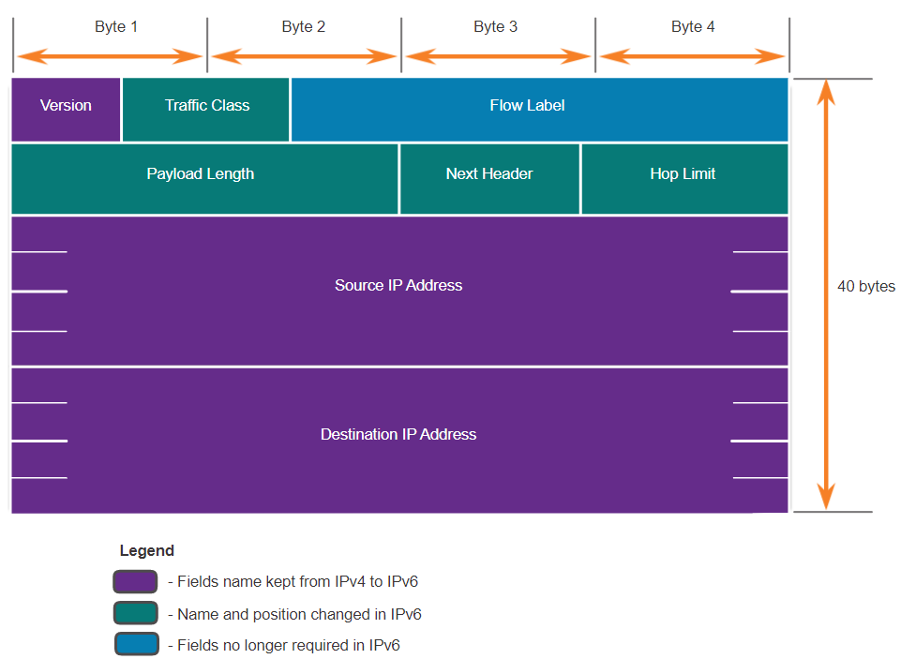

* The fields in the IPv6 packet header include the following:
  + Version - This field contains a 4-bit binary value set to 0110 that identifies this as an IP version 6 packet.
  + Traffic Class - This 8-bit field is equivalent to the IPv4 Differentiated Services (DS) field.
  + Flow Label - This 20-bit field suggests that all packets with the same flow label receive the same type of handling by routers.
  + Payload Length - This 16-bit field indicates the length of the data portion or payload of the IPv6 packet. This does not include the length of the IPv6 header, which is a fixed 40-byte header.
  + Next Header - This 8-bit field is equivalent to the IPv4 Protocol field. It indicates the data payload type that the packet is carrying, enabling the network layer to pass the data to the appropriate upper-layer protocol.
  + Hop Limit - This 8-bit field replaces the IPv4 TTL field. This value is decremented by a value of 1 by each router that forwards the packet. When the counter reaches 0, the packet is discarded, and an ICMPv6 Time Exceeded message is forwarded to the sending host,. This indicates that the packet did not reach its destination because the hop limit was exceeded. Unlike IPv4, IPv6 does not include an IPv6 Header Checksum, because this function is performed at both the lower and upper layers. This means the checksum does not need to be recalculated by each router when it decrements the Hop Limit field, which also improves network performance.
  + Source IPv6 Address - This 128-bit field identifies the IPv6 address of the sending host.
  + Destination IPv6 Address - This 128-bit field identifies the IPv6 address of the receiving host.
* An IPv6 packet may also contain extension headers (EH), which provide optional network layer information. Extension headers are optional and are placed between the IPv6 header and the payload. EHs are used for fragmentation, security, to support mobility and more.
  + Unlike IPv4, routers do not fragment routed IPv6 packets.

## How a Host Routes

* With both IPv4 and IPv6, packets are always created at the source host. The source host must be able to direct the packet to the destination host. To do this, host end devices create their own routing table. This topic discusses how end devices use routing tables.
* A host can send a packet to the following:
  + Itself - A host can ping itself by sending a packet to a special IPv4 address of 127.0.0.1 or an IPv6 address ::1, which is referred to as the loopback interface. Pinging the loopback interface tests the TCP/IP protocol stack on the host.
  + Local Hosts – destination is on the same LAN
  + Remote Hosts – devices are not on the same LAN
* The Source device determines whether the destination is local or remote
  + Method of determination:
    - IPv4 – Source uses its own IP address and Subnet mask, along with the destination IP address
    - IPv6 – Source uses the network address and prefix advertised by the local router
  + If a host is sending a packet to a device that is configured with the same IP network as the host device, the packet is simply forwarded out of the host interface, through the intermediary device, and to the destination device directly.
  + Remote traffic is forwarded directly to the default gateway on the LAN.
* The default gateway is the network device (i.e., router or Layer 3 switch) that can route traffic to other networks. It has these features:
  + It has a local IP address in the same address range as other hosts on the local network.
  + It can accept data into the local network and forward data out of the local network.
  + It routes traffic to other networks.
  + If a device has no default gateway or a bad default gateway, its traffic will not be able to leave the LAN.
* A host routing table will typically include a default gateway. In IPv4, the host receives the IPv4 address of the default gateway either dynamically from Dynamic Host Configuration Protocol (DHCP) or configured manually. In IPv6, the router advertises the default gateway address or the host can be configured manually.
* Having a default gateway configured creates a default route in the routing table of the PC. A default route is the route or pathway your computer will take when it tries to contact a remote network.
* On Windows, route print or netstat -r to display the PC routing table
  + Three sections displayed by these two commands:
    - Interface List – all potential interfaces and MAC addressing
    - IPv4 Routing Table
    - IPv6 Routing Table

## Introduction to Routing

* What happens when a packet arrives on a router interface?
  + The router examines the destination IP address of the packet and searches its routing table to determine where to forward the packet. The routing table contains a list of all known network addresses (prefixes) and where to forward the packet. These entries are known as route entries or routes. The router will forward the packet using the best (longest) matching route entry.

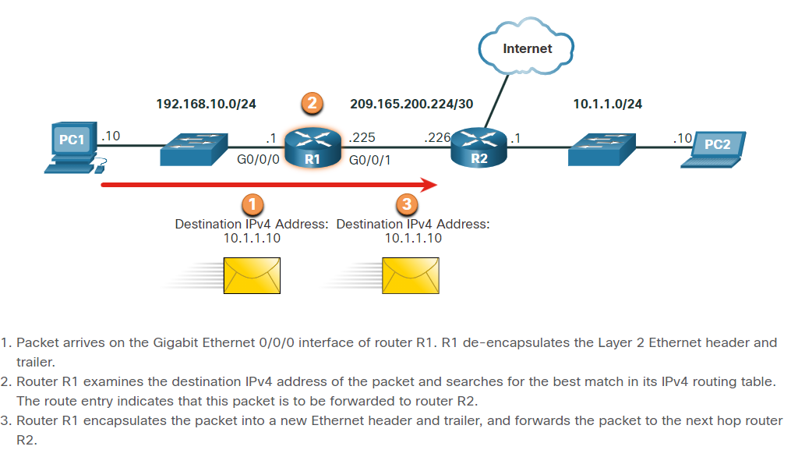

* The routing table stores three types of route entries:
  + Directly-connected networks - These network route entries are active router interfaces. Routers add a directly connected route when an interface is configured with an IP address and is activated. Each router interface is connected to a different network segment.
  + Remote networks - These network route entries are connected to other routers. A router can learn about remote networks in one of two ways:
    - Manually - Remote networks are manually entered into the route table using static routes.
    - Dynamically - Remote routes are automatically learned using a dynamic routing protocol.
  + Default route – Like a host, most routers also include a default route entry, a gateway of last resort. The default route is used when there is no better (longer) match in the IP routing table.

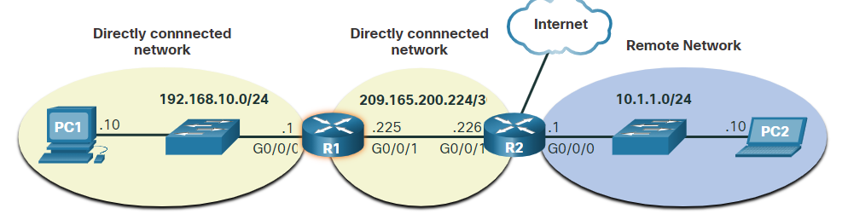

* Static routes are route entries that are manually configured. It has the following characteristics:
  + A static route must be configured manually.
  + The administrator needs to reconfigure a static route if there is a change in the topology and the static route is no longer viable.
  + A static route is appropriate for a small network and when there are few or no redundant links.
  + A static route is commonly used with a dynamic routing protocol for configuring a default route.
* A dynamic routing protocol allows the routers to automatically learn about remote networks, including a default route, from other routers.
* Routers that use dynamic routing protocols automatically share routing information with other routers and compensate for any topology changes without involving the network administrator.
* Dynamic routing protocols include OSPF and Enhanced Interior Gateway Routing Protocol (EIGRP).
* The dynamic routing protocol will automatically do as follows:
  + Discover remote networks
  + Maintain up-to-date routing information
  + Choose the best path to destination networks
  + Attempt to find a new best path if the current path is no longer available
  + Dynamic routing can also share static default routes with the other routers.
* The **show ip route** privileged EXEC mode command is used to view the IPv4 routing table on a Cisco IOS router.
* At the beginning of each routing table entry is a code that is used to identify the type of route or how the route was learned. Common route sources (codes) include these:
  + L - Directly connected local interface IP address
  + C – Directly connected network
  + S – Static route was manually configured by an administrator
  + O - OSPF
  + D - EIGRP
* A directly connected route is automatically created when a router interface is configured with IP address information and is activated. The router adds two route entries with the codes C (i.e., the connected network) and L (i.e., the local interface IP address of the connected network). The route entries also identify the exit interface to use to reach the network.
* A default route has a network address of all zeroes. For example, the IPv4 network address is 0.0.0.0. A static route entry in the routing table begins with a code of S*

# Address resolution

## MAC and IP

* How are the IP addresses of the IP packets in a data flow associated with the MAC addresses on each link along the path to the destination?
  + ARP is used by IPv4 to associate the IPv4 address of a device with the MAC address of the device NIC.
  + ICMPv6 is used by IPv6 to associate the IPv6 address of a device with the MAC address of the device NIC.

## ARP

* A device uses Address Resolution Protocol (ARP) to determine the destination MAC address of a local device when it knows its IPv4 address.
* ARP provides two basic functions:
  + Resolving IPv4 addresses to MAC addresses
  + Maintaining a table of IPv4 to MAC address mappings
* When a packet is sent to the data link layer to be encapsulated into an Ethernet frame, the device refers to a table in its memory to find the MAC address that is mapped to the IPv4 address. This table is stored temporarily in RAM memory and called the ARP table or the ARP cache.
* The sending device will search its ARP table for a destination IPv4 address and a corresponding MAC address.
  + If the packet’s destination IPv4 address is on the same network as the source IPv4 address, the device will search the ARP table for the destination IPv4 address.
  + If the destination IPv4 address is on a different network than the source IPv4 address, the device will search the ARP table for the IPv4 address of the default gateway.
  + Each entry, or row, of the ARP table binds an IPv4 address with a MAC address. We call the relationship between the two values a map. This simply means that you can locate an IPv4 address in the table and discover the corresponding MAC address. The ARP table temporarily saves (caches) the mapping for the devices on the LAN.
  + If the device locates the IPv4 address, its corresponding MAC address is used as the destination MAC address in the frame. If there is no entry is found, then the device sends an ARP request and puts the current PDU, that needs the address, on hold.
* An ARP request is sent when a device needs to determine the MAC address that is associated with an IPv4 address, and it does not have an entry for the IPv4 address in its ARP table.
* ARP messages are encapsulated directly within an Ethernet frame. There is no IPv4 header. The ARP request is encapsulated in an Ethernet frame using the following header information:
  + Destination MAC address – This is a broadcast address FF-FF-FF-FF-FF-FF requiring all Ethernet NICs on the LAN to accept and process the ARP request.
  + Source MAC address – This is MAC address of the sender of the ARP request.
  + Type - ARP messages have a type field of 0x806. This informs the receiving NIC that the data portion of the frame needs to be passed to the ARP process.

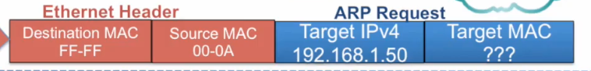

* Because ARP requests are broadcasts, they are flooded out all ports by the switch, except the receiving port.
  + Only one device on the LAN will have an IPv4 address that matches the target IPv4 address in the ARP request. All other devices will not reply.
  + All Ethernet NICs on the LAN process broadcasts and must deliver the ARP request to its operating system for processing. Every device must process the ARP request to see if the target IPv4 address matches its own.
  + A router will not forward broadcasts out other interfaces.
  + Only the device that originally sent the ARP request will receive the unicast ARP reply. After the ARP reply is received, the device will add the IPv4 address and the corresponding MAC address to its ARP table.
  + If no device responds to the ARP request, the packet is dropped because a frame cannot be created.

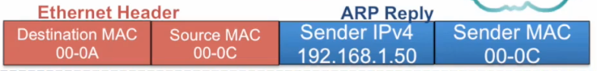

* Entries in the ARP table are time stamped. If a device does not receive a frame from a particular device before the timestamp expires, the entry for this device is removed from the ARP table.
  + Commands may also be used to manually remove some or all of the entries in the ARP table.
* Additionally, static map entries can be entered in an ARP table, but this is rarely done. Static ARP table entries do not expire over time and must be manually removed.
* The IPv4 address of the default gateway is stored in the IPv4 configuration of the hosts. When a host creates a packet for a destination, it compares the destination IPv4 address and its own IPv4 address to determine if the two IPv4 addresses are located on the same Layer 3 network. If the destination host is not on its same network, the source checks its ARP table for an entry with the IPv4 address of the default gateway. If there is not an entry, it uses the ARP process to determine a MAC address of the default gateway.
* On a Cisco router, the **show ip arp** command is used to display the ARP table.
* On a Windows 10 PC, the **arp –a** command is used to display the ARP table.
* Excessive ARP broadcasts, like if a large number of devices were to be powered up and all start accessing network services at the same time, can cause some reduction in performance.
* ARP replies can be spoofed by a threat actor to perform an ARP poisoning attack. This is a technique used by a threat actor to reply to an ARP request for an IPv4 address that belongs to another device, such as the default gateway
* Enterprise level switches include mitigation techniques to protect against ARP attacks.
* Eventueel video eens bekijken 9.2

## IPv6 Neighbor Discovery

* IPv6 Neighbor Discovery protocol is sometimes referred to as ND or NDP. ND provides address resolution, router discovery, and redirection services for IPv6 using ICMPv6. ICMPv6 ND uses five ICMPv6 messages to perform these services:
  + Neighbor Solicitation messages
  + Neighbor Advertisement messages
  + Router Solicitation messages
  + Router Advertisement messages
  + Redirect Message
* 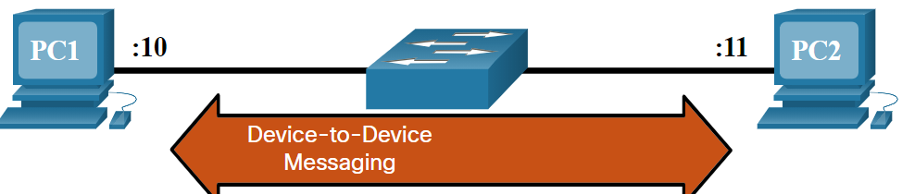Neighbor Solicitation and Neighbor Advertisement messages are used for device-to-device messaging such as address resolution (similar to ARP for IPv4). (router to router or host computer to host computer)
* Router Solicitation and Router Advertisement messages are for messaging between devices and routers. Typically router discovery is used for dynamic address allocation and stateless address autoconfiguration (SLAAC).

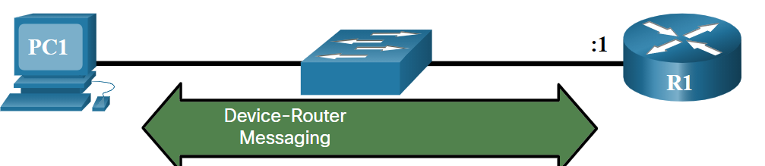

* ICMPv6 Neighbor Solicitation and Neighbor Advertisement messages are used for MAC address resolution. This is similar to ARP Requests and ARP Replies used by ARP for IPv4. To determine the MAC address for the known IPv6 address, PC1 sends an ICMPv6 Neighbor Solicitation message.
  + ICMPv6 Neighbor Solicitation messages are sent using special Ethernet and IPv6 multicast addresses. This allows the Ethernet NIC of the receiving device to determine whether the Neighbor Solicitation message is for itself without having to send it to the operating system for processing.
  + PC2 replies to the request with an ICMPv6 Neighbor Advertisement message which includes its MAC address.

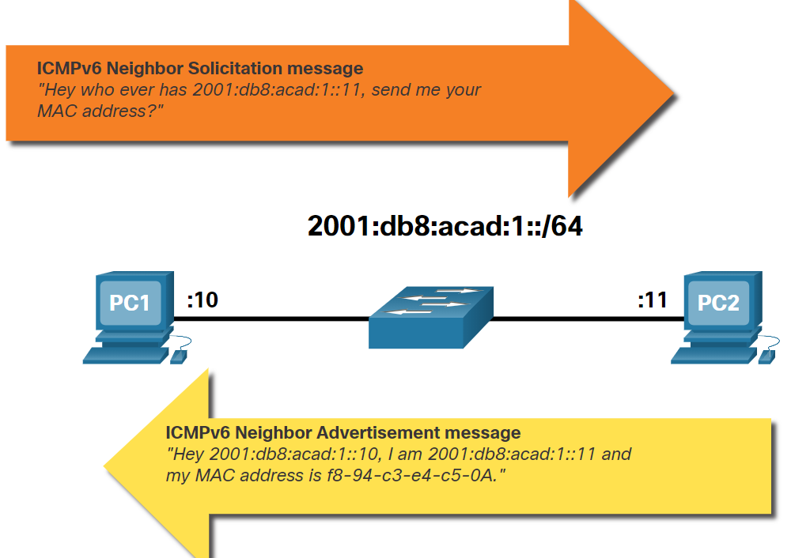

# Basic router configuration

## Configure Initial Router Settings

1.Configure the device name.

Router(config)# **hostname** *hostname*

2. Secure privileged EXEC mode.

Router(config)# **enable secret** *password*

3. Secure user EXEC mode.

Router(config)# **line console 0**  
Router(config-line)# **password** *password*  
Router(config-line)# **login**

4. Secure remote Telnet / SSH access.

Router(config-line)# **line vty 0 4**  
Router(config-line)# **password** *password*  
Router(config-line)# **login**  
Router(config-line)# **transport input** {**ssh** | **telnet**}

5. Secure all passwords in the config file.

Router(config-line)# **exit**  
Router(config)# **service password-encryption**

6. Provide legal notification.

Router(config)# **banner motd** *delimiter message delimiter*

7. Save the configuration.

Router(config)# **end**  
Router# **copy running-config startup-config**

* If a router cannot locate the startup-config file in NVRAM it will enter setup mode to allow the configuration to be entered from the console device.

## Configure Interfaces

* The next step is to configure their interfaces. This is because routers are not reachable by end devices until the interfaces are configured.
* The task to configure a router interface is very similar to a management SVI on a switch. Specifically, it includes issuing the following commands:

Router(config)# **interface** type-and-number  
Router(config-if)# **description** description-text  
Router(config-if)# **ip address** ipv4-address subnet-mask  
Router(config-if)# **ipv6 address** ipv6-address/prefix-length  
Router(config-if)# **no shutdown**

* Although the description command is not required to enable an interface, it is good practice to use it. It can be helpful in troubleshooting on production networks by providing information about the type of network connected.
* Using the no shutdown command activates the interface and is similar to powering on the interface. The interface must also be connected to another device, such as a switch or a router, for the physical layer to be active.
* 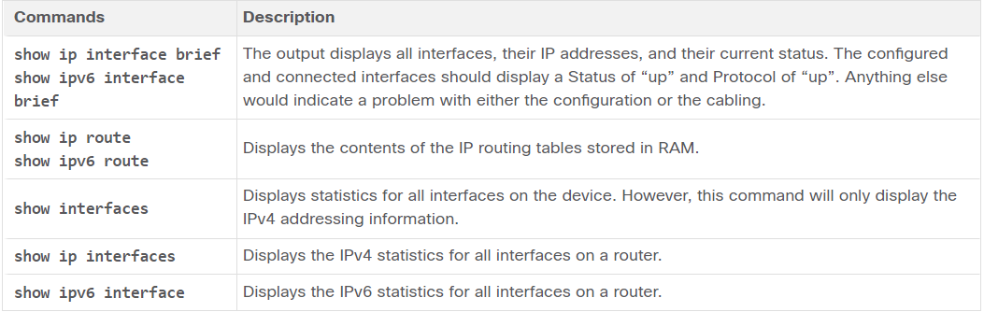To verify interface configuration use the **show ip interface brief** and **show ipv6 interface brief** commands

## Configure the Default Gateway

* If your local network has only one router, it will be the gateway router and all hosts and switches on your network must be configured with this information. If your local network has multiple routers, you must select one of them to be the default gateway router.
* To connect to and manage a switch over a local IP network, it must have a switch virtual interface (SVI) configured. The SVI is configured with an IPv4 address and subnet mask on the local LAN. The switch must also have a default gateway address configured to remotely manage the switch from another network.
* To configure an IPv4 default gateway on a switch, use the **ip default-gateway *ip-address*** global configuration command. The ip-address that is configured is the IPv4 address of the local router interface connected to the switch.

# IPv4 addressing

## IPv4 Address Structure

* An IPv4 address is a 32-bit hierarchical address that is made up of a network portion and a host portion.
* The bits within the network portion of the address must be identical for all devices that reside in the same network. The bits within the host portion of the address must be unique to identify a specific host within a network.
* But how do hosts know which portion of the 32-bits identifies the network and which identifies the host? That is the role of the subnet mask.
  + To identify the network and host portions of an IPv4 address, the subnet mask is compared to the IPv4 address bit for bit, from left to right.
* IPv4 address - This is the unique IPv4 address of the host.
* Subnet mask- This is used to identify the network/host portion of the IPv4 address.

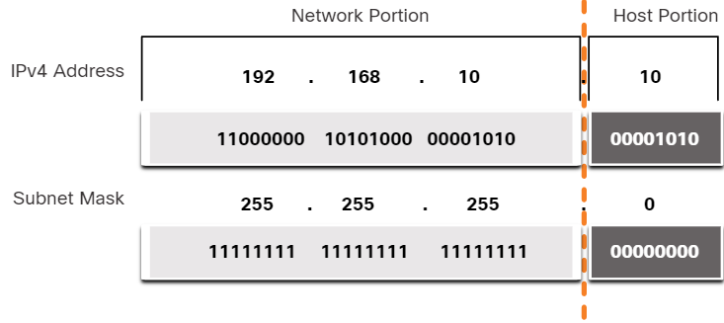

* Note that the subnet mask does not actually contain the network or host portion of an IPv4 address, it just tells the computer where to look for the part of the IPv4 address that is the network portion and which part is the host portion.
* The actual process used to identify the network portion and host portion is called ANDing.
* The prefix length is the number of bits set to 1 in the subnet mask. It is written in “slash notation”, which is noted by a forward slash (/) followed by the number of bits set to 1.

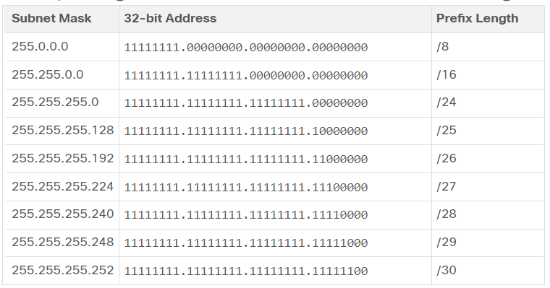

* When representing an IPv4 address using a prefix length, the IPv4 address is written followed by the prefix length with no spaces. For example, 192.168.10.10 255.255.255.0 would be written as 192.168.10.10/24.
* A logical AND Boolean operation is used in determining the network address.
  + To identify the network address, the host IPv4 address is logically ANDed, bit by bit, with the subnet mask to identify the network address.

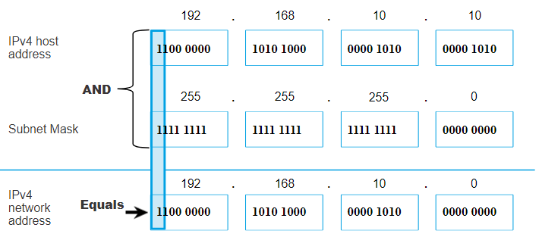

* Within each network are three types of IP addresses:
  + Network address:
    - A network address is an address that represents a specific network. A device belongs to this network if it meets three criteria:
      * It has the same subnet mask as the network address.
      * It has the same network bits as the network address, as indicated by the subnet mask.
      * It is located on the same broadcast domain as other hosts with the same network address.
    - A host determines its network address by performing an AND operation between its IPv4 address and its subnet mask.
  + Host addresses:
    - Host addresses are addresses that can be assigned to a device.
    - The host portion of the address is the bits indicated by 0 bits in the subnet mask.
    - Host addresses can have any combination of bits in the host portion except for all 0 bits (network address) or all 1 bits (broadcast address).
    - All devices within the same network, must have the same subnet mask and the same network bits. Only the host bits will differ and must be unique.
    - First host address - This first host within a network has all 0 bits with the last (right-most) bit as a 1 bit.
    - Last host address - This last host within a network has all 1 bits with the last (right-most) bit as a 0 bit.
  + Broadcast address:
    - A broadcast address is an address that is used when it is required to reach all devices on the IPv4 network. The network broadcast address has all 1 bits in the host portion, as determined by the subnet mask.
    - It cannot be assigned to a device.

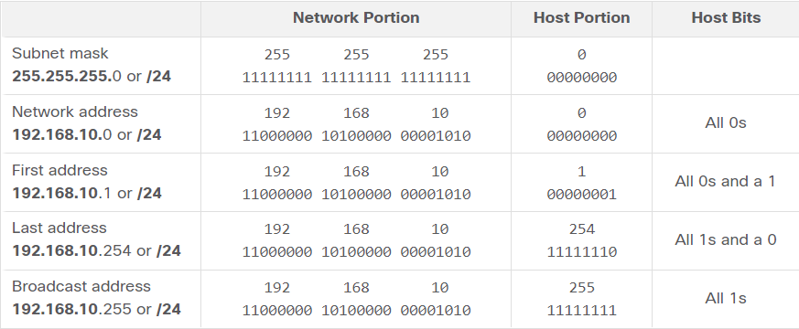

## IPv4 Unicast, Broadcast and Multicast

* Unicast transmission refers to one device sending a message to one other device in one-to-one communications.
* A unicast packet has a destination IP address that is a unicast address which goes to a single recipient. A source IP address can only be a unicast address, because the packet can only originate from a single source. This is regardless of whether the destination IP address is a unicast, broadcast or multicast.
* Broadcast transmission refers to a device sending a message to all the devices on a network in one-to-all communications.
* A broadcast packet has a destination IP address with all ones (1s) in the host portion, or 32 one (1) bits.
* Note: IPv4 uses broadcast packets. However, there are no broadcast packets with IPv6.
* A broadcast packet must be processed by all devices in the same broadcast domain. A broadcast domain identifies all hosts on the same network segment. A broadcast may be directed or limited. A limited broadcast is sent to 255.255.255.255. By default, routers do not forward broadcasts. In addition to the 255.255.255.255 broadcast address, there is a broadcast IPv4 address for each network. Called a directed broadcast, this address uses the highest address in the network, which is the address where all the host bits are 1s.
* Note: Because of security concerns and prior abuse from malicious users, directed broadcasts are turned off by default starting with Cisco IOS Release 12.0 with the global configuration command **no ip directed-broadcasts**.
* Multicast transmission reduces traffic by allowing a host to send a single packet to a selected set of hosts that subscribe to a multicast group.
* A multicast packet is a packet with a destination IP address that is a multicast address. IPv4 has reserved the 224.0.0.0 to 239.255.255.255 addresses as a multicast range.
* Hosts that receive particular multicast packets are called multicast clients. The multicast clients use services requested by a client program to subscribe to the multicast group.
* Each multicast group is represented by a single IPv4 multicast destination address. When an IPv4 host subscribes to a multicast group, the host processes packets addressed to this multicast address, and packets addressed to its uniquely allocated unicast address.
* Routing protocols such as OSPF use multicast transmissions. For example, routers enabled with OSPF communicate with each other using the reserved OSPF multicast address 224.0.0.5. Only devices enabled with OSPF will process these packets with 224.0.0.5 as the destination IPv4 address. All other devices will ignore these packets.

## Types of IPv4 Addresses

* Public IPv4 addresses are addresses which are globally routed between internet service provider (ISP) routers. However, not all available IPv4 addresses can be used on the internet. There are blocks of addresses called private addresses that are used by most organizations to assign IPv4 addresses to internal hosts.
* In the mid-1990s, with the introduction of the World Wide Web (WWW), private IPv4 addresses were introduced because of the depletion of IPv4 address space. Private IPv4 addresses are not unique and can be used internally within any network.

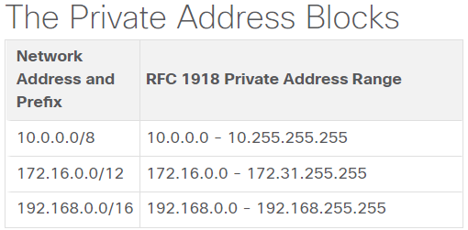

* Private addresses are defined in RFC 1918 and sometimes referred to as RFC 1918 address space.
* Most internal networks, from large enterprises to home networks, use private IPv4 addresses for addressing all internal devices (intranet) including hosts and routers.

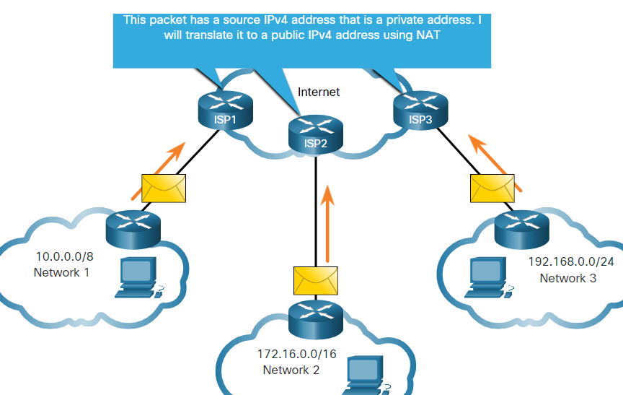

* These packets have a source IPv4 address that is a private address and a destination IPv4 address that is public (globally routable). Packets with a private address must be filtered (discarded) or translated to a public address before forwarding the packet to an ISP.
* Before the ISP can forward this packet, it must translate the source IPv4 address, which is a private address, to a public IPv4 address using Network Address Translation (NAT). NAT is used to translate between private IPv4 and public IPv4 addresses. This is usually done on the router that connects the internal network to the ISP network.

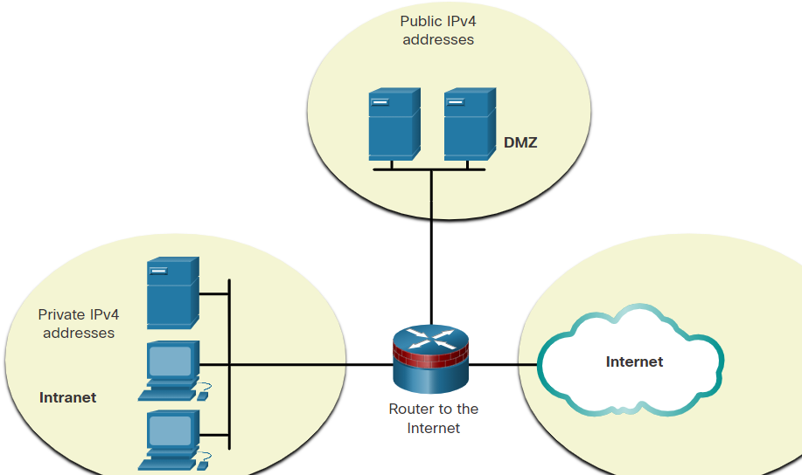

* Organizations that have resources available to the internet, such as a web server, will also have devices that have public IPv4 addresses. As shown in the figure, this part of the network is known as the DMZ (demilitarized zone). The router in the figure not only performs routing, it also performs NAT and acts as a firewall for security.
* There are certain addresses, such as the network address and broadcast address, that cannot be assigned to hosts. There are also special addresses that can be assigned to hosts, but with restrictions on how those hosts can interact within the network.
  + Loopback addresses:
    - 127.0.0.0 /8 (127.0.0.1 to 127.255.255.254)
    - Commonly identified as only 127.0.0.1
    - Used on a host to test if TCP/IP is operational.
  + Link-Local addresses:
    - 169.254.0.0 /16 (169.254.0.1 to 169.254.255.254)
    - Commonly known as the Automatic Private IP Addressing (APIPA) addresses or self-assigned addresses.
    - Used by Windows DHCP clients to self-configure when no DHCP servers are available.
* In 1981, IPv4 addresses were assigned using classful addressing as defined in RFC 790, Assigned Numbers. Customers were allocated a network address based on one of three classes, A, B, or C. The RFC divided the unicast ranges into specific classes as follows:
  + Class A (0.0.0.0/8 to 127.0.0.0/8) - Designed to support extremely large networks with more than 16 million host addresses. Class A used a fixed /8 prefix with the first octet to indicate the network address and the remaining three octets for host addresses (more than 16 million host addresses per network).
  + Class B (128.0.0.0 /16 - 191.255.0.0 /16) - Designed to support the needs of moderate to large size networks with up to approximately 65,000 host addresses. Class B used a fixed /16 prefix with the two high-order octets to indicate the network address and the remaining two octets for host addresses (more than 65,000 host addresses per network).
  + Class C (192.0.0.0 /24 - 223.255.255.0 /24) - Designed to support small networks with a maximum of 254 hosts. Class C used a fixed /24 prefix with the first three octets to indicate the network and the remaining octet for the host addresses (only 254 host addresses per network).
  + There is also a Class D multicast block consisting of 224.0.0.0 to 239.0.0.0 and a Class E experimental address block consisting of 240.0.0.0 - 255.0.0.0.
  + Classful addressing wasted many IPv4 addresses.
  + Classful address allocation was replaced with classless addressing which ignores the rules of classes (A, B, C).

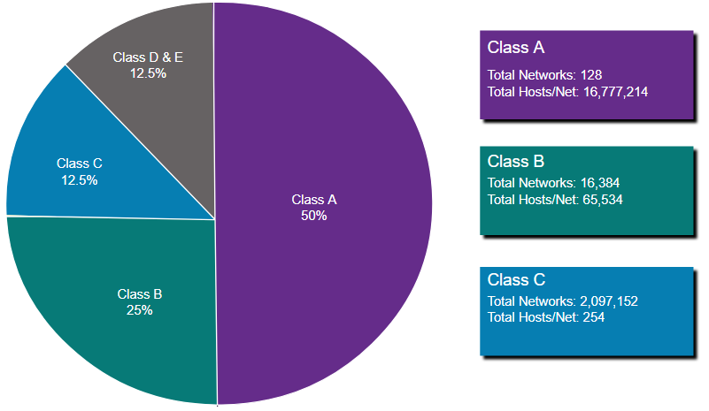

* Both IPv4 and IPv6 addresses are managed by the Internet Assigned Numbers Authority (IANA). The IANA manages and allocates blocks of IP addresses to the Regional Internet Registries (RIRs). The five RIRs are shown in the figure.
* RIRs are responsible for allocating IP addresses to ISPs who provide IPv4 address blocks to organizations and smaller ISPs. Organizations can also get their addresses directly from an RIR (subject to the policies of that RIR).

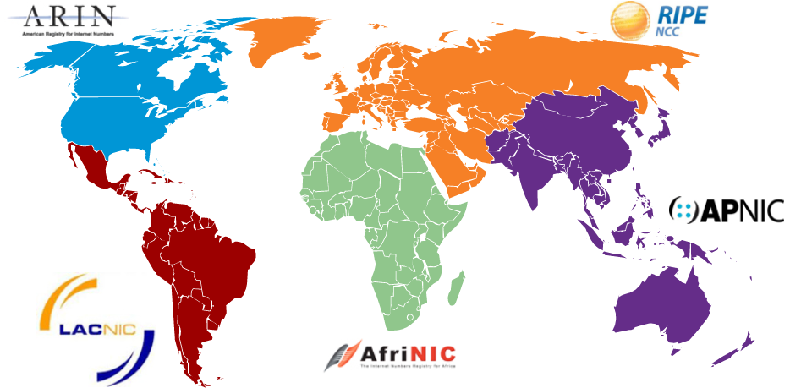

## Network Segmentation

* Many protocols use broadcasts or multicasts (e.g., ARP use broadcasts to locate other devices, hosts send DHCP discover broadcasts to locate a DHCP server.)
* Switches propagate broadcasts out all interfaces except the interface on which it was received.
* The only device that stops broadcasts is a router.
  + Routers do not propagate broadcasts.
  + Each router interface connects to a broadcast domain and broadcasts are only propagated within that specific broadcast domain.
* A large broadcast domain is a network that connects many hosts. A problem with a large broadcast domain is that these hosts can generate excessive broadcasts and negatively affect the network.
  + This results in slow network operations due to the significant amount of traffic it can cause, and slow device operations because a device must accept and process each broadcast packet.
* The solution is to reduce the size of the network to create smaller broadcast domains in a process called subnetting. These smaller network spaces are called subnets.
  + The basis of subnetting: using host bits to create additional subnets.
* Reasons for Segmenting Networks:
  + Subnetting reduces overall network traffic and improves network performance.
  + It can be used to implement security policies between subnets.
  + Subnetting reduces the number of devices affected by abnormal broadcast traffic.
* There are various ways a network administrator can group devices and services into subnets, for example, based on location (first floor, second floor, …), based on group or function (students, teachers, …), based on device type (hosts, servers, printers, …) and any other division that makes sense for the network.

## Subnet an IPv4 Network

* IPv4 subnets are created by using one or more of the host bits as network bits. This is done by extending the subnet mask to borrow some of the bits from the host portion of the address to create additional network bits. The more host bits that are borrowed, the more subnets that can be defined. The more bits that are borrowed to increase the number of subnets reduces the number of hosts per subnet.
  + Networks are most easily subnetted at the octet boundary of /8, /16, and /24.

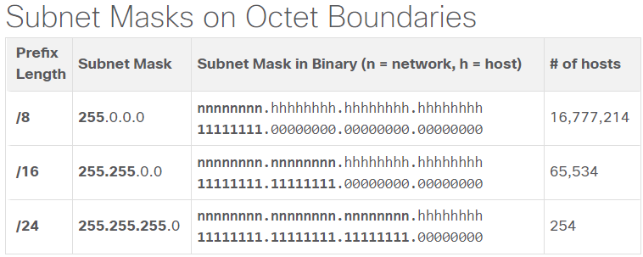

* Example:
  + The enterprise could further subnet the 10.0.0.0/8 address at the octet boundary of /16 as shown in the table. This would provide the enterprise the ability to define up to 256 subnets (i.e., 10.0.0.0/16 - 10.255.0.0/16) with each subnet capable of connecting 65,534 hosts. Notice how the first two octets identify the network portion of the address whereas the last two octets are for host IP addresses.

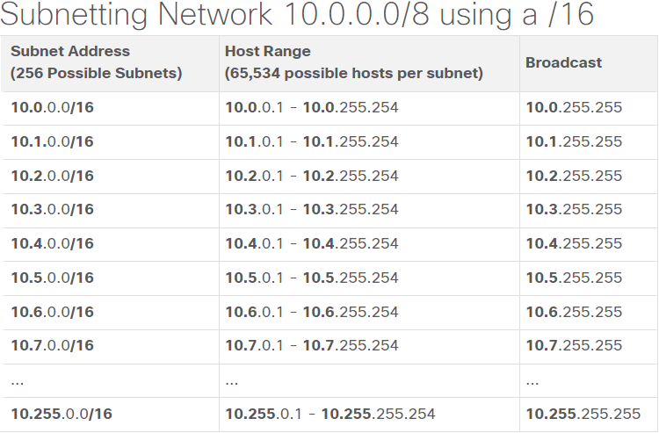

* + Alternatively, the enterprise could choose to subnet the 10.0.0.0/8 network at the /24 octet boundary, as shown in the table. This would enable the enterprise to define 65,536 subnets each capable of connecting 254 hosts. The /24 boundary is very popular in subnetting because it accommodates a reasonable number of hosts and conveniently subnets at the octet boundary.

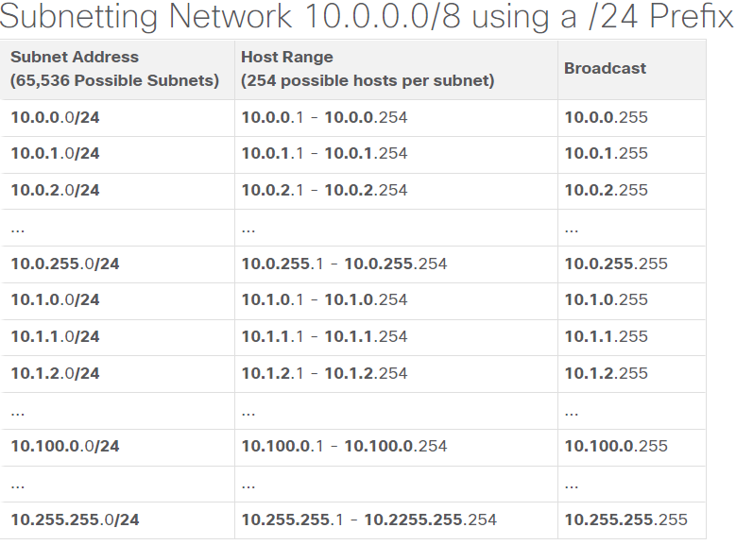

* The examples shown thus far borrowed host bits from the common /8, /16, and /24 network prefixes. However, subnets can borrow bits from any host bit position to create other masks.
  + Remember that you need 2 addresses from the hosts for the broadcast and network address.

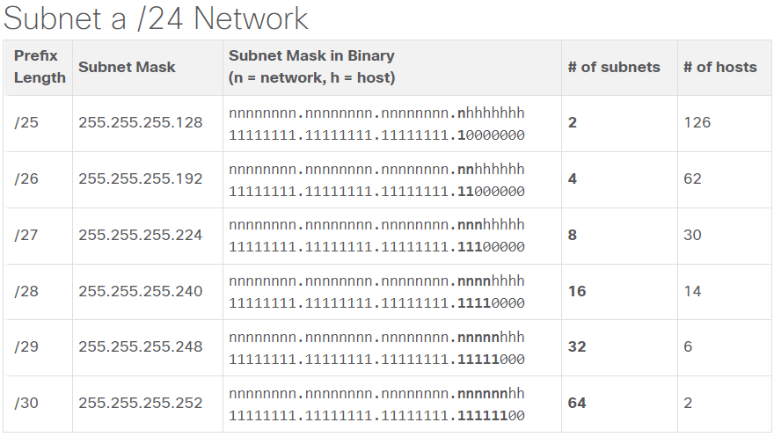

* # of hosts = 2n – 2 (n = bits for host portion, -2 because of the broadcast and network address)
* # of subnets = 2n (n = bits used for the subnet)
* We do not go higher then a /30 subnet mask because there would be no room for usable host addresses
* In each network there are two special addresses; network address and broadcast address. Network address represents the network itself while broadcast address represents all the hosts which belong to it. These two addresses can’t be assigned to any individual host in network.

## Subnet A Slash 16 and a Slash 8 Prefix

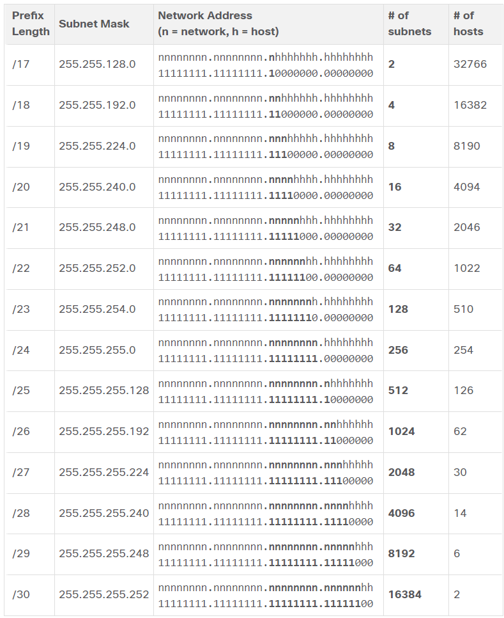

* Consider a large enterprise that requires at least 100 subnets and has chosen the private address 172.16.0.0/16 as its internal network address.
* When borrowing bits from a /16 address, start borrowing bits in the third octet, going from left to right. Borrow a single bit at a time until the number of bits necessary to create 100 subnets is reached.
  + So you need 7 bits for the network portion, that leaves 29 = 512 – 2 = 510 total host addresses for each /23 subnet.

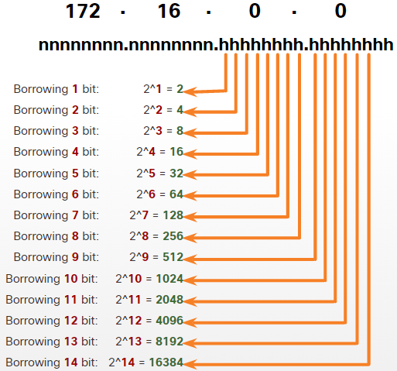

* Some organizations, such as small service providers or large enterprises, may need even more subnets. For example, take a small ISP that requires 1000 subnets for its clients. Each client will need plenty of space in the host portion to create its own subnets.
* The ISP has a network address 10.0.0.0 255.0.0.0 or 10.0.0.0/8. This means there are 8 bits in the network portion and 24 host bits available to borrow toward subnetting. Therefore, the small ISP will subnet the 10.0.0.0/8 network.
  + Borrowing 10 bits to create the subnets, leaves 14 host bits for each subnet.
  + 214 - 2 = 16382 hosts per subnet.
  + This means that each of the 1000 subnets can support up to 16,382 hosts.

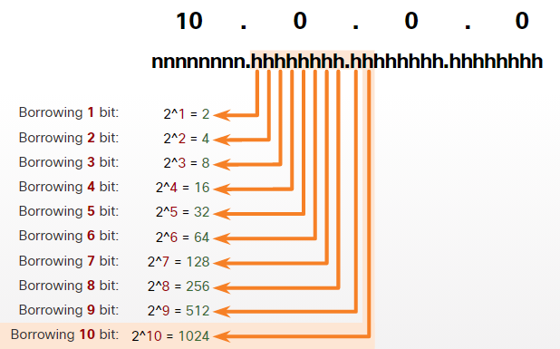

* The magic number trick:
  + Take for example this network and its subnetworks:

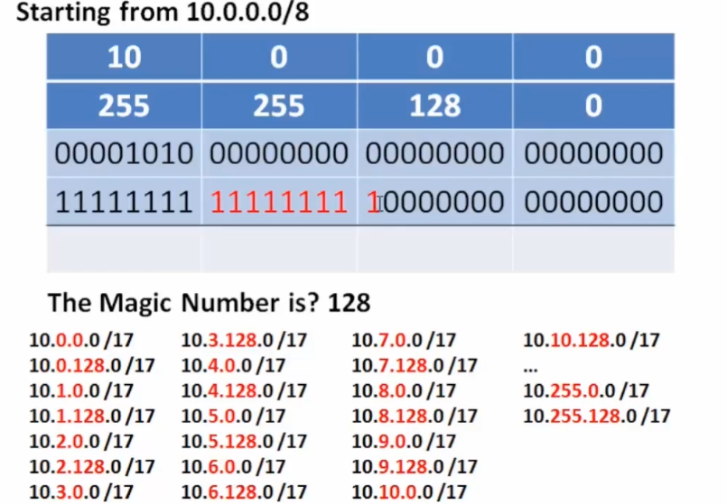

* + If we look at the third octet, or the last red number, it equals to 27 or 128. This means that the network address of the subnet will add up with 128 in the third octet.

## Subnet to Meet Requirements

* A typica enterprise looks like this:
  + Intranet - This is the internal part of a company’s network, accessible only within the organization. Devices in the intranet use private IPv4 addresses.
  + DMZ - This is part of the company’s network containing resources available to the internet such as a web server. Devices in the DMZ use public IPv4 addresses.

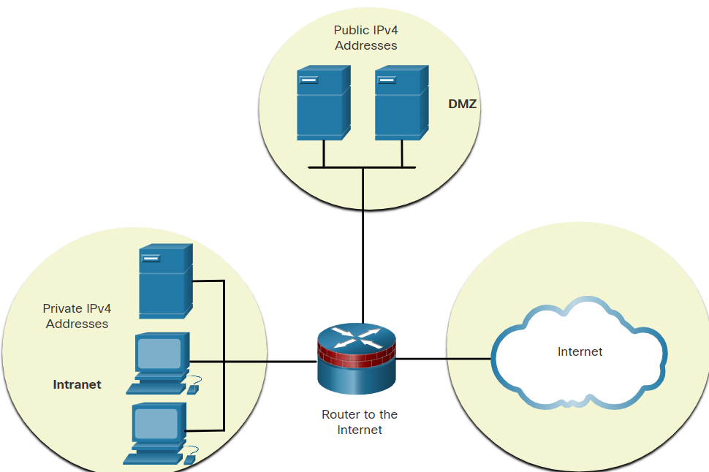

* Both the intranet and the DMZ have their own subnetting requirements and challenges.
* The intranet uses private IPv4 addressing space. This allows an organization to use any of the private IPv4 network addresses including the 10.0.0.0/8 prefix with 24 host bits and over 16 million hosts. Using a network address with 24 host bits makes subnetting easier and more flexible.
* the devices in the DMZ require public IPv4 addresses. The depletion of public IPv4 address space became an issue beginning in the mid-1990s. Since 2011, IANA and four out of five RIRs have run out of IPv4 address space. Although organizations are making the transition to IPv6, the remaining IPv4 address space remains severely limited. This means an organization must maximize its own limited number of public IPv4 addresses. This requires the network administrator to subnet their public address space into subnets with different subnet masks, in order to minimize the number of unused host addresses per subnet. This is known as Variable Subnet Length Masking (VLSM).
* To minimize the number of unused host IPv4 addresses and maximize the number of available subnets, there are two considerations when planning subnets: the number of host addresses required for each network and the number of individual subnets needed.
  + There is an inverse relationship between the number of subnets and the number of hosts. The more bits that are borrowed to create subnets, the fewer host bits remain available. If more host addresses are needed, more host bits are required, resulting in fewer subnets.
  + Network administrators must devise the network addressing scheme to accommodate the maximum number of hosts for each network and the number of subnets. The addressing scheme should allow for growth in both the number of host addresses per subnet and the total number of subnets.

## VLSM

* For example, the topology shown in the figure requires seven subnets and the largest number of host is in Building D with 28 hosts.
  + A /27 mask would provide 8 subnets of 30 host IP addresses and therefore support this topology.

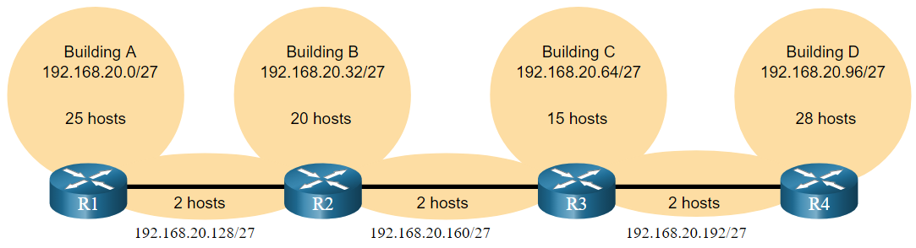

* + However, the point-to-point WAN links only require two addresses and therefore waste 28 addresses each for a total of 84 unused addresses.
  + Applying a traditional subnetting scheme to this scenario is not very efficient and is wasteful.
  + VLSM was developed to avoid wasting addresses by enabling us to subnet a subnet.

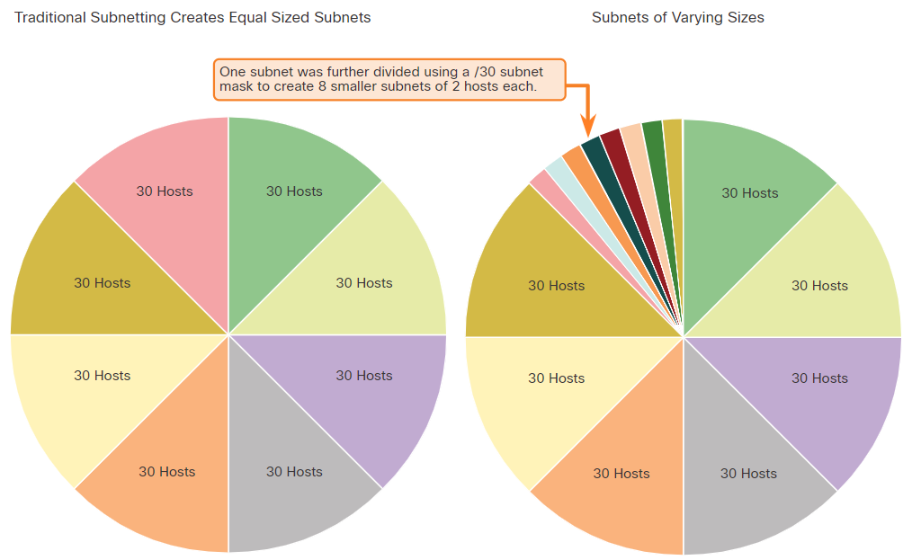

* + The left side displays the traditional subnetting scheme (i.e., the same subnet mask) while the right side illustrates how VLSM can be used to subnet a subnet and divided the last subnet into eight /30 subnets.
* When using VLSM, always begin by satisfying the host requirements of the largest subnet and continue subnetting until the host requirements of the smallest subnet are satisfied.
* The resulting topology with VLSM applied:

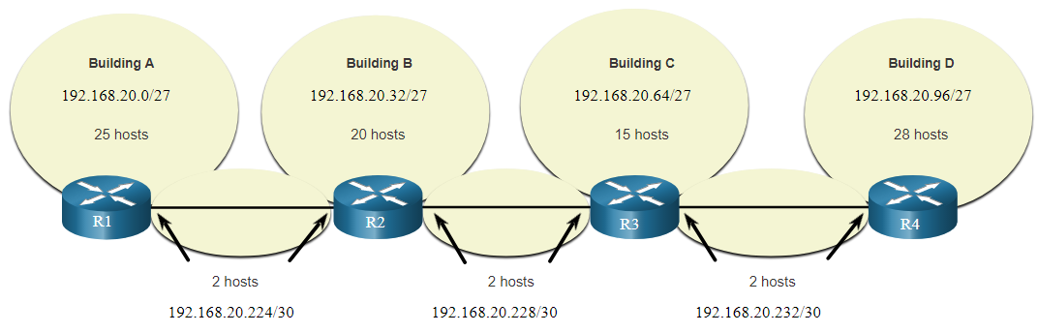

## Structured Design

* Before you start subnetting, you should develop an IPv4 addressing scheme for your entire network. You will need to know how many subnets you need, how many hosts a particular subnet requires, what devices are part of the subnet, which parts of your network use private addresses, and which use public, and many other determining factors. A good addressing scheme allows for growth. A good addressing scheme is also the sign of a good network administrator.
* Examine the needs of an organization’s network usage and how the subnets will be structured.
  + Perform a network requirement study by looking at the entire network to determining how each area will be segmented.
  + Determine how many subnets are needed and how many hosts per subnet.
  + Determine DHCP address pools and Layer 2 VLAN pools.
* Within a network, there are different types of devices that require addresses:
  + End user clients - Most networks allocate IPv4 addresses to client devices dynamically, using Dynamic Host Configuration Protocol (DHCP). This reduces the burden on network support staff and virtually eliminates entry errors. With DHCP, addresses are only leased for a period of time, and can be reused when the lease expires. This is an important feature for networks that support transient users and wireless devices. Changing the subnetting scheme means that the DHCP server needs to be reconfigured, and the clients must renew their IPv4 addresses. IPv6 clients can obtain address information using DHCPv6 or SLAAC.
  + Servers and peripherals - These should have a predictable static IP address. Use a consistent numbering system for these devices.
  + Servers that are accessible from the internet - Servers that need to be publicly available on the internet must have a public IPv4 address, most often accessed using NAT. In some organizations, internal servers (not publicly available) must be made available to the remote users. In most cases, these servers are assigned private addresses internally, and the user is required to create a virtual private network (VPN) connection to access the server. This has the same effect as if the user is accessing the server from a host within the intranet.
  + Intermediary devices - These devices are assigned addresses for network management, monitoring, and security. Because we must know how to communicate with intermediary devices, they should have predictable, statically assigned addresses.
  + Gateway - Routers and firewall devices have an IP address assigned to each interface which serves as the gateway for the hosts in that network. Typically, the router interface uses either the lowest or highest address in the network.
* When developing an IP addressing scheme, it is generally recommended that you have a set pattern of how addresses are allocated to each type of device. This benefits administrators when adding and removing devices, filtering traffic based on IP, as well as simplifying documentation.

# IPv6 addressing

## IPv4 Issues

* Need for IPv6:
  + IPv4 is running out of addresses. IPv6 is the successor to IPv4. IPv6 has a much larger 128-bit address space.
  + The development of IPv6 also included fixes for IPv4 limitations and other enhancements.
  + With an increasing internet population, a limited IPv4 address space, issues with NAT and the IoT, the time has come to begin the transition to IPv6.
  + NAT is problematic for many applications, creates latency, and has limitations that severely impede peer-to-peer communications.
* There is no specific date to move to IPv6. Both IPv4 and IPv6 will coexist in the near future and the transition will take several years. The IETF has created various protocols and tools to help network administrators migrate their networks to IPv6. The migration techniques can be divided into three categories:
  + Dual stack - Dual stack allows IPv4 and IPv6 to coexist on the same network segment. Dual stack devices run both IPv4 and IPv6 protocol stacks simultaneously. Known as native IPv6, this means the customer network has an IPv6 connection to their ISP and is able to access content found on the internet over IPv6.
  + Tunneling - Tunneling is a method of transporting an IPv6 packet over an IPv4 network. The IPv6 packet is encapsulated inside an IPv4 packet, similar to other types of data.
  + Translation - Network Address Translation 64 (NAT64) allows IPv6-enabled devices to communicate with IPv4-enabled devices using a translation technique similar to NAT for IPv4. An IPv6 packet is translated to an IPv4 packet and an IPv4 packet is translated to an IPv6 packet.
  + Note: Tunneling and translation are for transitioning to native IPv6 and should only be used where needed. The goal should be native IPv6 communications from source to destination.

## IPv6 Address Representation

* IPv6 addresses are 128 bits in length and written as a string of hexadecimal values. Every four bits is represented by a single hexadecimal digit; for a total of 32 hexadecimal values.
* IPv6 addresses are not case-sensitive and can be written in either lowercase or uppercase.
* The preferred format for writing an IPv6 address is x:x:x:x:x:x:x:x, with each “x” consisting of four hexadecimal values. In IPv6, a hextet is the unofficial term used to refer to a segment of 16 bits, or four hexadecimal values. Each “x” is a single hextet which is 16 bits or four hexadecimal digits.
* The first rule to help reduce the notation of IPv6 addresses is to omit any leading 0s (zeros) in any hextet. Here are four examples of ways to omit leading zeros:
  + 01ab can be represented as 1ab
  + 09f0 can be represented as 9f0
  + 0a00 can be represented as a00
  + 00ab can be represented as ab
  + This rule only applies to leading 0s, NOT to trailing 0s
* The second rule to help reduce the notation of IPv6 addresses is that a double colon (::) can replace any single, contiguous string of one or more 16-bit hextets consisting of all zeros. For example, 2001:db8:cafe:1:0:0:0:1 (leading 0s omitted) could be represented as 2001:db8:cafe:1::1. The double colon (::) is used in place of the three all-0 hextets (0:0:0).
  + The double colon (::) can only be used once within an address, otherwise there would be more than one possible resulting address.

## IPv6 Address Types

* There are three broad categories of IPv6 addresses:
  + Unicast – Unicast uniquely identifies an interface on an IPv6-enabled device.
  + Multicast – Multicast is used to send a single IPv6 packet to multiple destinations.
  + Anycast – This is any IPv6 unicast address that can be assigned to multiple devices. A packet sent to an anycast address is routed to the nearest device having that address.
  + Note: Unlike IPv4, IPv6 does not have a broadcast address. However, there is an IPv6 all-nodes multicast address that essentially gives the same result.
* Prefix length is represented in slash notation and is used to indicate the network portion of an IPv6 address.
  + The prefix length can range from 0 to 128. The recommended IPv6 prefix length for LANs and most other types of networks is /64
  + **Note**: It is strongly recommended to use a 64-bit Interface ID for most networks. This is because stateless address autoconfiguration (SLAAC) uses 64 bits for the Interface ID. It also makes subnetting easier to create and manage.

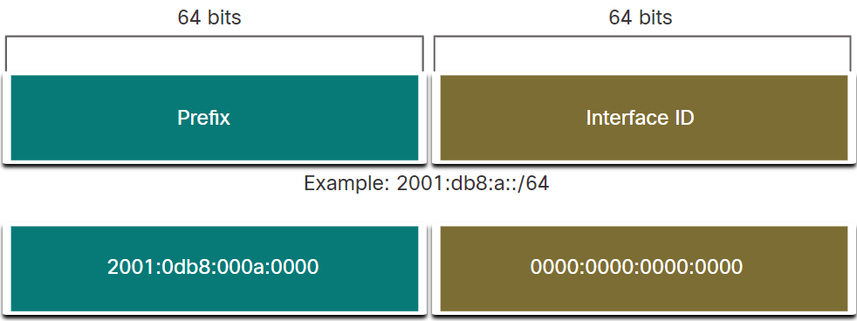

* An IPv6 unicast address uniquely identifies an interface on an IPv6-enabled device. Similar to IPv4, a source IPv6 address must be a unicast address. The destination IPv6 address can be either a unicast or a multicast address.
* Unlike IPv4 devices that have only a single address, IPv6 addresses typically have two unicast addresses:
  + Global Unicast Address (GUA) - This is similar to a public IPv4 address. These are globally unique, internet-routable addresses. GUAs can be configured statically or assigned dynamically.
  + Link-local Address (LLA) - This is required for every IPv6-enabled device. LLAs are used to communicate with other devices on the same local link. With IPv6, the term link refers to a subnet. LLAs are confined to a single link. Their uniqueness must only be confirmed on that link because they are not routable beyond the link. In other words, routers will not forward packets with a link-local source or destination address.

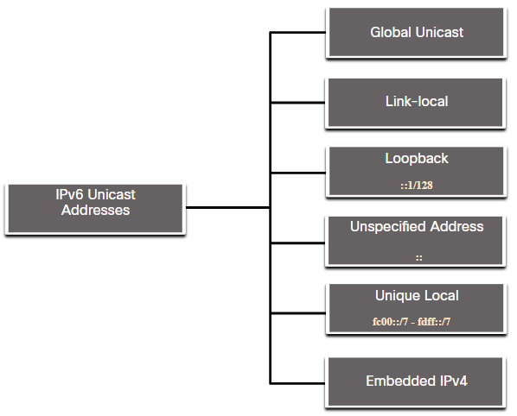

* + Unique local addresses (range fc00::/7 to fdff::/7) are not yet commonly implemented. Therefore, this module only covers GUA and LLA configuration. However, unique local addresses may eventually be used to address devices that should not be accessible from the outside, such as internal servers and printers.
  + The IPv6 unique local addresses have some similarity to RFC 1918 private addresses for IPv4, but there are significant differences:
    - Unique local addresses are used for local addressing within a site or between a limited number of sites.
    - Unique local addresses can be used for devices that will never need to access another network.
    - Unique local addresses are not globally routed or translated to a global IPv6 address.
* IPv6 global unicast addresses (GUAs) are globally unique and routable on the IPv6 internet. These addresses are equivalent to public IPv4 addresses. The Internet Committee for Assigned Names and Numbers (ICANN), the operator for IANA, allocates IPv6 address blocks to the five RIRs.
  + Currently, only GUAs with the first three bits of 001 or 2000::/3 are being assigned.
  + Currently available GUAs begins with a decimal 2 or a 3 (This is only 1/8th of the total available IPv6 address space).

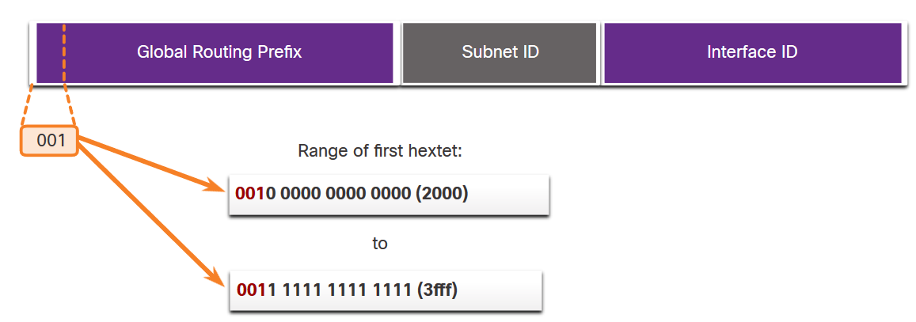

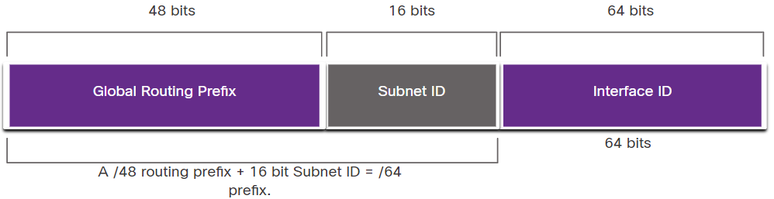

* IPv6 GUA Structure:
  + Global Routing Prefix:
    - The global routing prefix is the prefix, or network, portion of the address that is assigned by the provider, such as an ISP, to a customer or site. The global routing prefix will vary depending on ISP policies.
    - /48 prefixes are a common global routing prefix that is assigned
    - The size of the global routing prefix determines the size of the subnet ID.
  + Subnet ID:
    - The Subnet ID field is the area between the Global Routing Prefix and the Interface ID. The Subnet ID is used by an organization to identify subnets within its site.
    - IPv6 was designed with subnetting in mind.
    - The larger the subnet ID, the more subnets available.
    - Note: Many organizations are receiving a /32 global routing prefix. Using the recommended /64 prefix in order to create a 64-bit Interface ID, leaves a 32 bit Subnet ID.
  + Interface ID:
    - The IPv6 interface ID is equivalent to the host portion of an IPv4 address. It is strongly recommended that in most cases /64 subnets should be used, which creates a 64-bit interface ID.
  + Note: Unlike IPv4, in IPv6, the all-0s and all-1s host addresses can be assigned to a device. The all-1s address can be used because broadcast addresses are not used within IPv6. The all-0s address can also be used, but is reserved as a Subnet-Router anycast address, and should be assigned only to routers.
* An IPv6 link-local address (LLA) enables a device to communicate with other IPv6-enabled devices on the same link and only on that link (subnet). Packets with a source or destination LLA cannot be routed beyond the link from which the packet originated.
  + The GUA is not a requirement. However, every IPv6-enabled network interface must have an LLA.
  + If an LLA is not configured manually on an interface, the device will automatically create its own without communicating with a DHCP server.
  + IPv6-enabled hosts create an IPv6 LLA even if the device has not been assigned a global unicast IPv6 address. This allows IPv6-enabled devices to communicate with other IPv6-enabled devices on the same subnet. This includes communication with the default gateway (router).
  + IPv6 LLAs are in the fe80::/10 range. The /10 indicates that the first 10 bits are 1111 1110 10xx xxxx. The first hextet has a range of 1111 1110 1000 0000 (fe80) to 1111 1110 1011 1111 (febf).

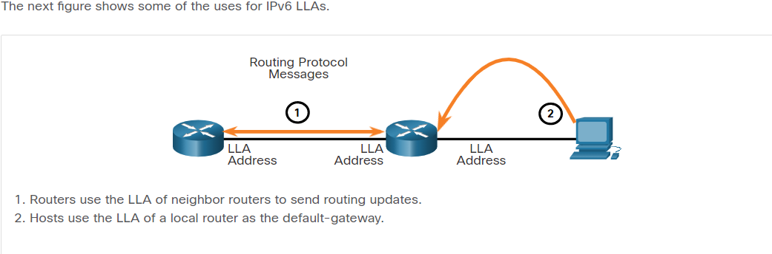

* + Note: Typically, it is the LLA of the router, and not the GUA, that is used as the default gateway for other devices on the link.
  + There are two ways that a device can obtain an LLA:
    - Statically - This means the device has been manually configured.
    - Dynamically - This means the device creates its own interface ID by using randomly generated values or using the Extended Unique Identifier (EUI) method, which uses the client MAC address along with additional bits.

## GUA and LLA Static Configuration

* Most IPv6 configuration and verification commands in the Cisco IOS are similar to their IPv4 counterparts. In many cases, the only difference is the use of ipv6 in place of ip within the commands.
* Static GUA Configuration on a Router:
  + The command to configure an IPv6 GUA on an interface is: **ipv6 address** ***ipv6-address/prefix-length.***
  + Note: To make a change in addressing with ipv6, you must remove the incorrect address or else both addresses will remain configured on the interface. Example: **no ipv6 address 2001:db8:1:5::1/64**
  + IPv6 GUA Configuration on Router R1:

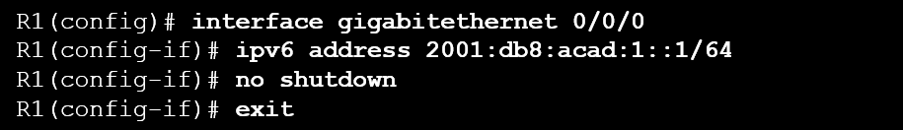

* Static GUA Configuration on a Windows Host:
  + Manually configuring the IPv6 address on a host is similar to configuring an IPv4 address.
  + The GUA or LLA of the router interface can be used as the default gateway. Best practice is to use the LLA.

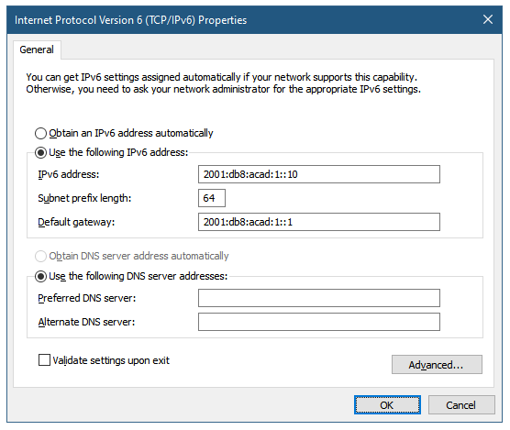

* Just as with IPv4, configuring static addresses on clients does not scale to larger environments. For this reason, most network administrators in an IPv6 network will enable dynamic assignment of IPv6 addresses.
* Note: When DHCPv6 or SLAAC is used, the LLA of the router will automatically be specified as the default gateway address.
* Static GUA Configuration of a Link-Local Unicast Address:
  + Configuring the LLA manually lets you create an address that is recognizable and easier to remember. Typically, it is only necessary to create recognizable LLAs on routers. This is beneficial because router LLAs are used as default gateway addresses and in routing advertisement messages.
  + LLAs can be configured manually using the **ipv6 address *ipv6-link-local-address*** **link-local** command.

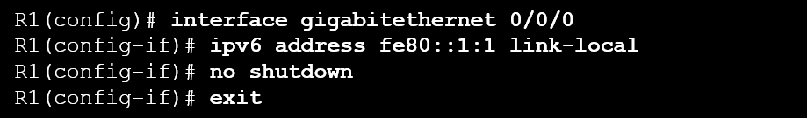

* + Note: The exact same LLA could be configured on each link as long as it is unique on that link. This is because LLAs only have to be unique on that link. However, common practice is to create a different LLA on each interface of the router to make it easy to identify the router and the specific interface.

## Dynamic Addressing for IPv6 GUAs

* Devices obtain GUA addresses dynamically through Internet Control Message Protocol version 6 (ICMPv6) messages.
  + Router Solicitation (RS) messages are sent by host devices to discover IPv6 routers
  + Router Advertisement (RA) messages are sent by routers to inform hosts on how to obtain an IPv6 GUA and provide useful network information such as:
    - Network prefix and prefix length - This tells the device which network it belongs to.
    - Default gateway address - This is an IPv6 LLA, the source IPv6 address of the RA message.
    - DNS addresses and domain name - These are the addresses of DNS servers and a domain name.
  + The RA can provide three methods for configuring an IPv6 GUA:
    - Method 1: SLAAC - “I have everything you need including the prefix, prefix length, and default gateway address.”
    - Method 2: SLAAC with a stateless DHCPv6 server - “Here is my information but you need to get other information such as DNS addresses from a stateless DHCPv6 server.”
    - Method 3: Stateful DHCPv6 (no SLAAC) - “I can give you your default gateway address. You need to ask a stateful DHCPv6 server for all your other information.”

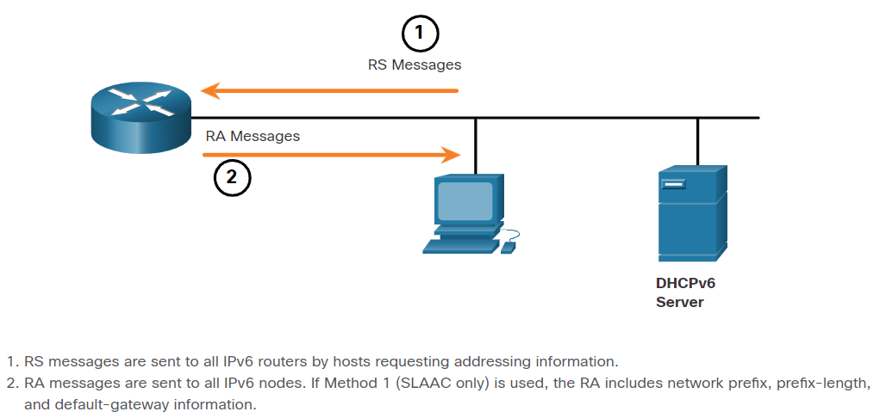

* RA messages are on IPv6 router Ethernet interfaces. The router must be enabled for IPv6 routing, which is not enabled by default. To enable a router as an IPv6 router, the **ipv6 unicast-routing** global configuration command must be used.
* The ICMPv6 RA message is a suggestion to a device on how to obtain an IPv6 GUA. The ultimate decision is up to the device operating system.
* Method 1: SLAAC
  + SLAAC allows a device to configure a GUA without the services of DHCPv6.
  + Devices obtain the necessary information to configure a GUA from the ICMPv6 RA messages of the local router.
  + SLAAC is stateless, which means there is no central server (for example, a stateful DHCPv6 server) allocating GUAs and keeping a list of devices and their addresses.
  + the two parts of the address are created as follows:
    - Prefix - This is advertised in the RA message.
    - Interface ID - This uses the EUI-64 process or by generating a random 64-bit number, depending on the device operating system.

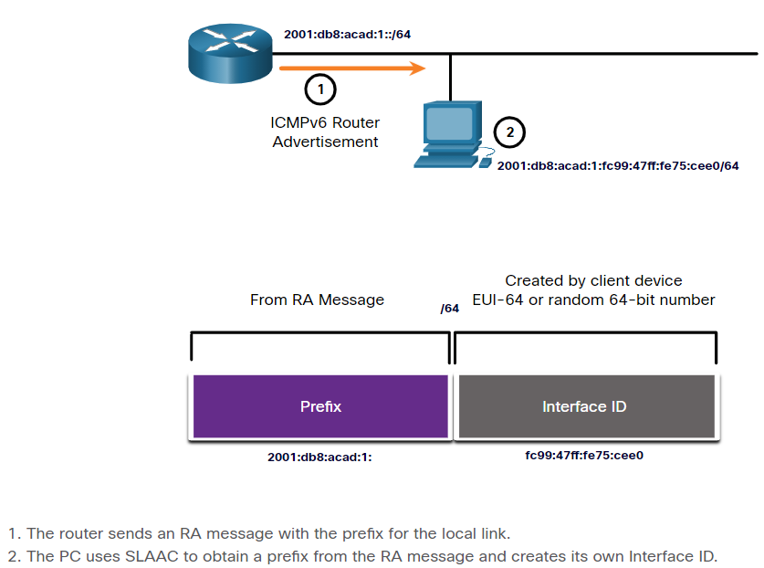

* Method 2: SLAAC and Stateless DHCPv6:
  + An RA can instruct a device to use both SLAAC and stateless DHCPv6.
  + The RA message suggests devices use the following:
    - SLAAC to create its own IPv6 GUA
    - The router LLA, which is the RA source IPv6 address, as the default gateway address
    - A stateless DHCPv6 server to obtain other information such as a DNS server address and a domain name
  + Note: A stateless DHCPv6 server distributes DNS server addresses and domain names. It does not allocate GUAs

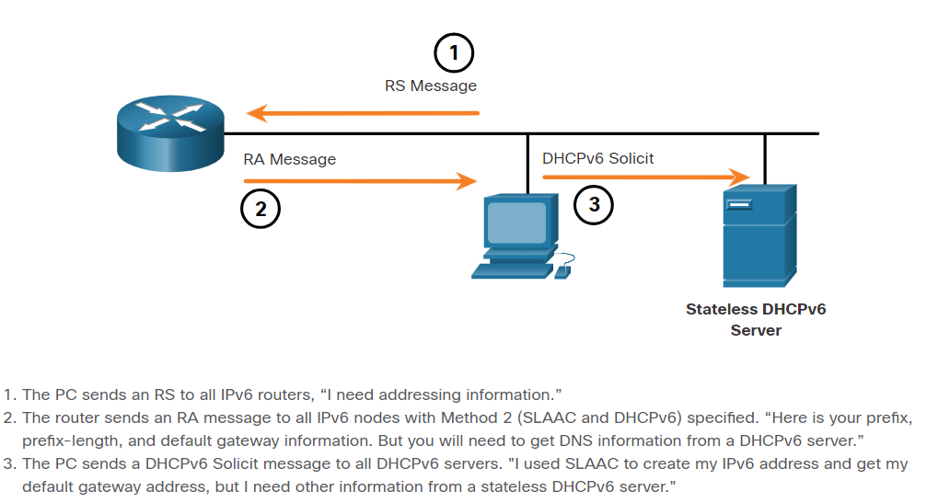

* Method 3: Stateful DHCPv6:
  + An RA can instruct a device to use stateful DHCPv6 only.
  + Stateful DHCPv6 is similar to DHCP for IPv4. A device can automatically receive a GUA, prefix length, and the addresses of DNS servers from a stateful DHCPv6 server.
  + The RA message suggests devices use the following:
    - The router LLA, which is the RA source IPv6 address, for the default gateway address.
    - A stateful DHCPv6 server to obtain a GUA, DNS server address, domain name and other necessary information.
  + A stateful DHCPv6 server allocates and maintains a list of which device receives which IPv6 address. DHCP for IPv4 is stateful.
  + Note: The default gateway address can only be obtained dynamically from the RA message. The stateless or stateful DHCPv6 server does not provide the default gateway address.

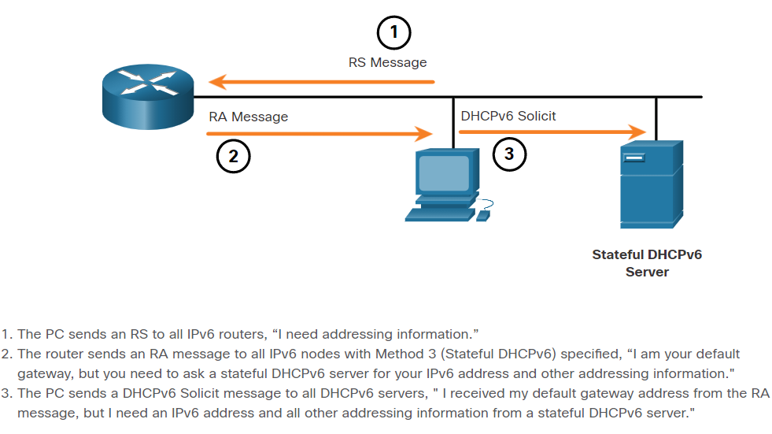

* When the RA message is either SLAAC or SLAAC with stateless DHCPv6, the client must generate its own interface ID. The interface ID can be created using the EUI-64 process or a randomly generated 64-bit number.
* IEEE defined the Extended Unique Identifier (EUI) or modified EUI-64 process. This process uses the 48-bit Ethernet MAC address of a client, and inserts another 16 bits in the middle of the 48-bit MAC address to create a 64-bit interface ID.
* Ethernet MAC addresses are usually represented in hexadecimal and are made up of two parts:
  + Organizationally Unique Identifier (OUI) - The OUI is a 24-bit (6 hexadecimal digits) vendor code assigned by IEEE.
  + Device Identifier - The device identifier is a unique 24-bit (6 hexadecimal digits) value within a common OUI.
* An EUI-64 Interface ID is represented in binary and is made up of three parts:
  + 24-bit OUI from the client MAC address, but the 7th bit (the Universally/Locally (U/L) bit) is reversed. This means that if the 7th bit is a 0, it becomes a 1, and vice versa.
  + The inserted 16-bit value fffe (in hexadecimal).
  + 24-bit Device Identifier from the client MAC address.
* The advantage of EUI-64 is that the Ethernet MAC address can be used to determine the interface ID. It also allows network administrators to easily track an IPv6 address to an end-device using the unique MAC address. However, this has caused privacy concerns among many users who worried that their packets could be traced to the actual physical computer. Due to these concerns, a randomly generated interface ID may be used instead.
* The EUI-64 process is illustrated in the figure, using the R1 GigabitEthernet MAC address of fc99:4775:cee0.

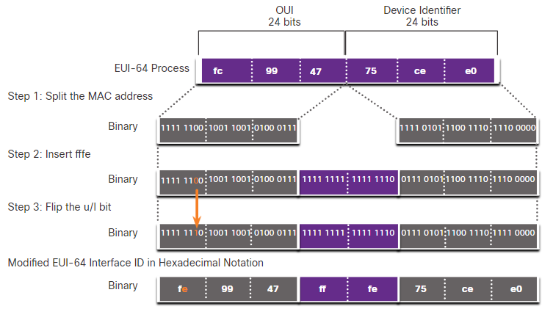

* The example output for the ipconfig command shows the IPv6 GUA being dynamically created using SLAAC and the EUI-64 process. An easy way to identify that an address was probably created using EUI-64 is the fffe located in the middle of the interface ID.

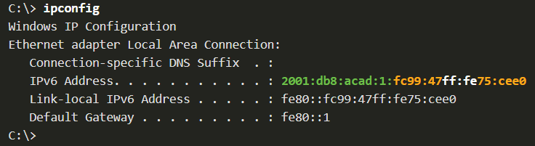

* Depending upon the operating system, a device may use a randomly generated interface ID instead of using the MAC address and the EUI-64 process. Beginning with Windows Vista, Windows uses a randomly generated interface ID instead of one created with EUI-64. Windows XP and previous Windows operating systems used EUI-64.
* After the interface ID is established, either through the EUI-64 process or through random generation, it can be combined with an IPv6 prefix in the RA message to create a GUA.

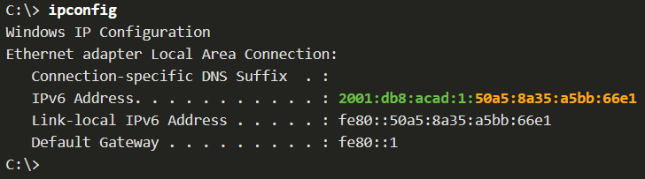

* Note: To ensure the uniqueness of any IPv6 unicast address, the client may use a process known as Duplicate Address Detection (DAD). This is similar to an ARP request for its own address. If there is no reply, then the address is unique.

## Dynamic Addressing for IPv6 LLAs

* All IPv6 devices must have an IPv6 LLA. Like IPv6 GUAs, you can also create LLAs dynamically.
* The figure shows the LLA is dynamically created using the fe80::/10 prefix and the interface ID using the EUI-64 process, or a randomly generated 64-bit number.

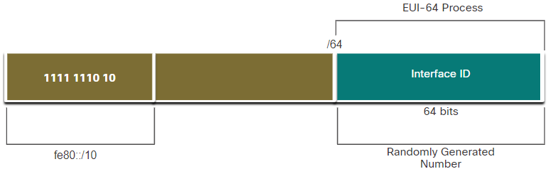

* Operating systems, such as Windows, will typically use the same method for both a SLAAC-created GUA and a dynamically assigned LLA. See the highlighted areas in the following examples that were shown previously.
* EUI-64 Generated Interface ID:

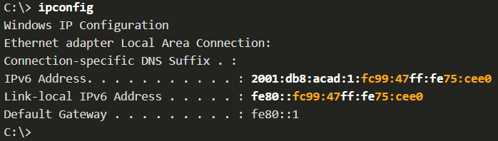

* Random 64-bit Generated Interface ID:

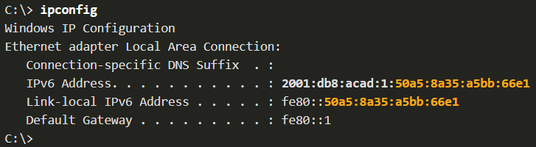

* Cisco routers automatically create an IPv6 LLA whenever a GUA is assigned to the interface. By default, Cisco IOS routers use EUI-64 to generate the interface ID for all LLAs on IPv6 interfaces.
  + However, a drawback to using the dynamically assigned LLA is its long interface ID, which makes it challenging to identify and remember assigned addresses.
* Here is an example of a LLA dynamically configured on the G0/0/0 interface of R1:

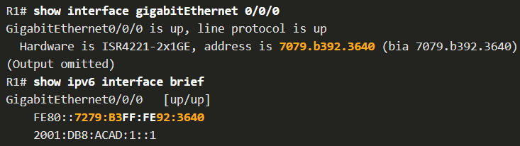

* Verify IPv6 Address Configuration:
  + The show ipv6 interface brief command displays the MAC address of the Ethernet interfaces. EUI-64 uses this MAC address to generate the interface ID for the LLA. Additionally, the show ipv6 interface brief command displays abbreviated output for each of the interfaces. The [up/up] output on the same line as the interface indicates the Layer 1/Layer 2 interface state. This is the same as the Status and Protocol columns in the equivalent IPv4 command.
  + Notice that each interface has two IPv6 addresses. The second address for each interface is the GUA that was configured. The first address, the one that begins with fe80, is the link-local unicast address for the interface. Recall that the LLA is automatically added to the interface when a GUA is assigned.
  + Also, notice that the R1 Serial 0/1/0 LLA is the same as its GigabitEthernet 0/0/0 interface. Serial interfaces do not have Ethernet MAC addresses, so Cisco IOS uses the MAC address of the first available Ethernet interface. This is possible because link-local interfaces only have to be unique on that link.

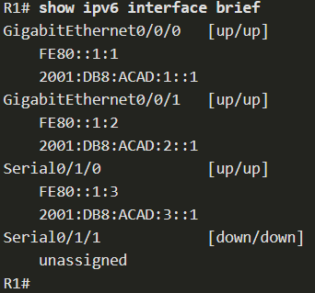

* + the show ipv6 route command can be used to verify that IPv6 networks and specific IPv6 interface addresses have been installed in the IPv6 routing table. The show ipv6 route command will only display IPv6 networks, not IPv4 networks.
  + Within the route table, a C next to a route indicates that this is a directly connected network. When the router interface is configured with a GUA and is in the “up/up” state, the IPv6 prefix and prefix length is added to the IPv6 routing table as a connected route.
  + Note: The L indicates a Local route, the specific IPv6 address assigned to the interface. This is not an LLA. LLAs are not included in the routing table of the router because they are not routable addresses.
  + The IPv6 GUA configured on the interface is also installed in the routing table as a local route. The local route has a /128 prefix. Local routes are used by the routing table to efficiently process packets with a destination address of the router interface address.

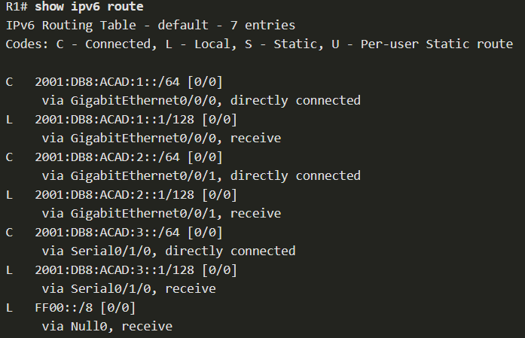

* + The ping command for IPv6 is identical to the command used with IPv4, except that an IPv6 address is used. When pinging an LLA from a router, Cisco IOS will prompt the user for the exit interface. Because the destination LLA can be on one or more of its links or networks, the router needs to know which interface to send the ping to.

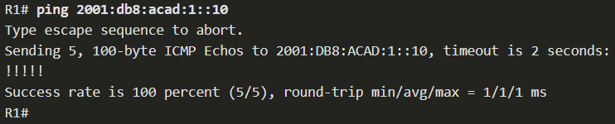

## IPv6 Multicast Addresses

* IPv6 multicast addresses have the prefix ff00::/8. There are two types of IPv6 multicast addresses:
  + Well-Known multicast addresses
  + Solicited node multicast addresses
* **Note**: Multicast addresses can only be destination addresses and not source addresses.
* Well-known IPv6 multicast addresses are assigned. Assigned multicast addresses are reserved multicast addresses for predefined groups of devices. An assigned multicast address is a single address used to reach a group of devices running a common protocol or service.
* These are two common IPv6 assigned multicast groups:
  + ff02::1 All-nodes multicast group - This is a multicast group that all IPv6-enabled devices join. A packet sent to this group is received and processed by all IPv6 interfaces on the link or network. This has the same effect as a broadcast address in IPv4.
  + ff02::2 All-routers multicast group - This is a multicast group that all IPv6 routers join. A router becomes a member of this group when it is enabled as an IPv6 router with the ipv6 unicast-routing global configuration command. A packet sent to this group is received and processed by all IPv6 routers on the link or network.
* A solicited-node multicast address is similar to the all-nodes multicast address. The advantage of a solicited-node multicast address is that it is mapped to a special Ethernet multicast address. This allows the Ethernet NIC to filter the frame by examining the destination MAC address without sending it to the IPv6 process to see if the device is the intended target of the IPv6 packet.

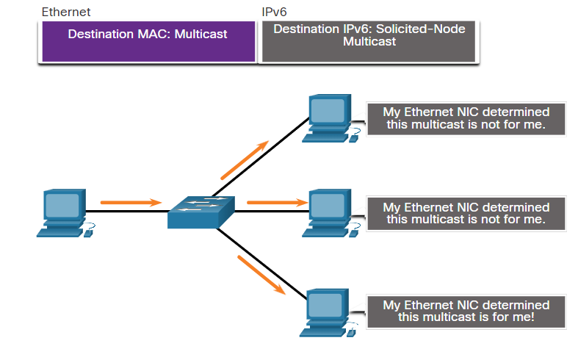

## Subnet an IPv6 Network

* IPv6 was designed with subnetting in mind. A separate subnet ID field in the IPv6 GUA is used to create subnets.
* The subnet ID field is the area between the Global Routing Prefix and the interface ID.

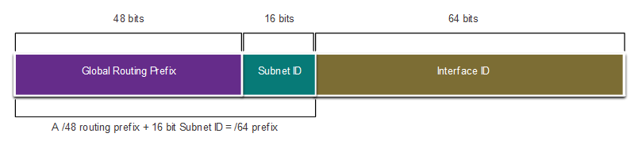

* The benefit of a 128-bit address is that it can support more than enough subnets and hosts per subnet, for each network.
* IPv6 subnetting is also easier to implement than IPv4, because there is no conversion to binary required. To determine the next available subnet, just count up in hexadecimal.
* For example, assume an organization has been assigned the 2001:db8:acad::/48 global routing prefix with a 16 bit subnet ID. This would allow the organization to create 65,536 /64 subnets, as shown in the figure. Notice how the global routing prefix is the same for all subnets. Only the subnet ID hextet is incremented in hexadecimal for each subnet.

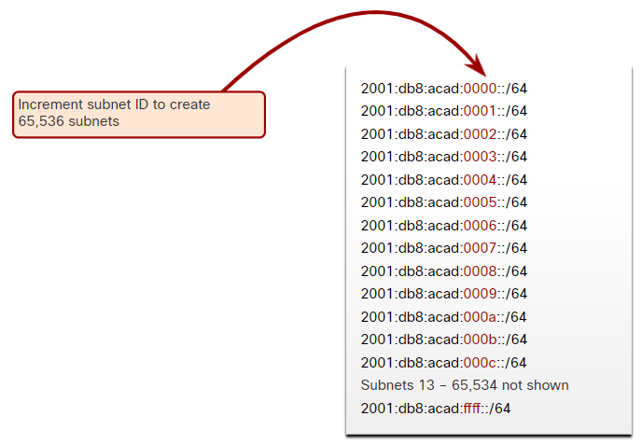

* With over 65,536 subnets to choose from, the task of the network administrator becomes one of designing a logical scheme to address the network.
* As shown in the figure, the example topology requires five subnets, one for each LAN as well as for the serial link between R1 and R2. Unlike the example for IPv4, with IPv6 the serial link subnet will have the same prefix length as the LANs. Although this may seem to “waste” addresses, address conservation is not a concern when using IPv6.

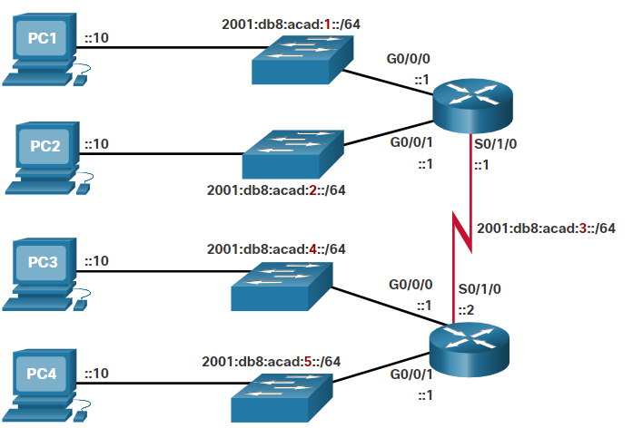

# ICMP

## ICMP Messages

* Although IP is only a best-effort protocol, the TCP/IP suite does provide for error messages and informational messages when communicating with another IP device. These messages are sent using the services of ICMP. The purpose of these messages is to provide feedback about issues related to the processing of IP packets under certain conditions, not to make IP reliable. ICMP messages are not required and are often not allowed within a network for security reasons.
* ICMPv4 is the messaging protocol for IPv4. ICMPv6 provides these same services for IPv6 but includes additional functionality.
* The ICMP messages common to both ICMPv4 and ICMPv6 include:
  + Host reachability:
  + Destination or Service Unreachable:
  + Time exceeded
* Host reachability:
  + An ICMP Echo Message can be used to test the reachability of a host on an IP network. The local host sends an ICMP Echo Request to a host. If the host is available, the destination host responds with an Echo Reply.
* Destination or Service Unreachable:
  + When a host or gateway receives a packet that it cannot deliver, it can use an ICMP Destination Unreachable message to notify the source that the destination or service is unreachable. The message will include a code that indicates why the packet could not be delivered.
  + Some of the Destination Unreachable codes for ICMPv4 are as follows:
    - 0 - Net unreachable
    - 1 - Host unreachable
    - 2 - Protocol unreachable
    - 3 - Port unreachable
  + Some of the Destination Unreachable codes for ICMPv6 are as follows:
    - 0 - No route to destination
    - 1 - Communication with the destination is administratively prohibited (e.g., firewall)
    - 2 – Beyond scope of the source address
    - 3 - Address unreachable
    - 4 - Port unreachable
* Time exceeded:
  + An ICMPv4 Time Exceeded message is used by a router to indicate that a packet cannot be forwarded because the Time to Live (TTL) field of the packet was decremented to 0. If a router receives a packet and decrements the TTL field in the IPv4 packet to zero, it discards the packet and sends a Time Exceeded message to the source host.
  + ICMPv6 also sends a Time Exceeded message if the router cannot forward an IPv6 packet because the packet has expired. Instead of the IPv4 TTL field, ICMPv6 uses the IPv6 Hop Limit field to determine if the packet has expired.
* ICMPv6 messages are encapsulated in IPv6.
* ICMPv6 has new features and improved functionality not found in ICMPv4, including four new protocols as part of the Neighbor Discovery Protocol (ND or NDP).
  + Messaging between an IPv6 router and an IPv6 device, including dynamic address allocation are as follows:
    - Router Solicitation (RS) message
    - Router Advertisement (RA) message:
  + Messaging between IPv6 devices, including duplicate address detection and address resolution are as follows:
    - Neighbor Solicitation (NS) message
    - Neighbor Advertisement (NA) message
* Note: ICMPv6 ND also includes the redirect message, which has a similar function to the redirect message used in ICMPv4.
* Router Solicitation (RS) message:
  + An IPv6-enabled router will also send out an RA message in response to an RS message. In the figure, PC1 sends a RS message to determine how to receive its IPv6 address information dynamically.

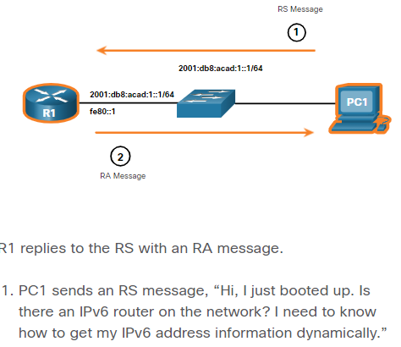

* Router Advertisement (RA) message:
  + RA messages are sent by IPv6-enabled routers every 200 seconds to provide addressing information to IPv6-enabled hosts. The RA message can include addressing information for the host such as the prefix, prefix length, DNS address, and domain name. A host using Stateless Address Autoconfiguration (SLAAC) will set its default gateway to the link-local address of the router that sent the RA.

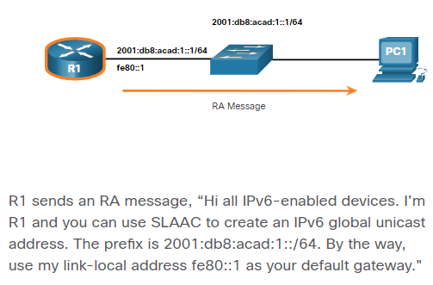

* Neighbor Solicitation (NS) message:
  + When a device is assigned a global IPv6 unicast or link-local unicast address, it may perform duplicate address detection (DAD) to ensure that the IPv6 address is unique. To check the uniqueness of an address, the device will send an NS message with its own IPv6 address as the targeted IPv6 address, as shown in the figure.
  + If another device on the network has this address, it will respond with an NA message. This NA message will notify the sending device that the address is in use. If a corresponding NA message is not returned within a certain amount of time, the unicast address is unique and acceptable for use.
  + Note: DAD is not required, but RFC 4861 recommends that DAD is performed on unicast addresses.

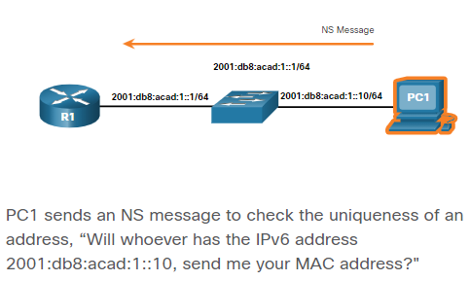

* Neighbor Advertisement (NA) message:
  + Address resolution is used when a device on the LAN knows the IPv6 unicast address of a destination but does not know its Ethernet MAC address. To determine the MAC address for the destination, the device will send an NS message to the solicited node address. The message will include the known (targeted) IPv6 address. The device that has the targeted IPv6 address will respond with an NA message containing its Ethernet MAC address.

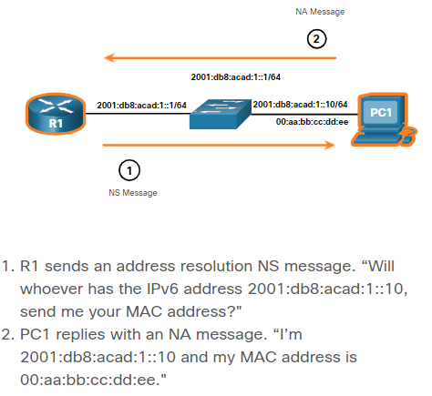

## Ping and Traceroute Tests

* Ping is an IPv4 and IPv6 testing utility that uses ICMP echo request and echo reply messages to test connectivity between hosts.
* To test connectivity to another host on a network, an echo request is sent to the host address using the ping command. If the host at the specified address receives the echo request, it responds with an echo reply. As each echo reply is received, ping provides feedback on the time between when the request was sent and when the reply was received. This can be a measure of network performance.
* Ping has a timeout value for the reply. If a reply is not received within the timeout, ping provides a message indicating that a response was not received. This may indicate that there is a problem, but could also indicate that security features blocking ping messages have been enabled on the network. It is common for the first ping to timeout if address resolution (ARP or ND) needs to be performed before sending the ICMP Echo Request.
* After all the requests are sent, the ping utility provides a summary that includes the success rate and average round-trip time to the destination.
* Ping the Loopback:
  + Ping can be used to test the internal configuration of IPv4 or IPv6 on the local host. To perform this test, ping the local loopback address of 127.0.0.1 for IPv4 (::1 for IPv6).
  + A response from 127.0.0.1 for IPv4, or ::1 for IPv6, indicates that IP is properly installed on the host.
  + An error message indicates that TCP/IP is not operational on the host.
* Ping the default gateway:
  + You can also use ping to test the ability of a host to communicate on the local network. For this test, the default gateway address is most often used because the router is normally always operational.
  + A successful ping to the default gateway indicates that the host and the router interface serving as the default gateway are both operational on the local network.
  + If the default gateway address does not respond, a ping can be sent to the IP address of another host on the local network that is known to be operational.
  + If either the default gateway or another host responds, then the local host can successfully communicate over the local network. If the default gateway does not respond but another host does, this could indicate a problem with the router interface serving as the default gateway.
  + One possibility is that the wrong default gateway address has been configured on the host. Another possibility is that the router interface may be fully operational but have security applied to it that prevents it from processing or responding to ping requests.
* Ping a remote host:
  + Ping can also be used to test the ability of a local host to communicate across an internetwork. A local host can ping a host on a remote network.
  + If this ping is successful, the operation of a large piece of the internetwork can be verified. A successful ping across the internetwork confirms communication on the local network, the operation of the router serving as the default gateway, and the operation of all other routers that might be in the path between the local network and the network of the remote host.
  + Additionally, the functionality of the remote host can be verified. If the remote host could not communicate outside of its local network, it would not have responded.
  + Note: Many network administrators limit or prohibit the entry of ICMP messages into the corporate network; therefore, the lack of a ping response could be due to security restrictions.
* Traceroute – Test the path:
  + Traceroute (tracert) is a utility that generates a list of hops that were successfully reached along the path. This list can provide important verification and troubleshooting information.
  + If the data reaches the destination, then the trace lists the interface of every router in the path between the hosts.
  + If the data fails at some hop along the way, the address of the last router that responded to the trace can provide an indication of where the problem or security restrictions are found.
  + Using traceroute provides round-trip time for each hop along the path and indicates if a hop fails to respond. The round-trip time is the time a packet takes to reach the remote host and for the response from the host to return. An asterisk (*) is used to indicate a lost or unreplied packet.
    - If the display shows high response times or data losses from a particular hop, this is an indication that the resources of the router or its connections may be stressed.
  + Traceroute makes use of a function of the TTL field in IPv4 and the Hop Limit field in IPv6 in the Layer 3 headers, along with the ICMP Time Exceeded message.
    - The first sequence of messages sent from traceroute will have a TTL field value of 1. This causes the TTL to time out the IPv4 packet at the first router. This router then responds with an ICMPv4 Time Exceeded message. Traceroute now has the address of the first hop.
    - Traceroute then progressively increments the TTL field (2, 3, 4...) for each sequence of messages. This provides the trace with the address of each hop as the packets time out further down the path. The TTL field continues to be increased until the destination is reached, or it is incremented to a predefined maximum.

# Transport layer

## Transportation of Data

* The transport layer is responsible for logical communications between applications running on different hosts. This may include services such as establishing a temporary session between two hosts and the reliable transmission of information for an application. The transport layer is also the link between the application layer and the lower layers that are responsible for network transmission.
* The transport layer has no knowledge of the destination host type, the type of media over which the data must travel, the path taken by the data, the congestion on a link, or the size of the network.
* Transport Layer Responsibilities:
  + Tracking Individual Conversations:
    - At the transport layer, each set of data flowing between a source application and a destination application is known as a conversation and is tracked separately. It is the responsibility of the transport layer to maintain and track these multiple conversations.
  + Segmenting Data and Reassembling Segments:
    - It is the transport layer responsibility to divide the application data into appropriately sized (smaller) blocks. Depending on the transport layer protocol used, the transport layer blocks are called either segments or datagrams.
  + Add Header Information:
    - The transport layer protocol also adds header information containing binary data organized into several fields to each block of data. It is the values in these fields that enable various transport layer protocols to perform different functions in managing data communication.
  + Identifying the Applications:
    - The transport layer must be able to separate and manage multiple communications with different transport requirement needs. To pass data streams to the proper applications, the transport layer identifies the target application using an identifier called a port number. Each software process that needs to access the network is assigned a port number unique to that host.
  + Conversion Multiplexing:
    - Uses segmentation and multiplexing to enable different communication conversations to be interleaved on the same network.
* Transport layer protocols specify how to transfer messages between hosts and are responsible for managing reliability requirements of a conversation. The transport layer includes the TCP and UDP protocols. Different applications have different transport reliability requirements. Therefore, TCP/IP provides two transport layer protocols.
* Transmission Control Protocol (TCP):
  + TCP is considered a reliable, full-featured transport layer protocol, which ensures that all of the data arrives at the destination.
  + TCP includes fields which ensure the delivery of the application data. These fields require additional processing by the sending and receiving hosts.
  + TCP provides reliability and flow control using these basic operations:
    - Number and track data segments transmitted to a specific host from a specific application
    - Acknowledge received data
    - Retransmit any unacknowledged data after a certain amount of time
    - Sequence data that might arrive in wrong order
    - Send data at an efficient rate that is acceptable by the receiver
  + In order to maintain the state of a conversation and track the information, TCP must first establish a connection between the sender and the receiver. This is why TCP is known as a connection-oriented protocol.
* User Datagram Protocol (UDP):
  + UDP is a simpler transport layer protocol than TCP. It does not provide reliability and flow control, which means it requires fewer header fields.
  + UDP datagrams can be processed faster than TCP segments.
  + UDP provides the basic functions for delivering datagrams between the appropriate applications, with very little overhead and data checking.
  + UDP is a connectionless protocol. Because UDP does not provide reliability or flow control, it does not require an established connection.
  + UDP is also known as a stateless protocol because UDP does not track information sent or received between the client and server.
  + UDP is also known as a best-effort delivery protocol because there is no acknowledgment that the data is received at the destination. With UDP, there are no transport layer processes that inform the sender of a successful delivery.
  + UDP is like placing a regular, nonregistered, letter in the mail. The sender of the letter is not aware of the availability of the receiver to receive the letter. Nor is the post office responsible for tracking the letter or informing the sender if the letter does not arrive at the final destination.
* UDP is often used for applications they can tolerate some data loss during transmission over the network, but delays in transmission are unacceptable (VoIP). UDP is also used by request-and-reply applications where the data is minimal, and retransmission can be done quickly (DNS).
* For other applications it is important that all the data arrives and that it can be processed in its proper sequence. For these types of applications, TCP is used as the transport protocol.
  + Databases, web browsers, email, ..

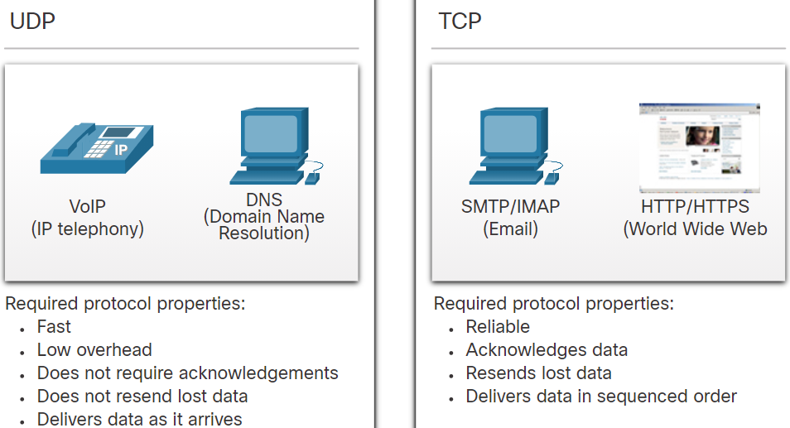

## TCP Overview

* In addition to supporting the basic functions of data segmentation and reassembly, TCP also provides the following services:
  + Establishes a Session - TCP is a connection-oriented protocol that negotiates and establishes a permanent connection (or session) between source and destination devices prior to forwarding any traffic. Through session establishment, the devices negotiate the amount of traffic that can be forwarded at a given time, and the communication data between the two can be closely managed.
  + Ensures Reliable Delivery - For many reasons, it is possible for a segment to become corrupted or lost completely, as it is transmitted over the network. TCP ensures that each segment that is sent by the source arrives at the destination.
  + Provides Same-Order Delivery - Because networks may provide multiple routes that can have different transmission rates, data can arrive in the wrong order. By numbering and sequencing the segments, TCP ensures segments are reassembled into the proper order.
  + Supports Flow Control - Network hosts have limited resources (i.e., memory and processing power). When TCP is aware that these resources are overtaxed, it can request that the sending application reduce the rate of data flow. This is done by TCP regulating the amount of data the source transmits. Flow control can prevent the need for retransmission of the data when the resources of the receiving host are overwhelmed.
* TCP is a stateful protocol which means it keeps track of the state of the communication session. To track the state of a session, TCP records which information it has sent and which information has been acknowledged. The stateful session begins with the session establishment and ends with the session termination.
* A TCP segment adds 10 fields of 20 bytes (i.e., 160 bits) of overhead when encapsulating the application layer data.

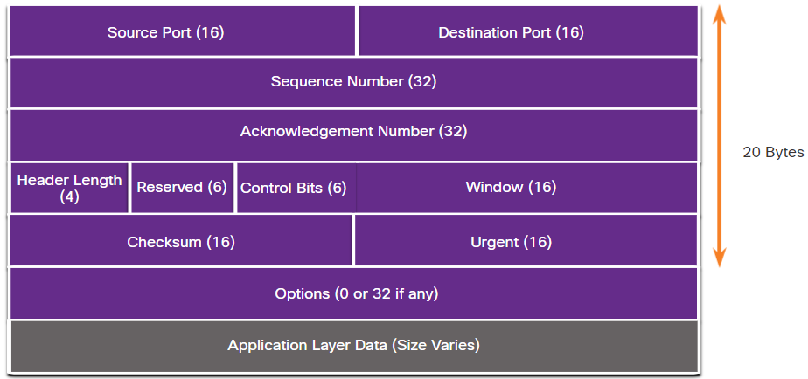

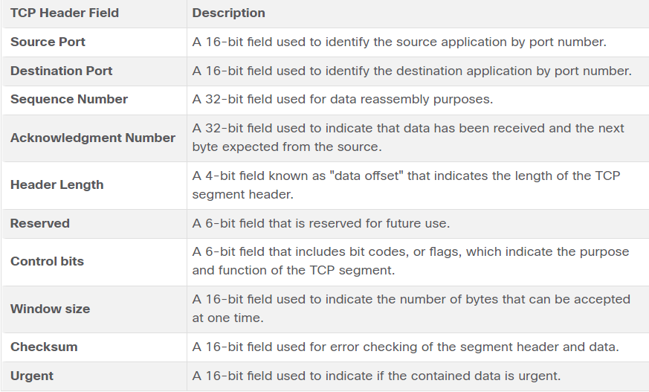

* TCP handles all tasks associated with dividing the data stream into segments, providing reliability, controlling data flow, and reordering segments.

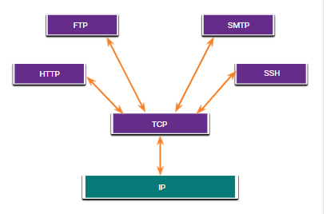

## UDP Overview

* UDP is a lightweight transport protocol that offers the same data segmentation and reassembly as TCP, but without TCP reliability and flow control.
* UDP features include the following:
  + Data is reconstructed in the order that it is received.
  + Any segments that are lost are not resent.
  + There is no session establishment.
  + The sending is not informed about resource availability.
* UDP is a stateless protocol, meaning neither the client, nor the server, tracks the state of the communication session. If reliability is required when using UDP as the transport protocol, it must be handled by the application.
* The blocks of communication in UDP are called datagrams, or segments. These datagrams are sent as best effort by the transport layer protocol.
* The UDP header is far simpler than the TCP header because it only has four fields and requires 8 bytes (i.e., 64 bits).

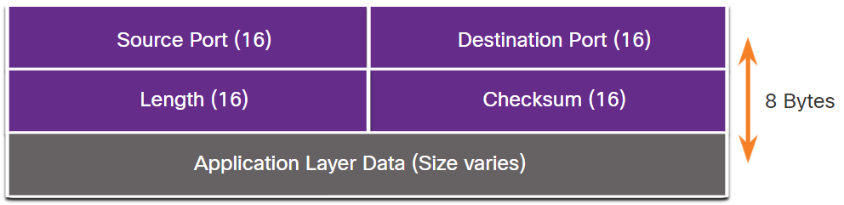

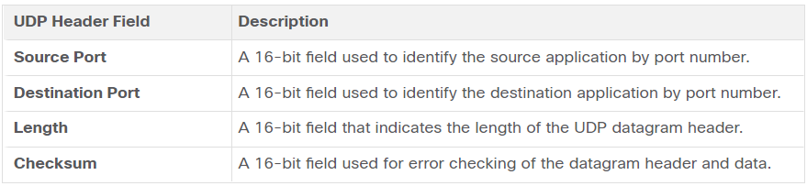

* There are three types of applications that are best suited for UDP:
  + Live video and multimedia applications - These applications can tolerate some data loss, but require little or no delay. Examples include VoIP and live streaming video.
  + Simple request and reply applications - Applications with simple transactions where a host sends a request and may or may not receive a reply. Examples include DNS and DHCP.
  + Applications that handle reliability themselves - Unidirectional communications where flow control, error detection, acknowledgments, and error recovery is not required, or can be handled by the application. Examples include SNMP and TFTP.

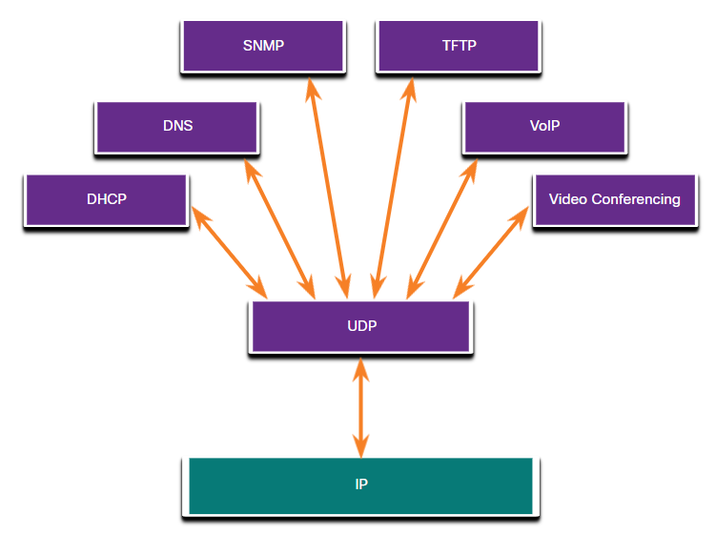

* Although DNS and SNMP use UDP by default, both can also use TCP. DNS will use TCP if the DNS request or DNS response is more than 512 bytes, such as when a DNS response includes many name resolutions. Similarly, under some situations the network administrator may want to configure SNMP to use TCP.

## Port Numbers

* TCP and UDP transport layer protocols use port numbers to manage multiple, simultaneous conversations.
* The source port number is associated with the originating application on the local host whereas the destination port number is associated with the destination application on the remote host.
* For instance, assume a host is initiating a web page request from a web server. When the host initiates the web page request, the source port number is dynamically generated by the host to uniquely identify the conversation. Each request generated by a host will use a different dynamically created source port number. This process allows multiple conversations to occur simultaneously.
* In the request, the destination port number is what identifies the type of service being requested of the destination web server.. For example, when a client specifies port 80 in the destination port, the server that receives the message knows that web services are being requested.
* A server can offer more than one service simultaneously such as web services on port 80 while it offers File Transfer Protocol (FTP) connection establishment on port 21.
* The source and destination ports are placed within the segment. The segments are then encapsulated within an IP packet. The IP packet contains the IP address of the source and destination. The combination of the source IP address and source port number, or the destination IP address and destination port number is known as a socket.
  + The socket is used to identify the server and service being requested by the client.
  + A client socket might look like this, with 1099 representing the source port number: 192.168.1.5:1099
  + The socket on a web server might be 192.168.1.7:80
  + Together, these two sockets combine to form a socket pair: 192.168.1.5:1099, 192.168.1.7:80
  + Sockets enable multiple processes, running on a client, to distinguish themselves from each other, and multiple connections to a server process to be distinguished from each other.
  + The source port number acts as a return address for the requesting application. The transport layer keeps track of this port and the application that initiated the request so that when a response is returned, it can be forwarded to the correct application.
* The Internet Assigned Numbers Authority (IANA) is the standards organization responsible for assigning various addressing standards, including the 16-bit port numbers. The 16 bits used to identify the source and destination port numbers provides a range of ports from 0 through 65535.

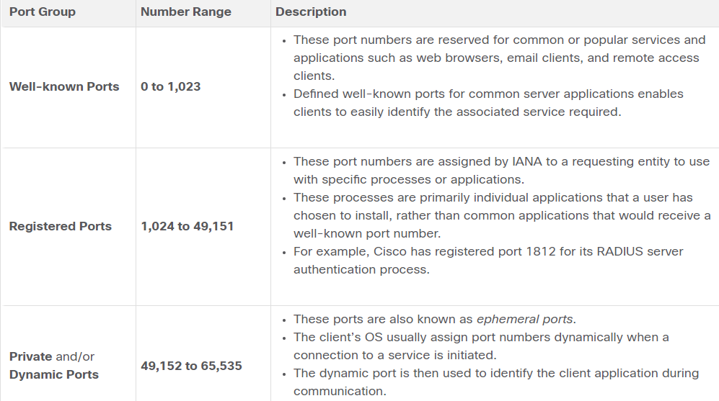

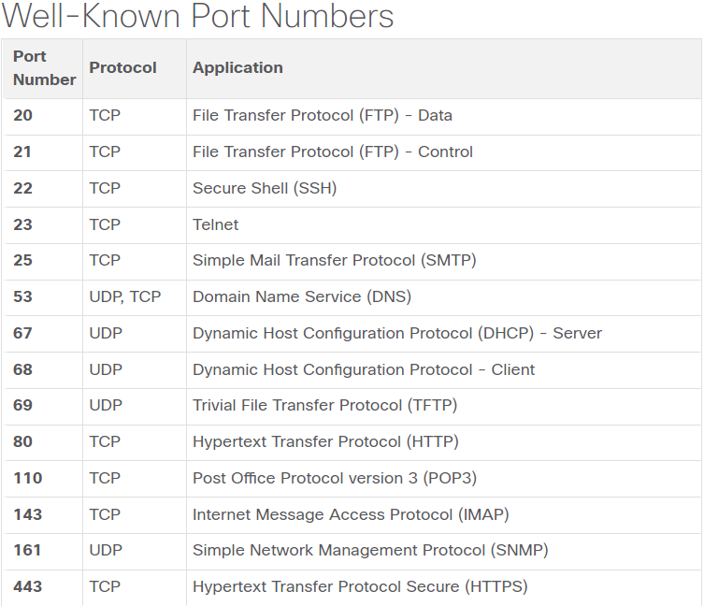

* Unexplained TCP connections can pose a major security threat. They can indicate that something or someone is connected to the local host. Sometimes it is necessary to know which active TCP connections are open and running on a networked host. Netstat is an important network utility that can be used to verify those connections. As shown below, enter the command **netstat** to list the protocols in use, the local address and port numbers, the foreign address and port numbers, and the connection state.
  + The -n option can be used to display IP addresses and port numbers in their numerical form.

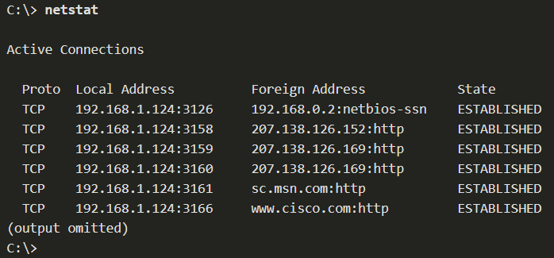

## TCP Communication Process

* Each application process running on a server is configured to use a port number. The port number is either automatically assigned or configured manually by a system administrator.
* An individual server cannot have two services assigned to the same port number within the same transport layer services.
  + For example, a host running a web server application and a file transfer application cannot have both configured to use the same port, such as TCP port 80.
* An active server application assigned to a specific port is considered open, which means that the transport layer accepts, and processes segments addressed to that port. Any incoming client request addressed to the correct socket is accepted, and the data is passed to the server application. There can be many ports open simultaneously on a server, one for each active server application.
* TCP connection establishment:
  + In TCP connections, the host client establishes the connection with the server using the three-way handshake process.
  + Step 1. SYN: The initiating client requests a client-to-server communication session with the server.
  + Step 2. ACK and SYN: The server acknowledges the client-to-server communication session and requests a server-to-client communication session.
  + Step 3. ACK: The initiating client acknowledges the server-to-client communication session.

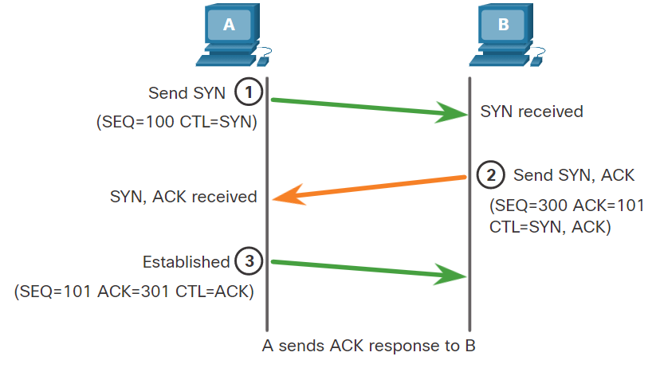

* TCP session termination:
  + To close a connection, the Finish (FIN) control flag must be set in the segment header.
  + Step 1. FIN: When the client has no more data to send in the stream, it sends a segment with the FIN flag set.
  + Step 2. ACK: The server sends an ACK to acknowledge the receipt of the FIN to terminate the session from client to server.
  + Step 3. FIN: The server sends a FIN to the client to terminate the server-to-client session.
  + Step 3. ACK: The client responds with an ACK to acknowledge the FIN from the server.

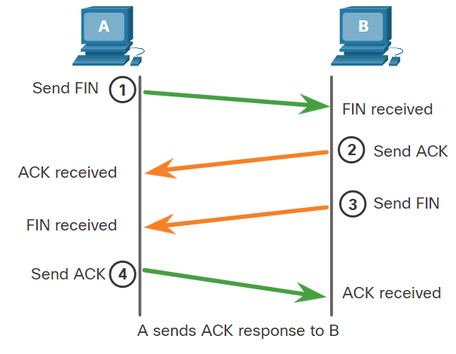

* Hosts maintain state, track each data segment within a session, and exchange information about what data is received using the information in the TCP header. TCP is a full-duplex protocol, where each connection represents two one-way communication sessions. To establish the connection, the hosts perform a three-way handshake. Control bits in the TCP header indicate the progress and status of the connection.
* These are the functions of the three-way handshake:
  + It establishes that the destination device is present on the network.
  + It verifies that the destination device has an active service and is accepting requests on the destination port number that the initiating client intends to use.
  + It informs the destination device that the source client intends to establish a communication session on that port number.
* After the communication is completed the sessions are closed, and the connection is terminated. The connection and session mechanisms enable TCP reliability function.

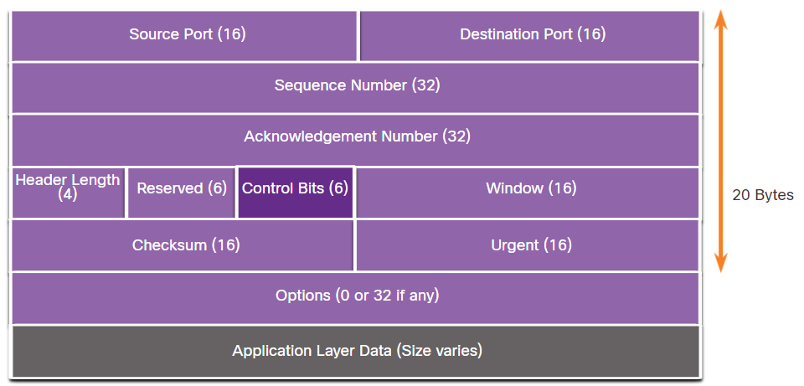

* The six bits in the Control Bits field of the TCP segment header are also known as flags. A flag is a bit that is set to either on or off.
* The six control bits flags are as follows:
  + URG - Urgent pointer field significant
  + ACK - Acknowledgment flag used in connection establishment and session termination
  + PSH - Push function
  + RST - Reset the connection when an error or timeout occurs
  + SYN - Synchronize sequence numbers used in connection establishment
  + FIN - No more data from sender and used in session termination

## Reliability and Flow Control

* The reason that TCP is the better protocol for some applications is because, unlike UDP, it resends dropped packets and numbers packets to indicate their proper order before delivery. TCP can also help maintain the flow of packets so that devices do not become overloaded.
* There may be times when TCP segments do not arrive at their destination or arrive out of order. All the data must be received and the data in these segments must be reassembled into the original order. Sequence numbers are assigned in the header of each packet to achieve this goal.
* During session setup, an initial sequence number (ISN) is set. This ISN represents the starting value of the bytes that are transmitted to the receiving application. As data is transmitted during the session, the sequence number is incremented by the number of bytes that have been transmitted. This data byte tracking enables each segment to be uniquely identified and acknowledged. Missing segments can then be identified.
  + The ISN does not begin at one but is effectively a random number. This is to prevent certain types of malicious attacks.

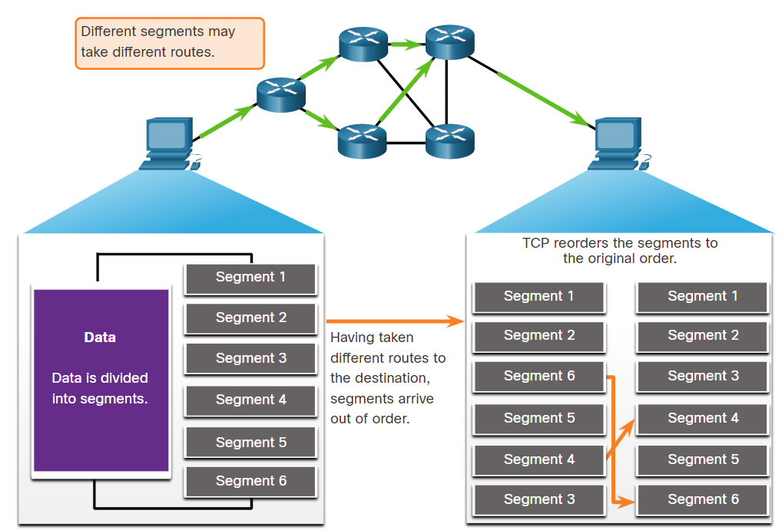

* + The receiving TCP process places the data from a segment into a receiving buffer. Segments are then placed in the proper sequence order and passed to the application layer when reassembled.
* No matter how well designed a network is, data loss occasionally occurs. TCP provides methods of managing these segment losses. Among these is a mechanism to retransmit segments for unacknowledged data.
  + The sequence (SEQ) number and acknowledgement (ACK) number are used together to confirm receipt of the bytes of data contained in the transmitted segments. The SEQ number identifies the first byte of data in the segment being transmitted. TCP uses the ACK number sent back to the source to indicate the next byte that the receiver expects to receive. This is called expectational acknowledgement.
  + Prior to later enhancements, TCP could only acknowledge the next byte expected. For example, in the figure, using segment numbers for simplicity, host A sends segments 1 through 10 to host B. If all the segments arrive except for segments 3 and 4, host B would reply with acknowledgment specifying that the next segment expected is segment 3. Host A has no idea if any other segments arrived or not. Host A would, therefore, resend segments 3 through 10. If all the resent segments arrived successfully, segments 5 through 10 would be duplicates. This can lead to delays, congestion, and inefficiencies.

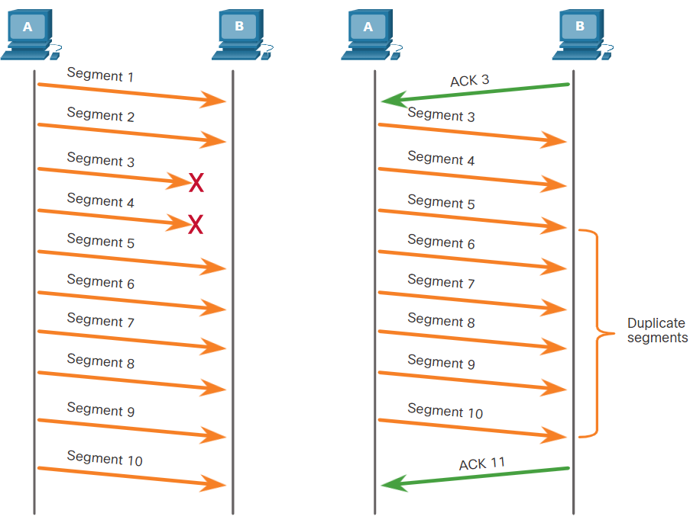

* + Host operating systems today typically employ an optional TCP feature called selective acknowledgment (SACK), negotiated during the three-way handshake. If both hosts support SACK, the receiver can explicitly acknowledge which segments (bytes) were received including any discontinuous segments. The sending host would therefore only need to retransmit the missing data.
  + For example, in the next figure, again using segment numbers for simplicity, host A sends segments 1 through 10 to host B. If all the segments arrive except for segments 3 and 4, host B can acknowledge that it has received segments 1 and 2 (ACK 3), and selectively acknowledge segments 5 through 10 (SACK 5-10). Host A would only need to resend segments 3 and 4.

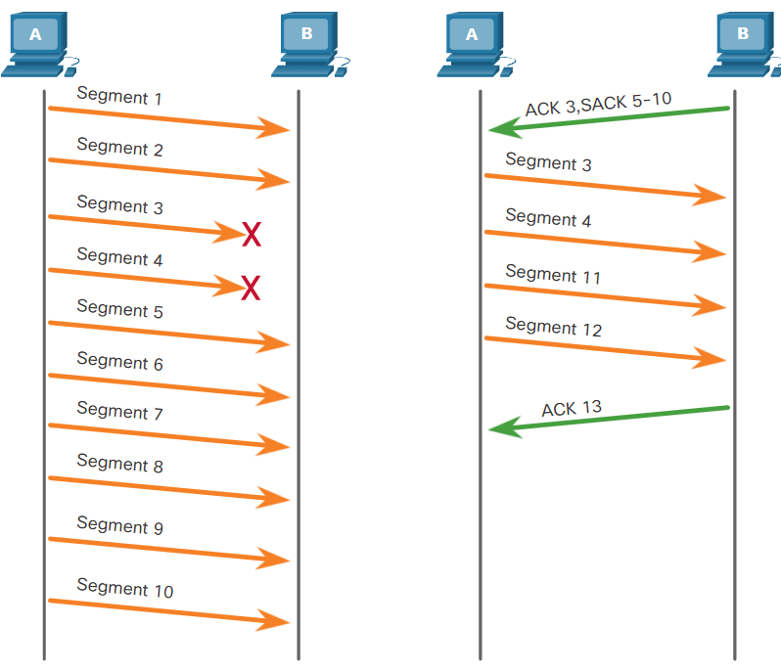

* TCP uses timers to know how long to wait before resending a segment.
* TCP also provides mechanisms for flow control. Flow control is the amount of data that the destination can receive and process reliably. Flow control helps maintain the reliability of TCP transmission by adjusting the rate of data flow between source and destination for a given session. To accomplish this, the TCP header includes a 16-bit field called the window size.

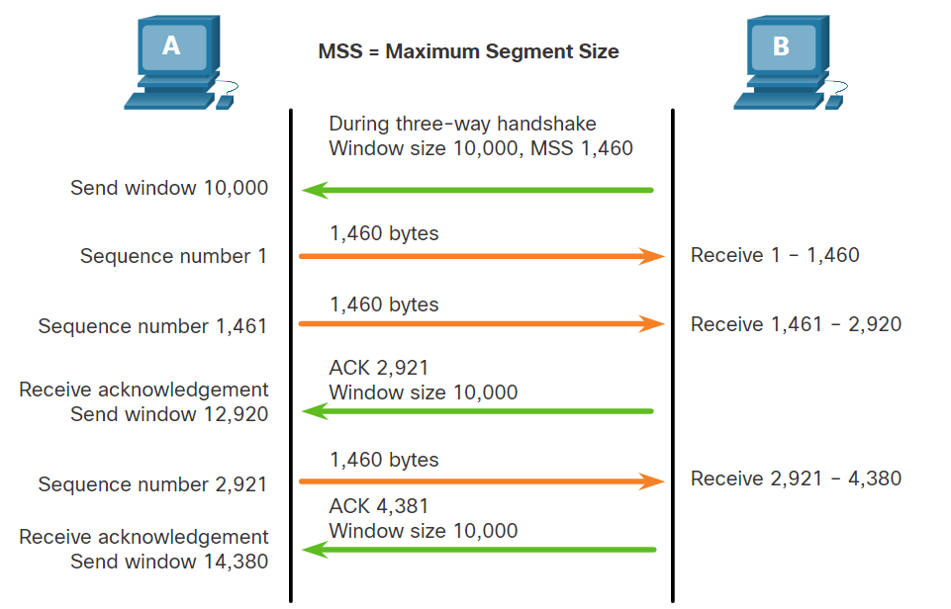

* + The window size determines the number of bytes that can be sent before expecting an acknowledgment. The acknowledgment number is the number of the next expected byte.
  + The window size is the number of bytes that the destination device of a TCP session can accept and process at one time. In this example, the PC B initial window size for the TCP session is 10,000 bytes. Starting with the first byte, byte number 1, the last byte PC A can send without receiving an acknowledgment is byte 10,000. This is known as the send window of PC A. The window size is included in every TCP segment so the destination can modify the window size at any time depending on buffer availability.
  + The initial window size is agreed upon when the TCP session is established during the three-way handshake. The source device must limit the number of bytes sent to the destination device based on the window size of the destination. Only after the source device receives an acknowledgment that the bytes have been received, can it continue sending more data for the session. Typically, the destination will not wait for all the bytes for its window size to be received before replying with an acknowledgment. As the bytes are received and processed, the destination will send acknowledgments to inform the source that it can continue to send additional bytes.
  + For example, it is typical that PC B would not wait until all 10,000 bytes have been received before sending an acknowledgment. This means PC A can adjust its send window as it receives acknowledgments from PC B. As shown in the figure, when PC A receives an acknowledgment with the acknowledgment number 2,921, which is the next expected byte. The PC A send window will increment 2,920 bytes. This changes the send window from 10,000 bytes to 12,920. PC A can now continue to send up to another 10,000 bytes to PC B as long as it does not send more than its new send window at 12,920.
  + A destination sending acknowledgments as it processes bytes received, and the continual adjustment of the source send window, is known as sliding windows. In the previous example, the send window of PC A increments or slides over another 2,921 bytes from 10,000 to 12,920.
  + If the availability of the destination’s buffer space decreases, it may reduce its window size to inform the source to reduce the number of bytes it should send without receiving an acknowledgment.
  + the source is transmitting 1,460 bytes of data within each TCP segment. This is typically the Maximum Segment Size (MSS) that the destination device can receive. The MSS is part of the options field in the TCP header that specifies the largest amount of data, in bytes, that a device can receive in a single TCP segment. The MSS size does not include the TCP header. The MSS is typically included during the three-way handshake.
  + A common MSS is 1,460 bytes when using IPv4. A host determines the value of its MSS field by subtracting the IP and TCP headers from the Ethernet maximum transmission unit (MTU). On an Ethernet interface, the default MTU is 1500 bytes. Subtracting the IPv4 header of 20 bytes and the TCP header of 20 bytes, the default MSS size will be 1460 bytes.

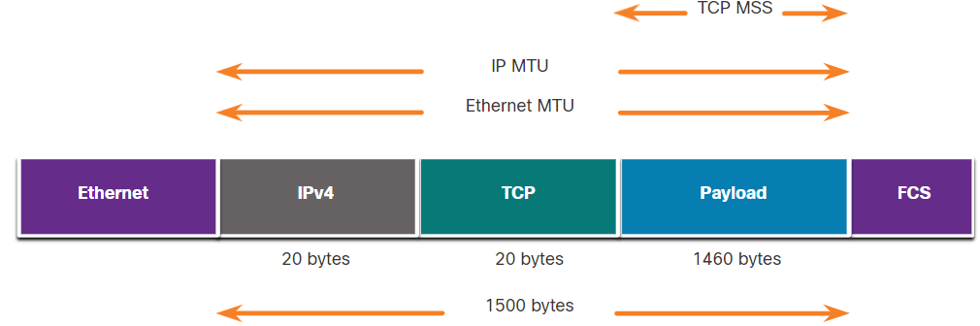

* When congestion occurs on a network, it results in packets being discarded by the overloaded router.
  + To avoid and control congestion, TCP employs several congestion handling mechanisms, timers, and algorithms.
  + If the source determines that the TCP segments are either not being acknowledged or not acknowledged in a timely manner, then it can reduce the number of bytes it sends before receiving an acknowledgment. As illustrated in the figure, PC A senses there is congestion and therefore, reduces the number of bytes it sends before receiving an acknowledgment from PC B.
  + Notice that it is the source that is reducing the number of unacknowledged bytes it sends and not the window size determined by the destination.

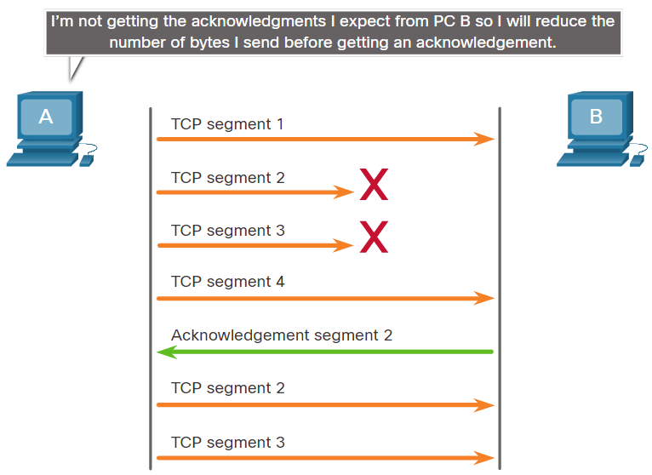

## UDP Communication

* UDP does not establish a connection. UDP provides low overhead data transport because it has a small datagram header and no network management traffic.
* UDP datagram reassembly:
  + UDP does not track sequence numbers the way TCP does.
  + UDP has no way to reorder the datagrams into their transmission order.
  + UDP simply reassembles the data in the order that it was received and forwards it to the application.
* UDP Server Processes and Requests:
  + UDP-based server applications are assigned well-known or registered port numbers.
  + UDP receives a datagram destined for one of these ports, it forwards the application data to the appropriate application based on its port number.
* UDP client process:
  + As with TCP, client-server communication is initiated by a client application that requests data from a server process. The UDP client process dynamically selects a port number from the range of port numbers and uses this as the source port for the conversation. The destination port is usually the well-known or registered port number assigned to the server process.
  + After a client has selected the source and destination ports, the same pair of ports are used in the header of all datagrams in the transaction. For the data returning to the client from the server, the source and destination port numbers in the datagram header are reversed.

# Application layer

## Application, Presentation and Session

* The upper three layers of the OSI model (application, presentation, and session) define functions of the TCP/IP application layer.
* The application layer provides the interface between the applications used to communicate, and the underlying network over which messages are transmitted.
* Some of the most widely known application layer protocols include Hypertext Transfer Protocol (HTTP), File Transfer Protocol (FTP), Trivial File Transfer Protocol (TFTP), Internet Message Access Protocol (IMAP), and Domain Name System (DNS) protocol.
* The presentation layer has three primary functions:
  + Formatting, or presenting, data at the source device into a compatible format for receipt by the destination device.
  + Compressing data in a way that can be decompressed by the destination device.
  + Encrypting data for transmission and decrypting data upon receipt.

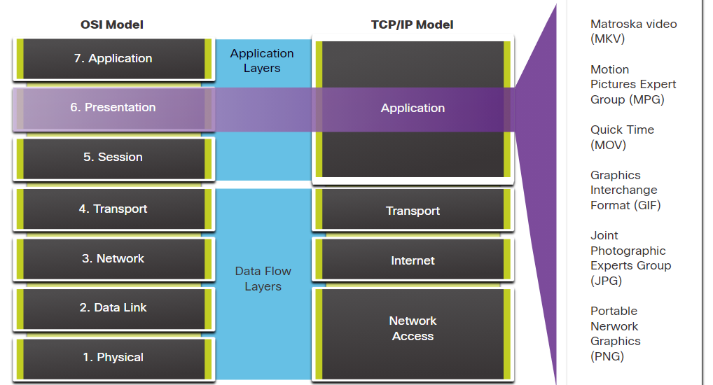

* The session layer functions:
  + It creates and maintains dialogs between source and destination applications.
  + It handles the exchange of information to initiate dialogs, keep them active, and to restart sessions that are disrupted or idle for a long period of time.
* The TCP/IP application protocols specify the format and control information necessary for many common internet communication functions. Application layer protocols are used by both the source and destination devices during a communication session. For the communications to be successful, the application layer protocols that are implemented on the source and destination host must be compatible.
  + Name System
    - DNS - Domain Name System (or Service)
      * TCP, UDP client 53
      * Translates domain names, such as cisco.com, into IP addresses.
  + Host Config
    - BOOTP - Bootstrap Protocol
      * UDP client 68, server 67
      * Enables a diskless workstation to discover its own IP address, the IP address of a BOOTP server on the network, and a file to be loaded into memory to boot the machine
      * BOOTP is being superseded by DHCP
    - DHCP - Dynamic Host Configuration Protocol
      * UDP client 68, server 67
      * Dynamically assigns IP addresses to be re-used when no longer needed
  + Email
    - SMTP - Simple Mail Transfer Protocol
      * TCP 25
      * Enables clients to send email to a mail server
      * Enables servers to send email to other servers
    - POP3 - Post Office Protocol
      * TCP 110
      * Enables clients to retrieve email from a mail server
      * Downloads the email to the local mail application of the client
    - IMAP - Internet Message Access Protocol
      * TCP 143
      * Enables clients to access email stored on a mail server
      * Maintains email on the server
  + File Transfer
    - FTP - File Transfer Protocol
      * TCP 20 to 21
      * Sets rules that enable a user on one host to access and transfer files to and from another host over a network
      * FTP is a reliable, connection-oriented, and acknowledged file delivery protocol
    - TFTP - Trivial File Transfer Protocol
      * UDP client 69
      * A simple, connectionless file transfer protocol with best-effort, unacknowledged file delivery
      * It uses less overhead than FTP
  + Web
    - HTTP - Hypertext Transfer Protocol
      * TCP 80, 8080
      * A set of rules for exchanging text, graphic images, sound, video, and other multimedia files on the World Wide Web
    - HTTPS - HTTP Secure
      * TCP, UDP 443
      * The browser uses encryption to secure HTTP communications
      * Authenticates the website to which you are connecting your browser

## Peer-To-Peer

* In the client/server model, the device requesting the information is called a client and the device responding to the request is called a server.
* Client and server processes are considered to be in the application layer.
* Application layer protocols describe the format of the requests and responses between clients and servers.
* The client begins the exchange by requesting data from the server, which responds by sending one or more streams of data to the client. In addition to the actual data transfer, this exchange may also require user authentication and the identification of a data file to be transferred.
* Data transfer from a client to a server is referred to as an upload and data from a server to a client as a download.
* In a P2P network, two or more computers are connected via a network and can share resources (such as printers and files) without having a dedicated server.
  + Every connected end device (known as a peer) can function as both a server and a client.
  + One computer might assume the role of server for one transaction while simultaneously serving as a client for another. The roles of client and server are set on a per request basis.

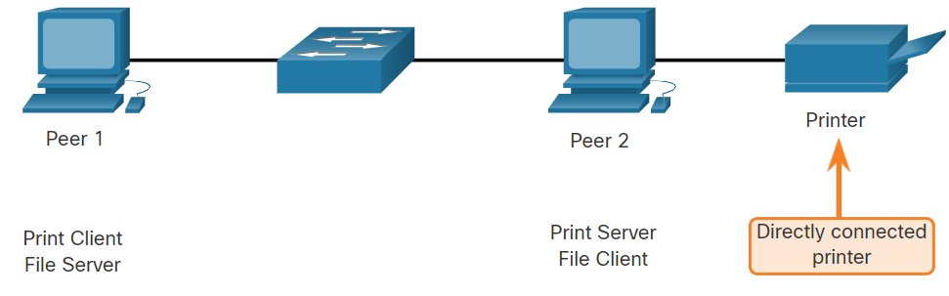

* A P2P application allows a device to act as both a client and a server within the same communication.
  + P2P applications require that each end device provide a user interface and run a background service.
  + Some P2P applications use a hybrid system where resource sharing is decentralized, but the indexes that point to resource locations are stored in a centralized directory. In a hybrid system, each peer accesses an index server to get the location of a resource stored on another peer.
* With P2P applications, each computer in the network that is running the application can act as a client or a server for the other computers in the network that are also running the application. Common P2P networks include the following:
  + BitTorrent
  + Direct Connect
  + eDonkey
  + Freenet
* Many P2P applications allow users to share pieces of many files with each other at the same time. Clients use a torrent file to locate other users who have pieces that they need so that they can then connect directly to them. This file also contains information about tracker computers that keep track of which users have specific pieces of certain files. Clients ask for pieces from multiple users at the same time. This is known as a swarm and the technology is called BitTorrent.
* Some P2P applications are based on the Gnutella protocol, where each user shares whole files with other users.

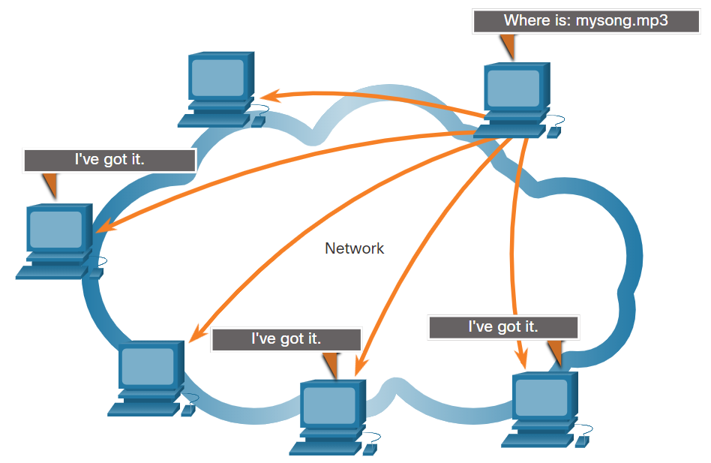

## Web and Email Protocols

* When a web address or Uniform Resource Locator (URL) is typed into a web browser, the web browser establishes a connection to the web service. The web service is running on the server that is using the HTTP protocol. URLs and Uniform Resource Identifiers (URIs) are the names most people associate with web addresses.
* Step 1:
  + The browser interprets the three parts of the URL:
    - http (the protocol or scheme)
    - www.cisco.com (the server name)
    - index.html (the specific filename requested)

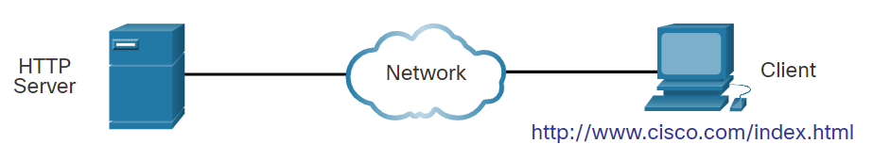

* Step 2:
  + The browser then checks with a name server to convert www.cisco.com into a numeric IP address, which it uses to connect to the server. The client initiates an HTTP request to a server by sending a GET request to the server and asks for the index.html file.
* Step 3:
  + In response to the request, the server sends the HTML code for this web page to the browser.
* Step 4:
  + The browser deciphers the HTML code and formats the page for the browser window.
* HTTP is a request/response protocol that specifies the message types used for that communication.
* The three common message types are GET, POST, and PUT:
  + GET - This is a client request for data. A client (web browser) sends the GET message to the web server to request HTML pages.
  + POST - This uploads data files to the web server, such as form data.
  + PUT - This uploads resources or content to the web server, such as an image.
* Although HTTP is remarkably flexible, it is not a secure protocol. The request messages send information to the server in plaintext that can be intercepted and read. The server responses, typically HTML pages, are also unencrypted.
* For secure communication across the internet, the HTTP Secure (HTTPS) protocol is used. HTTPS uses authentication and encryption to secure data as it travels between the client and server. HTTPS uses the same client request-server response process as HTTP, but the data stream is encrypted with Transport Layer Security (TLS) or its predecessor Secure Socket Layer (SSL) before being transported across the network.
* Email is a store-and-forward method of sending, storing, and retrieving electronic messages across a network. Email messages are stored in databases on mail servers.
* Email clients communicate with mail servers to send and receive email. Mail servers communicate with other mail servers to transport messages from one domain to another. An email client does not communicate directly with another email client when sending email. Instead, both clients rely on the mail server to transport messages.
* Email supports three separate protocols for operation: Simple Mail Transfer Protocol (SMTP), Post Office Protocol (POP), and IMAP. The application layer process that sends mail uses SMTP. A client retrieves email using one of the two application layer protocols: POP or IMAP.

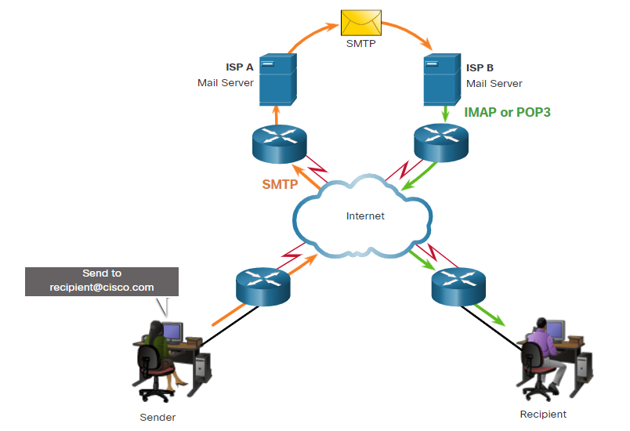

* SMTP:
  + SMTP message formats require a message header and a message body. Although the message body can contain any amount of text, the message header must have a properly formatted recipient email address and a sender address.
  + When a client sends email, the client SMTP process connects with a server SMTP process on well-known port 25. After the connection is made, the client attempts to send the email to the server across the connection. When the server receives the message, it either places the message in a local account, if the recipient is local, or forwards the message to another mail server for delivery.
  + The destination email server may not be online, or may be busy, when email messages are sent. Therefore, SMTP spools messages to be sent at a later time. Periodically, the server checks the queue for messages and attempts to send them again. If the message is still not delivered after a predetermined expiration time, it is returned to the sender as undeliverable.

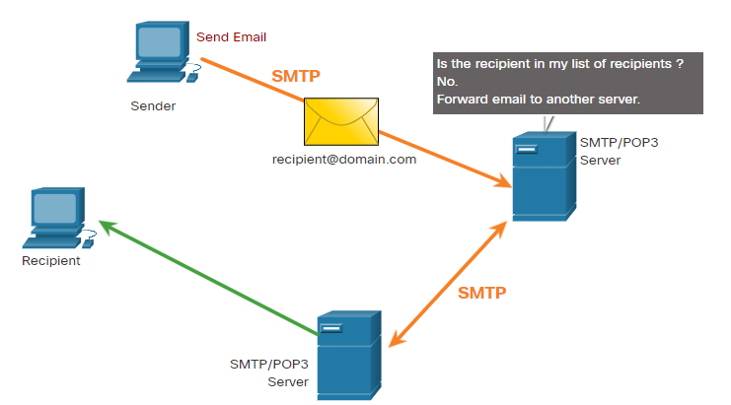

* POP:
  + POP is used by an application to retrieve mail from a mail server. With POP, mail is downloaded from the server to the client and then deleted on the server. This is the default operation of POP.
  + The server starts the POP service by passively listening on TCP port 110 for client connection requests. When a client wants to make use of the service, it sends a request to establish a TCP connection with the server. When the connection is established, the POP server sends a greeting. The client and POP server then exchange commands and responses until the connection is closed or aborted.
  + With POP, email messages are downloaded to the client and removed from the server, so there is no centralized location where email messages are kept. Because POP does not store messages, it is not recommended for a small business that needs a centralized backup solution.
  + POP3 is the most commonly used version.

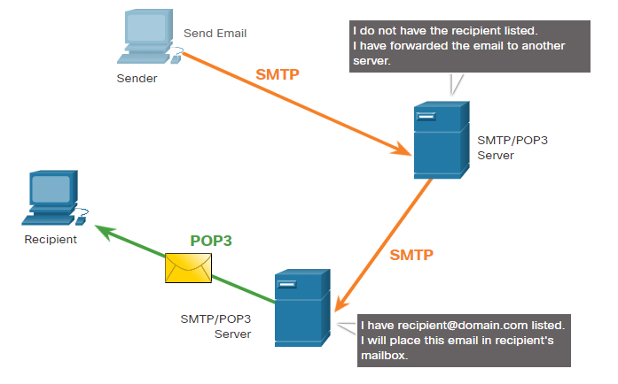

* IMAP:
  + IMAP is another protocol that describes a method to retrieve email messages. Unlike POP, when the user connects to an IMAP-capable server, copies of the messages are downloaded to the client application, as shown in the figure. The original messages are kept on the server until manually deleted. Users view copies of the messages in their email client software.
  + Users can create a file hierarchy on the server to organize and store mail. That file structure is duplicated on the email client as well. When a user decides to delete a message, the server synchronizes that action and deletes the message from the server.

## IP Addressing Services

* Domain names were created to convert the numeric IP addresses into a simple, recognizable name.
* On the internet, fully-qualified domain names (FQDNs), such as http://www.cisco.com, are much easier for people to remember than 198.133.219.25, which is the actual numeric address for this server. If Cisco decides to change the numeric address of www.cisco.com, it is transparent to the user because the domain name remains the same.
* The DNS protocol defines an automated service that matches resource names with the required numeric network address. It includes the format for queries, responses, and data. The DNS protocol communications use a single format called a message. This message format is used for all types of client queries and server responses, error messages, and the transfer of resource record information between servers.
  + Step 1: The user types an FQDN into a browser application Address field.
  + Step 2: A DNS query is sent to the designated DNS server for the client computer.
  + Step 3: The DNS server matches the FQDN with its IP address.
  + Step 4: The DNS query response is sent back to the client with the IP address for the FQDN.
  + Step 5: The client computer uses the IP address to make requests of the server.
* The DNS server stores different types of resource records that are used to resolve names. These records contain the name, address, and type of record. Some of these record types are as follows:
  + A - An end device IPv4 address
  + NS - An authoritative name server
  + AAAA - An end device IPv6 address (pronounced quad-A)
  + MX - A mail exchange record
* When a client makes a query, the server DNS process first looks at its own records to resolve the name. If it is unable to resolve the name by using its stored records, it contacts other servers to resolve the name. After a match is found and returned to the original requesting server, the server temporarily stores the numbered address in the event that the same name is requested again.
* The DNS cient service on Windows PCs also stores previously resolved names in memory. The ipconfig /displaydns command displays all of the cached DNS entries.
* DNS uses the same message format between servers, consisting of a question, answer, authority, and additional information for all types of client queries and server responses, error messages, and transfer of resource record information.

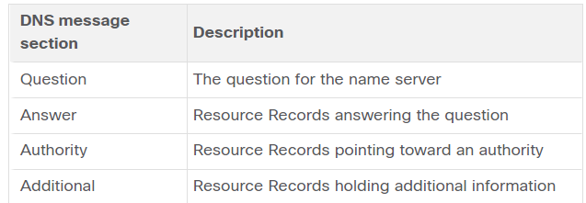

* DNS uses a hierarchical system to create a database to provide name resolution.
* The naming structure is broken down into small, manageable zones. Each DNS server maintains a specific database file and is only responsible for managing name-to-IP mappings for that small portion of the entire DNS structure. When a DNS server receives a request for a name translation that is not within its DNS zone, the DNS server forwards the request to another DNS server within the proper zone for translation.
* DNS is scalable because hostname resolution is spread across multiple servers.
* The different top-level domains represent either the type of organization or the country of origin. Examples of top-level domains are the following:
  + .com - a business or industry
  + .org - a non-profit organization

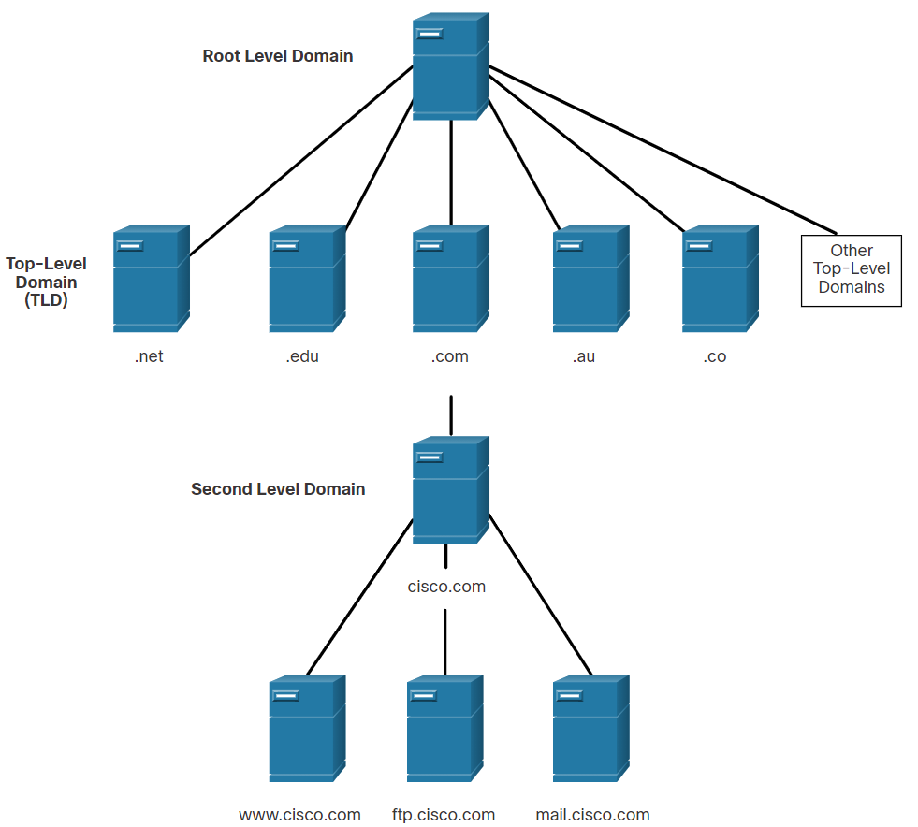

* When configuring a network device, one or more DNS Server addresses are provided that the DNS client can use for name resolution. Usually the ISP provides the addresses to use for the DNS servers. When a user application requests to connect to a remote device by name, the requesting DNS client queries the name server to resolve the name to a numeric address.
* Computer operating systems also have a utility called Nslookup that allows the user to manually query the name servers to resolve a given host name. This utility can also be used to troubleshoot name resolution issues and to verify the current status of the name servers.
* When the **nslookup** command is issued, the default DNS server configured for your host is displayed.
* The name of a host or domain can be entered at the nslookup prompt.



* The Dynamic Host Configuration Protocol (DHCP) for IPv4 service automates the assignment of IPv4 addresses, subnet masks, gateways, and other IPv4 networking parameters. This is referred to as dynamic addressing. The alternative to dynamic addressing is static addressing. When using static addressing, the network administrator manually enters IP address information on hosts.
* When a host connects to the network, the DHCP server is contacted, and an address is requested. The DHCP server chooses an address from a configured range of addresses called a pool and assigns (leases) it to the host.
* On larger networks, or where the user population changes frequently, DHCP is preferred for address assignment. New users may arrive and need connections; others may have new computers that must be connected. Rather than use static addressing for each connection, it is more efficient to have IPv4 addresses assigned automatically using DHCP.
* DHCP can allocate IP addresses for a configurable period of time, called a lease period. The lease period is an important DHCP setting, When the lease period expires or the DHCP server gets a DHCPRELEASE message the address is returned to the DHCP pool for reuse. Users can freely move from location to location and easily re-establish network connections through DHCP.
* Many networks use both DHCP and static addressing. DHCP is used for general purpose hosts, such as end user devices. Static addressing is used for network devices, such as gateway routers, switches, servers, and printers.
* DHCP for IPv6 (DHCPv6) provides similar services for IPv6 clients. One important difference is that DHCPv6 does not provide a default gateway address. This can only be obtained dynamically from the Router Advertisement message of the router.

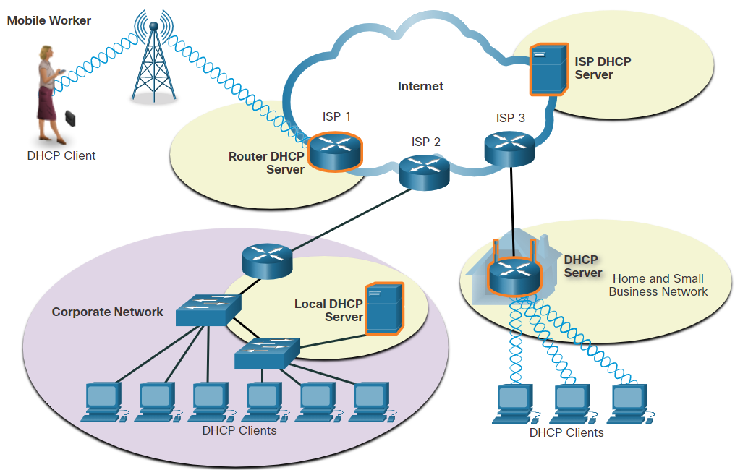

* The DHCP Process:
  + When an IPv4, DHCP-configured device boots up or connects to the network, the client broadcasts a DHCP discover (DHCPDISCOVER) message to identify any available DHCP servers on the network.
  + A DHCP server replies with a DHCP offer (DHCPOFFER) message, which offers a lease to the client. (If a client receives more than one offer due to multiple DHCP servers on the network, it must choose one.)
  + The client sends a DHCP request (DHCPREQUEST) message that identifies the explicit server and lease offer that the client is accepting.
  + The server then returns a DHCP acknowledgment (DHCPACK) message that acknowledges to the client that the lease has been finalized.
  + If the offer is no longer valid, then the selected server responds with a DHCP negative acknowledgment (DHCPNAK) message and the process must begin with a new DHCPDISCOVER message.

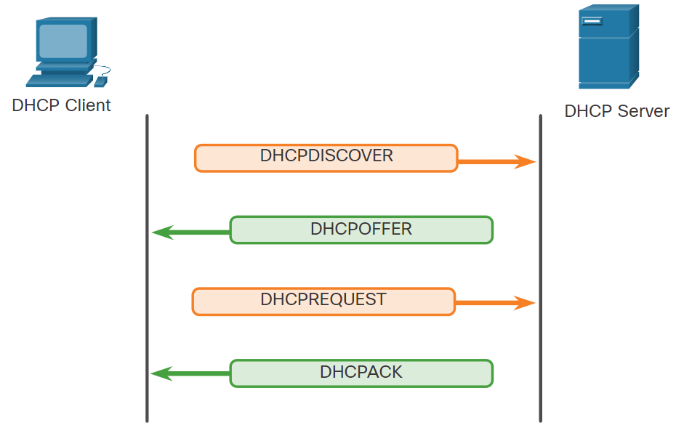

* Note: DHCPv6 has a set of messages that is similar to those for DHCPv4. The DHCPv6 messages are SOLICIT, ADVERTISE, INFORMATION REQUEST, and REPLY.

## File Sharing Services

* FTP was developed to allow for data transfers between a client and a server. An FTP client is an application which runs on a computer that is being used to push and pull data from an FTP server.

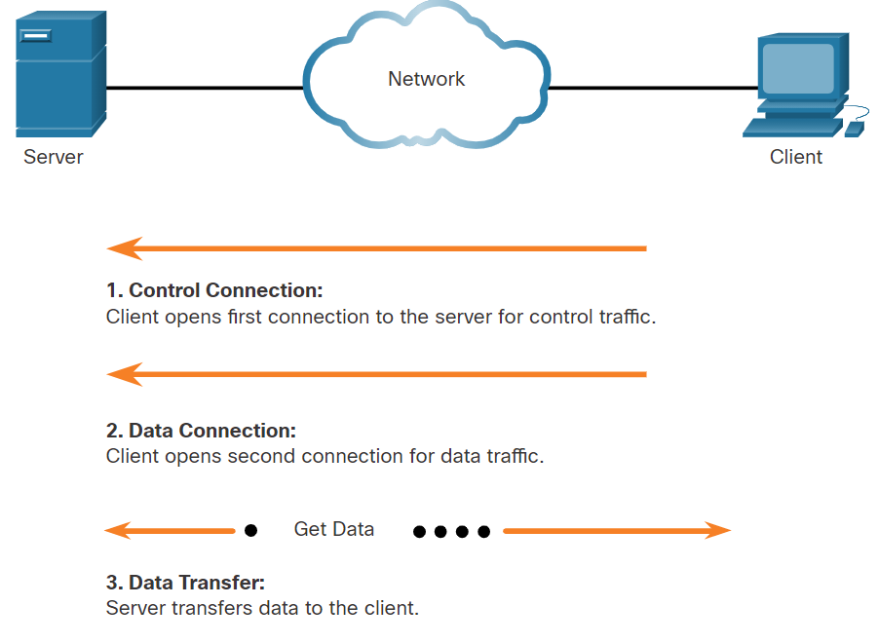

* + Step 1 - The client establishes the first connection to the server for control traffic using TCP port 21. The traffic consists of client commands and server replies.
  + Step 2 - The client establishes the second connection to the server for the actual data transfer using TCP port 20. This connection is created every time there is data to be transferred.
  + Step 3 - The data transfer can happen in either direction. The client can download (pull) data from the server, or the client can upload (push) data to the server.
* The Server Message Block (SMB) is a client/server file sharing protocol that describes the structure of shared network resources, such as directories, files, printers, and serial ports. It is a request-response protocol. All SMB messages share a common format. This format uses a fixed-sized header, followed by a variable-sized parameter and data component.
* Here are three functions of SMB messages:
  + Start, authenticate, and terminate sessions.
  + Control file and printer access.
  + Allow an application to send or receive messages to or from another device.
* SMB file-sharing and print services have become the mainstay of Microsoft networking.
* Unlike the file sharing supported by FTP, clients establish a long-term connection to servers. After the connection is established, the user of the client can access the resources on the server as though the resource is local to the client host.
* The LINUX and UNIX operating systems also provide a method of sharing resources with Microsoft networks by using a version of SMB called SAMBA. The Apple Macintosh operating systems also support resource sharing by using the SMB protocol.

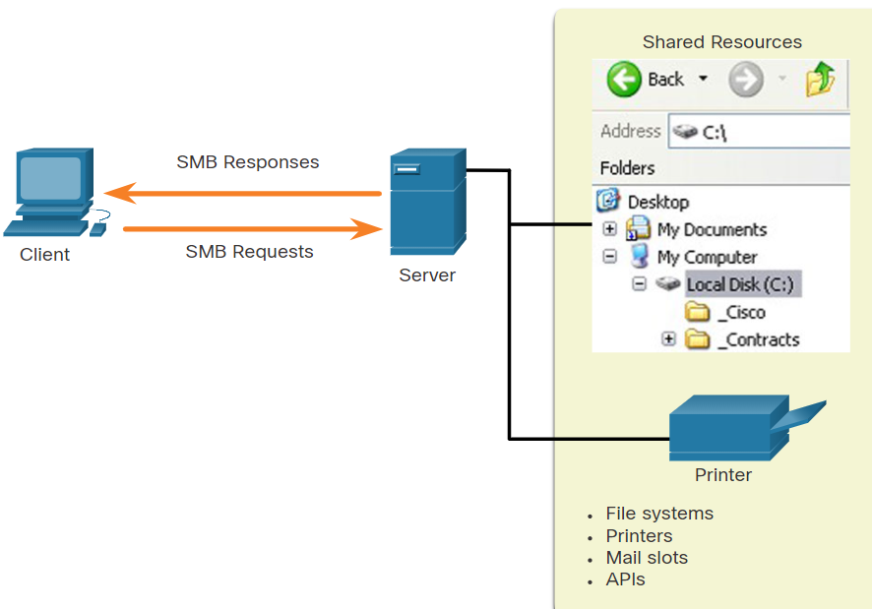

1. Network security fundamentals
   1. Security Threats and Vulnerabilities

* Attacks on a network can be devastating and can result in a loss of time and money due to damage, or theft of important information or assets. Intruders can gain access to a network through software vulnerabilities, hardware attacks, or through guessing someone's username and password. Intruders who gain access by modifying software or exploiting software vulnerabilities are called threat actors.
* After the threat actor gains access to the network, four types of threats may arise:
  + Information Theft: breaking into a computer to obtain confidential information.
  + Data Loss and manipulation: breaking into a computer to destroy or alter data records.
  + Identity Theft: information theft where personal information is stolen for the purpose of taking over the identity of someone.
  + Disruption of Service: preventing legitimate users from accessing services to which they are entitled.
* Vulnerability is the degree of weakness in a network or a device. Some degree of vulnerability is inherent in routers, switches, desktops, servers, and even security devices. Typically, the network devices under attack are the endpoints, such as servers and desktop computers.
* There are three primary vulnerabilities or weaknesses:
  + Technological Vulnerabilities might include TCP/IP Protocol weaknesses, Operating System Weaknesses, and Network Equipment weaknesses.
  + Configuration Vulnerabilities might include unsecured user accounts, system accounts with easily guessed passwords, misconfigured internet services, unsecure default settings, and misconfigured network equipment.
  + Security Policy Vulnerabilities might include lack of a written security policy, politics, lack of authentication continuity, logical access controls not applied, software and hardware installation and changes not following policy, and a nonexistent disaster recovery plan.
* An equally important vulnerable area of the network to consider is the physical security of devices. If network resources can be physically compromised, a threat actor can deny the use of network resources.
* The four classes of physical threats are as follows:
  + Hardware threats - This includes physical damage to servers, routers, switches, cabling plant, and workstations.
  + Environmental threats - This includes temperature extremes (too hot or too cold) or humidity extremes (too wet or too dry).
  + Electrical threats - This includes voltage spikes, insufficient supply voltage (brownouts), unconditioned power (noise), and total power loss.
  + Maintenance threats - This includes poor handling of key electrical components (electrostatic discharge), lack of critical spare parts, poor cabling, and poor labeling.
* A good plan for physical security must be created and implemented to address these issues.
  1. Network Attacks
* Malware is short for malicious software. It is code or software specifically designed to damage, disrupt, steal, or inflict “bad” or illegitimate action on data, hosts, or networks. The following are types of malware:
  + Viruses - A computer virus is a type of malware that propagates by inserting a copy of itself into, and becoming part of, another program. It spreads from one computer to another, leaving infections as it travels. Almost all viruses are attached to an executable file. When the host code is executed, the viral code is executed as well.
  + Worms - Computer worms are similar to viruses in that they replicate functional copies of themselves and can cause the same type of damage. In contrast to viruses, which require the spreading of an infected host file, worms are standalone software and do not require a host program or human help to propagate. Worms take advantage of system features to travel through the network unaided.
  + Trojan Horses - It is a harmful piece of software that looks legitimate. Unlike viruses and worms, Trojan horses do not reproduce by infecting other files. They self-replicate. Trojan horses must spread through user interaction such as opening an email attachment or downloading and running a file from the internet. Trojan horses are also known to create back doors to give malicious users access to the system.
* In addition to malicious code attacks, it is also possible for networks to fall prey to various network attacks. Network attacks can be classified into three major categories:
  + Reconnaissance attacks - The discovery and mapping of systems, services, or vulnerabilities.
  + Access attacks - The unauthorized manipulation of data, system access, or user privileges.
  + Denial of service - The disabling or corruption of networks, systems, or services.
* For reconnaissance attacks, external threat actors can use internet tools, such as the nslookup and whois utilities, to easily determine the IP address space assigned to a given corporation or entity. After the IP address space is determined, a threat actor can then ping the publicly available IP addresses to identify the addresses that are active. To help automate this step, a threat actor may use a ping sweep tool, such as fping or gping. This systematically pings all network addresses in a given range or subnet.
* Access attacks exploit known vulnerabilities in authentication services, FTP services, and web services to gain entry to web accounts, confidential databases, and other sensitive information.
* Access attacks can be classified into four types:
  + Password attacks - Implemented using brute force, trojan horse, and packet sniffers
  + Trust exploitation - A threat actor uses unauthorized privileges to gain access to a system, possibly compromising the target.
  + Port redirection: - A threat actor uses a compromised system as a base for attacks against other targets. For example, a threat actor using SSH (port 22) to connect to a compromised host A. Host A is trusted by host B and, therefore, the threat actor can use Telnet (port 23) to access it.
  + Man-in-the middle - The threat actor is positioned in between two legitimate entities in order to read or modify the data that passes between the two parties.
* Denial of service (DoS) attacks are the most publicized form of attack and among the most difficult to eliminate. However, because of their ease of implementation and potentially significant damage, DoS attacks deserve special attention from security administrators.
* DoS attacks take many forms. Ultimately, they prevent authorized people from using a service by consuming system resources. To help prevent DoS attacks it is important to stay up to date with the latest security updates for operating systems and applications.
* DoS attacks are a major risk because they interrupt communication and cause significant loss of time and money. These attacks are relatively simple to conduct, even by an unskilled threat actor.
* A DDoS is similar to a DoS attack, but it originates from multiple, coordinated sources. For example, a threat actor builds a network of infected hosts, known as zombies. A network of zombies is called a botnet. The threat actor uses a command and control (CnC) program to instruct the botnet of zombies to carry out a DDoS attack.
  1. Network Attack Mitigations
* To mitigate network attacks, you must first secure devices including routers, switches, servers, and hosts. Most organizations employ a defense-in-depth approach (also known as a layered approach) to security. This requires a combination of networking devices and services working in tandem.
* Several security devices and services are implemented to protect an organization’s users and assets against TCP/IP threats:
  + VPN - A router is used to provide secure VPN services with corporate sites and remote access support for remote users using secure encrypted tunnels.
  + ASA Firewall - This dedicated device provides stateful firewall services. It ensures that internal traffic can go out and come back, but external traffic cannot initiate connections to inside hosts.
  + IPS - An intrusion prevention system (IPS) monitors incoming and outgoing traffic looking for malware, network attack signatures, and more. If it recognizes a threat, it can immediately stop it.
  + ESA/WSA - The email security appliance (ESA) filters spam and suspicious emails. The web security appliance (WSA) filters known and suspicious internet malware sites.
  + AAA Server - This server contains a secure database of who is authorized to access and manage network devices. Network devices authenticate administrative users using this database.

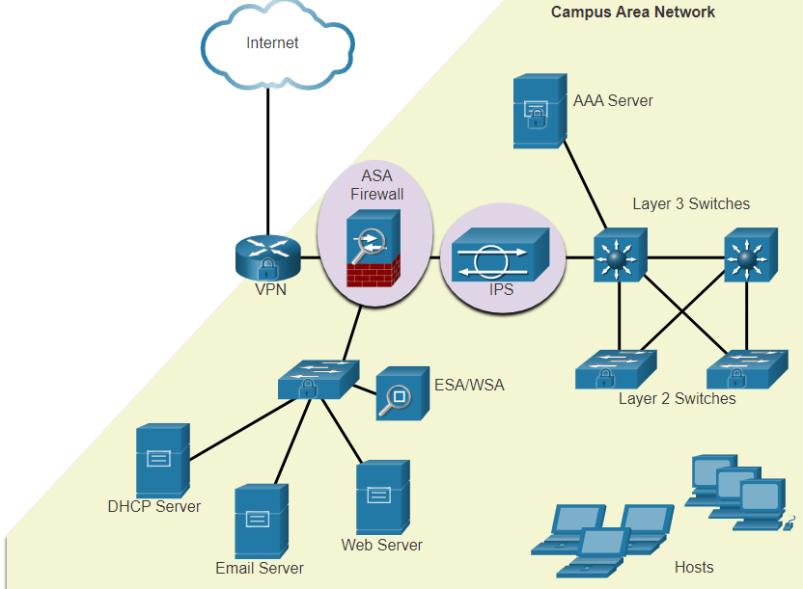

* Backing up device configurations and data is one of the most effective ways of protecting against data loss. Backups should be performed on a regular basis as identified in the security policy. Data backups are usually stored offsite to protect the backup media if anything happens to the main facility.

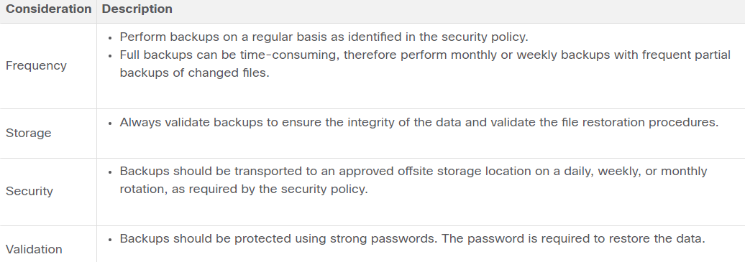

* As new malware is released, enterprises need to keep current with the latest versions of antivirus software.
  + The most effective way to mitigate a worm attack is to download security updates from the operating system vendor and patch all vulnerable systems.
  + One solution to the management of critical security patches is to make sure all end systems automatically download updates.
* Authentication, authorization, and accounting (AAA, or “triple A”) network security services provide the primary framework to set up access control on network devices.
  + AAA is a way to control who is permitted to access a network (authenticate), what actions they perform while accessing the network (authorize), and making a record of what was done while they are there (accounting).
* A firewall protects computers and networks by preventing undesirable traffic from entering internal networks.
* Network firewalls reside between two or more networks, control the traffic between them, and help prevent unauthorized access.
* A firewall could allow outside users controlled access to specific services. For example, servers accessible to outside users are usually located on a special network referred to as the demilitarized zone (DMZ). The DMZ enables a network administrator to apply specific policies for hosts connected to that network.
* Firewall products come packaged in various forms. These products use different techniques for determining what will be permitted or denied access to a network. They include the following:
  + Packet filtering - Prevents or allows access based on IP or MAC addresses
  + Application filtering - Prevents or allows access by specific application types based on port numbers
  + URL filtering - Prevents or allows access to websites based on specific URLs or keywords
  + Stateful packet inspection (SPI) - Incoming packets must be legitimate responses to requests from internal hosts. Unsolicited packets are blocked unless permitted specifically. SPI can also include the capability to recognize and filter out specific types of attacks, such as denial of service (DoS).
* An endpoint, or host, is an individual computer system or device that acts as a network client. Common endpoints are laptops, desktops, servers, smartphones, and tablets. Securing endpoint devices is one of the most challenging jobs of a network administrator because it involves human nature. A company must have well-documented policies in place and employees must be aware of these rules. Employees need to be trained on proper use of the network. Policies often include the use of antivirus software and host intrusion prevention. More comprehensive endpoint security solutions rely on network access control.
  1. Device Security
* The security settings are set to the default values when a new operating system is installed on a device. In most cases, this level of security is inadequate. For Cisco routers, the Cisco AutoSecure feature can be used to assist securing the system. Command: **auto secure**

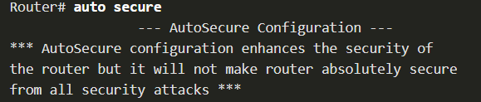

* In addition, there are some simple steps that should be taken that apply to most operating systems:
  + Default usernames and passwords should be changed immediately.
  + Access to system resources should be restricted to only the individuals that are authorized to use those resources.
  + Any unnecessary services and applications should be turned off and uninstalled when possible.
  + Often, devices shipped from the manufacturer have been sitting in a warehouse for a period of time and do not have the most up-to-date patches installed. It is important to update any software and install any security patches prior to implementation.
* To protect network devices, it is important to use strong passwords. Here are standard guidelines to follow:
  + Use a password length of at least eight characters, preferably 10 or more characters.
  + Make passwords complex. Include a mix of uppercase and lowercase letters, numbers, symbols, and spaces, if allowed.
  + Avoid passwords based on repetition, common dictionary words, letter or number sequences, usernames, relative or pet names, biographical information, such as birthdates, ID numbers, ancestor names, or other easily identifiable pieces of information.
  + Deliberately misspell a password. For example, Smith = Smyth = 5mYth or Security = 5ecur1ty.
  + Change passwords often. If a password is unknowingly compromised, the window of opportunity for the threat actor to use the password is limited.
  + Do not write passwords down and leave them in obvious places such as on the desk or monitor.
* On Cisco routers, leading spaces are ignored for passwords, but spaces after the first character are not. Therefore, one method to create a strong password is to use the space bar and create a phrase made of many words. This is called a passphrase. A passphrase is often easier to remember than a simple password. It is also longer and harder to guess.
* There are several steps that can be taken to help ensure that passwords remain secret on a Cisco router and switch including these:
  + Encrypt all plaintext passwords with the **service password-encryption** command.
  + Set a minimum acceptable password length with the **security passwords min-length** command.
  + Deter brute-force password guessing attacks with the **login block-for *#* attempts *#* within *#*** command.
  + Disable an inactive privileged EXEC mode access after a specified amount of time with the **exec-timeout** command.

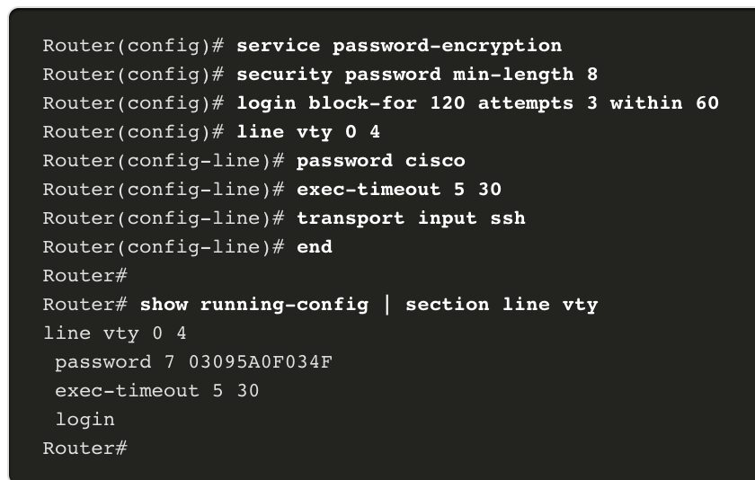

* It is possible to configure a Cisco device to support SSH using the following steps:
  1. Configure a unique device hostname. A device must have a unique hostname other than the default.
  2. Configure the IP domain name. Configure the IP domain name of the network by using the global configuration mode command **ip-domain name *name***.
  3. Generate a key to encrypt SSH traffic. SSH encrypts traffic between source and destination. However, to do so, a unique authentication key must be generated by using the global configuration command **crypto key generate rsa general-keys modulus** ***bits***. The modulus *bits* determines the size of the key and can be configured from 360 bits to 2048 bits. The larger the bit value, the more secure the key. However, larger bit values also take longer to encrypt and decrypt information. The minimum recommended modulus length is 1024 bits.
  4. Verify or create a local database entry. Create a local database username entry using the **username** ***username* secret *password*** global configuration command. the parameter secret is used so that the password will be encrypted using MD5.
  5. Authenticate against the local database. Use the **login local** line configuration command to authenticate the vty line against the local database.
  6. Enable vty inbound SSH sessions. By default, no input session is allowed on vty lines. You can specify multiple input protocols including Telnet and SSH using the **transport input [ssh | telnet]** command.

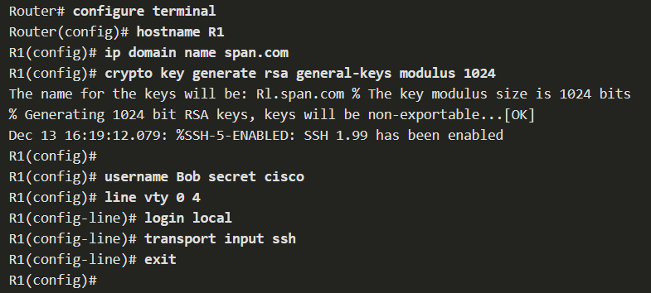

* Cisco routers and switches start with a list of active services that may or may not be required in your network. Disable any unused services to preserve system resources, such as CPU cycles and RAM, and prevent threat actors from exploiting these services.
  + The type of services that are on by default will vary depending on the IOS version. For example, IOS-XE typically will have only HTTPS and DHCP ports open. You can verify this with the show ip ports all command.
  + IOS versions prior to IOS-XE use the show control-plane host open-ports command.
* An older router may have HTTP and telnet running.
  + Disable HTTP with the **no ip http server** global configuration command.
  + Disable Telnet by specifying only SSH in the line configuration command, **transport input ssh**.

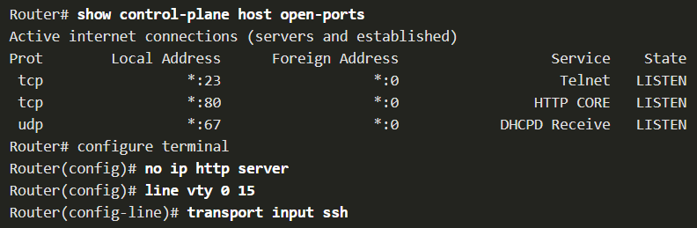

1. Build a small network
   1. Devices in a Small Network

* The majority of businesses are small most of the business networks are also small.
* A small network design is usually simple.
* Small networks typically have a single WAN connection provided by DSL, cable, or an Ethernet connection.
* Large networks require an IT department to maintain, secure, and troubleshoot network devices and to protect organizational data. Small networks are managed by a local IT technician or by a contracted professional.
* Like large networks, small networks require planning and design to meet user requirements. Planning ensures that all requirements, cost factors, and deployment options are given due consideration. One of the first design considerations is the type of intermediary devices to use to support the network.
* Factors that must be considered when selecting network devices include:
  + cost
  + speed and types of ports/interfaces
  + expandability: Networking devices are available in fixed and modular physical configurations. Fixed configuration devices have a specific number and type of ports or interfaces and cannot be expanded. Modular devices have expansion slots to add new modules as requirements evolve.
  + operating system features and services
* When implementing a network, create an IP addressing scheme and use it. All hosts and devices within an internetwork must have a unique address. Devices that will factor into the IP addressing scheme include the following:
  + End user devices - The number and type of connections (i.e., wired, wireless, remote access)
  + Servers and peripherals devices (e.g., printers and security cameras)
  + Intermediary devices including switches and access points
* It is recommended that you plan, document, and maintain an IP addressing scheme based on device type. The use of a planned IP addressing scheme makes it easier to identify a type of device and to troubleshoot problems.
* In order to maintain a high degree of reliability, *redundancy* is required in the network design. Redundancy helps to eliminate single points of failure.
* Redundancy can be accomplished by installing duplicate equipment. It can also be accomplished by supplying duplicate network links for critical areas.

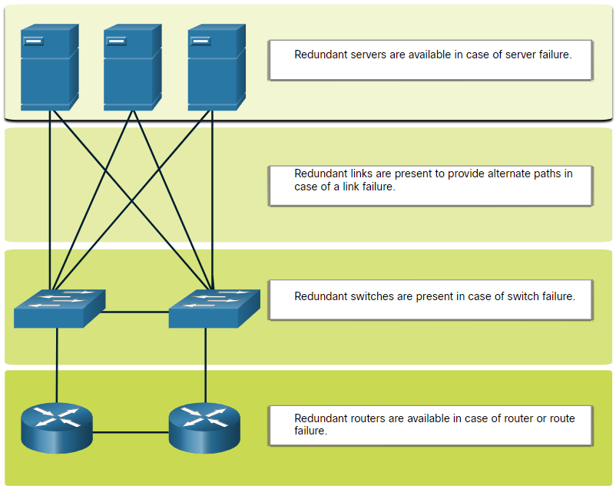

* The goal for a good network design is to enhance the productivity of the employees and minimize network downtime.
* The routers and switches in a small network should be configured to support real-time traffic, such as voice and video, in an appropriate manner relative to other data traffic. A good network design will implement quality of service (QoS).
* Priority queuing has four queues. The high-priority queue is always emptied first.

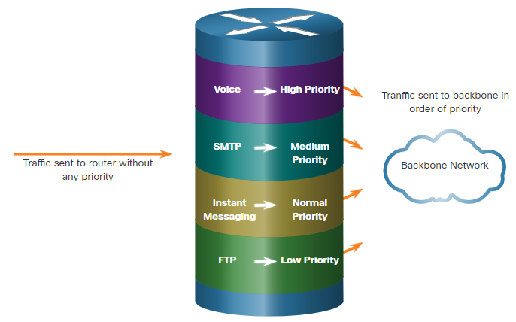

* 1. Small Network Applications and Protocols
* After you have set it up, your network still needs certain types of applications and protocols in order to work. The network is only as useful as the applications that are on it.
* There are two forms of software programs or processes that provide access to the network:
  + Network Applications: Applications are the software programs used to communicate over the network. Some end-user applications are network-aware, meaning that they implement application layer protocols and are able to communicate directly with the lower layers of the protocol stack.
    - Email client, web browsers, …
  + Application Layer Services: For applications that are not network-aware. These services are the programs that interface with the network and prepare the data for transfer. Different types of data, whether text, graphics or video, require different network services to ensure that they are properly prepared for processing by the functions occurring at the lower layers of the OSI model.
    - File transfer, network print spooling, …
* SSH is used to establish a secure remote access connection between an SSH client and other SSH-enabled devices:
  + Network device - The network device (e.g., router, switch, access point, etc.) must support SSH to provide remote access SSH server services to clients.
  + Server - The server (e.g., web server, email server, etc.) must support remote access SSH server services to clients.
* Network protocols support the applications and services used by employees in a small network.
  + Network administrators commonly require access to network devices and servers. The two most common remote access solutions are Telnet and Secure Shell (SSH).
  + Hypertext Transfer Protocol (HTTP) and Hypertext Transfer Protocol Secure (HTTPS) are used between web clients and web servers.
  + Simple Mail Transfer Protocol (SMTP) is used to send email, Post Office Protocol (POP3) or Internet Mail Access Protocol (IMAP) are used by clients to retrieve email.
  + File Transfer Protocol (FTP) and Security File Transfer Protocol (SFTP) are used to download and upload files between a client and an FTP server.
  + Dynamic Host Configuration Protocol (DHCP) is used by clients to acquire an IP configuration from a DHCP Server.
  + The Domain Name Service (DNS) resolves domain names to IP addresses.
* Note: A server could provide multiple network services. For instance, a server could be an email, FTP and SSH server.
* These network protocols comprise the fundamental toolset of a network professional, defining:
  + Processes on either end of a communication session.
  + Types of messages.
  + Syntax of the messages.
  + Meaning of informational fields.
  + How messages are sent and the expected response.
  + Interaction with the next lower layer.
* Many companies have established a policy of using secure versions (e.g., SSH, SFTP, and HTTPS) of these protocols whenever possible.
* Businesses today are increasingly using IP telephony and streaming media to communicate with customers and business partners, as well as enabling their employees to work remotely.
* The network administrator must ensure the proper equipment is installed in the network and that the network devices are configured to ensure priority delivery.
* The factors that a small network administrator must consider when supporting real-time applications:
  + Infrastructure - Does it have the capacity and capability to support real-time applications?
  + VoIP - VoIP devices convert analog telephone signals into digital IP packets. VoIP is typically less expensive than IP Telephony, but at the cost of quality and features.
  + IP Telephony - An IP phone performs voice-to-IP conversion with the use of a dedicated server for call control and signaling.
  + Real-Time Applications - The network must support Quality of Service (QoS) mechanisms to minimize latency issues. Real-Time Transport Protocol (RTP) and Real-Time Transport Control Protocol (RTCP) are two protocols that support real-time applications.
  1. Scale to Larger Networks
* Growth is a natural process for many small businesses, and their networks must grow accordingly. Ideally, the network administrator has enough lead-time to make intelligent decisions about growing the network in alignment with the growth of the company.
* To scale a network, several elements are required:
  + Network documentation - Physical and logical topology
  + Device inventory - List of devices that use or comprise the network
  + Budget - Itemized IT budget, including fiscal year equipment purchasing budget
  + Traffic analysis - Protocols, applications, and services and their respective traffic requirements should be documented
* These elements are used to inform the decision-making that accompanies the scaling of a small network.
* It is important to understand the type of traffic that is crossing the network as well as the current traffic flow. There are several network management tools that can be used for this purpose. (Wireshark)
* To determine traffic flow patterns, it is important to do the following:
  + Capture traffic during peak utilization times to get a good representation of the different traffic types.
  + Perform the capture on different network segments and devices as some traffic will be local to a particular segment.
  + Information gathered by the protocol analyzer is evaluated based on the source and destination of the traffic, as well as the type of traffic being sent.
  + This analysis can be used to make decisions on how to manage the traffic more efficiently.
* Many operating systems provide built-in tools to display such network utilization information. These tools can be used to capture a “snapshot” of information such as the following:
  + OS and OS Version
  + CPU utilization
  + RAM utilization
  + Drive utilization
  + Non-Network applications
  + Network applications
* Documenting snapshots for employees in a small network over a period of time is very useful to identify evolving protocol requirements and associated traffic flows.
  1. Verify Connectivity
* Whether your network is small and new, or you are scaling an existing network, you will always want to be able to verify that your components are properly connected to each other and to the internet.
  + The ping command, available on most operating systems, is the most effective way to quickly test Layer 3 connectivity between a source and destination IP address.
  + The ping command uses the Internet Control Message Protocol (ICMP) echo (ICMP Type 8) and echo reply (ICMP Type 0) messages.

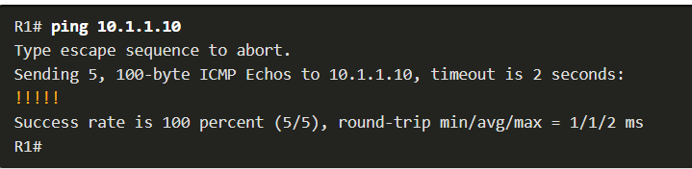

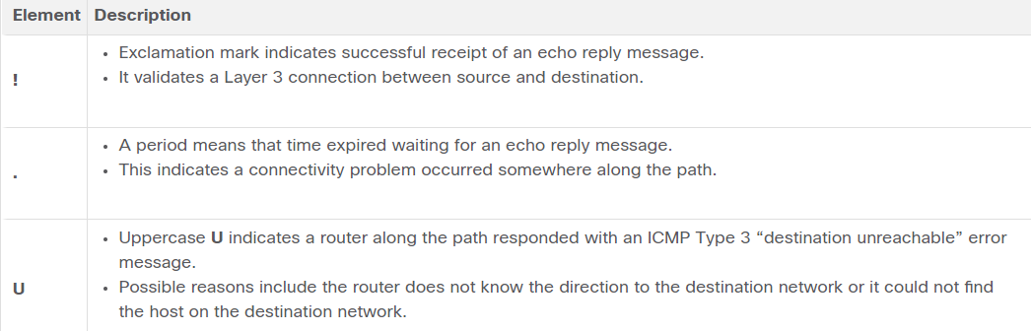

* The Cisco IOS offers an "extended" mode of the ping command.
* Extended ping is entered in privileged EXEC mode by typing ping without a destination IP address. You will then be given several prompts to customize the extended ping.
  + For example, assume you wanted to test connectivity from the R1 LAN (i.e., 192.168.10.0/24) to the 10.1.1.0 LAN. This could be verified from the PC A. However, an extended ping could be configured on R1 to specify a different source address.
* Note: Pressing Enter accepts the indicated default values. The ping ipv6 command is used for IPv6 extended pings.

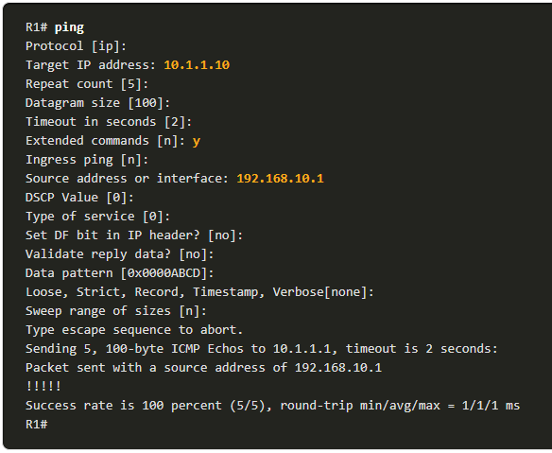

* The ping command is useful to quickly determine if there is a Layer 3 connectivity problem. However, it does not identify where the problem is located along the path.
* Traceroute can help locate Layer 3 problem areas in a network. A trace returns a list of hops as a packet is routed through a network.
* The syntax of the trace command varies between operating systems.
* The following is a sample output of tracert command on a Windows 10 host.
* Note: Use Ctrl-C to interrupt a tracert in Windows.
* The only successful response was from the gateway on R1. Trace requests to the next hop timed out as indicated by the asterisk (*), meaning that the next hop router did not respond or there is a failure in the network path. In this example there appears to be a problem between R1 and R2.

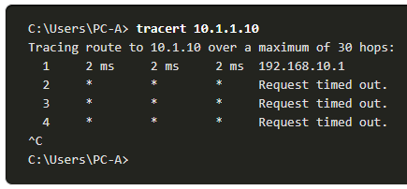

* Like the extended ping command, there is also an extended traceroute command. It allows the administrator to adjust parameters related to the command operation.
* The Windows tracert command allows the input of several parameters through options in the command line. However, it is not guided like the extended traceroute IOS command. The following output displays the available options for the Windows tracert command:

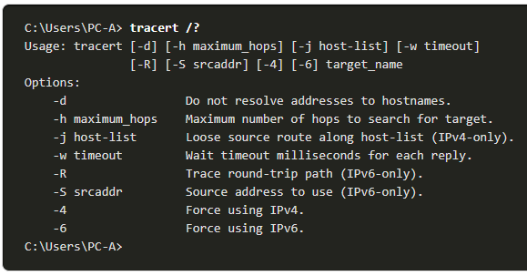

* The Cisco IOS extended traceroute option enables the user to create a special type of trace by adjusting parameters related to the command operation.
* Extended traceroute is entered in privileged EXEC mode by typing traceroute without a destination IP address. IOS will guide you through the command options by presenting a number of prompts related to the setting of all the different parameters.
* Note: Pressing Enter accepts the indicated default values.

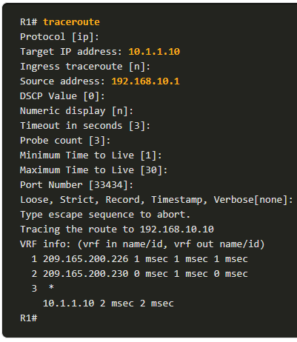

* One of the most effective tools for monitoring and troubleshooting network performance is to establish a network baseline.
* One method for starting a baseline is to copy and paste the results from an executed ping, trace, or other relevant commands into a text file. These text files can be time stamped with the date and saved into an archive for later retrieval and comparison.
* Among items to consider are error messages and the response times from host to host.
* Corporate networks should have extensive baselines; more extensive than we can describe in this course. Professional-grade software tools are available for storing and maintaining baseline information.
  1. Host and IOS Commands
* In Windows 10, you can access the IP address details from the Network and Sharing Center to quickly view the four important settings: address, mask, router, and DNS. Or you can issue the **ipconfig** command at the command line of a Windows computer.
* Use the **ipconfig /all** command to view the MAC address, as well as a number of details regarding the Layer 3 addressing of the device.
* If a host is configured as a DHCP client, the IP address configuration can be renewed using the **ipconfig /release** and **ipconfig /renew** commands.
* The DNS Client service on Windows PCs also optimizes the performance of DNS name resolution by storing previously resolved names in memory. The **ipconfig /displaydns** command displays all of the cached DNS entries on a Windows computer system.
* Verifying IP settings using the GUI on a Linux machine will differ depending on the Linux distribution and desktop interface.
* On the command line, use the **ifconfig** command to display the status of the currently active interfaces and their IP configuration. This command can also be used on a macOS.
* The Linux **ip address** command is used to display addresses and their properties. It can also be used to add or delete IP addresses.
* Note: The output displayed may vary depending on the Linux distribution.
* The **arp** command is executed from the Windows, Linux, or Mac command prompt. The command lists all devices currently in the ARP cache of the host.
  + The **arp -a** command displays the known IP address and MAC address binding. The ARP cache only displays information from devices that have been recently accessed.
  + To ensure that the ARP cache is populated, **ping** a device so that it will have an entry in the ARP table.
  + The cache can be cleared by using the **netsh interface ip delete arpcache** command in the event the network administrator wants to repopulate the cache with updated information.
* Note: You may need administrator access on the host to be able to use the **netsh interface ip delete arpcache** command.
* The Cisco IOS CLI show commands display relevant information about the configuration and operation of the device.

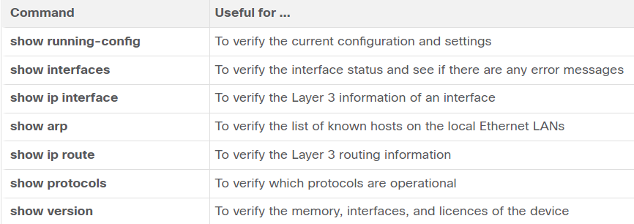

* There are several other IOS commands that are useful. The Cisco Discovery Protocol (CDP) is a Cisco proprietary protocol that runs at the data link layer. Because CDP operates at the data link layer, two or more Cisco network devices, such as routers that support different network layer protocols, can learn about each other even if Layer 3 connectivity has not been established.
* When a Cisco device boots, CDP starts by default. CDP automatically discovers neighboring Cisco devices running CDP, regardless of which Layer 3 protocol or suites are running. CDP exchanges hardware and software device information with its directly connected CDP neighbors.
* CDP provides the following information about each CDP neighbor device:
  + Device identifiers - The configured host name of a switch, router, or other device
  + Address list - Up to one network layer address for each protocol supported
  + Port identifier - The name of the local and remote port in the form of an ASCII character string, such as FastEthernet 0/0
  + Capabilities list - For example, whether a specific device is a Layer 2 switch or a Layer 3 switch
  + Platform - The hardware platform of the device--for example, a Cisco 1841 series router.
* The **show cdp neighbors detail** command reveals the IP address of a neighboring device.

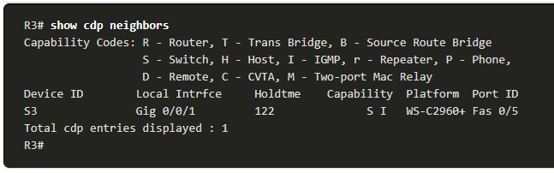

* One of the most frequently used commands is the **show ip interface brief** command. This command provides a more abbreviated output than the **show ip interface** command. It provides a summary of the key information for all the network interfaces on a router.
  1. Troubleshooting Methodologies

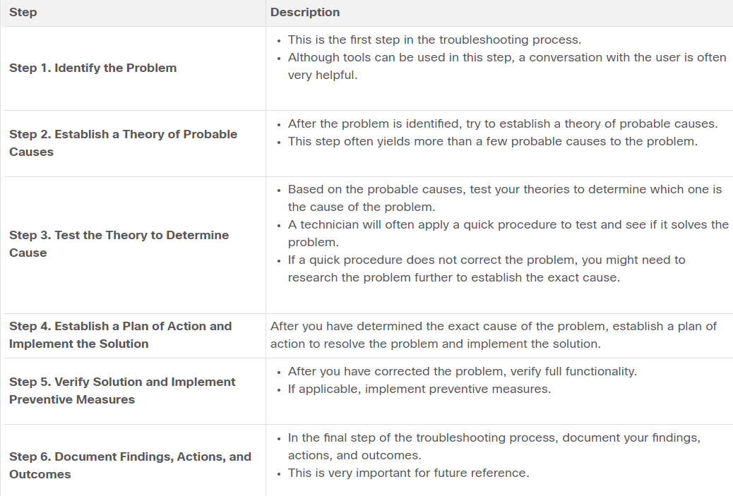

* In some situations, it may not be possible to resolve the problem immediately. A problem should be escalated when it requires a manager decision, some specific expertise, or network access level unavailable to the troubleshooting technician.
* A company policy should clearly state when and how a technician should escalate a problem.
* The IOS **debug** command allows the administrator to display OS process, protocol, mechanism and event messages in real-time for analysis.
* All debug commands are entered in privileged EXEC mode. The Cisco IOS allows for narrowing the output of debug to include only the relevant feature or subfeature. Use debug commands only to troubleshoot specific problems.
* To list a brief description of all the debugging command options, use the **debug ?** command in privileged EXEC mode at the command line.
* To turn off a specific debugging feature, add the **no** keyword in front of the **debug** command
* Alternatively, you can enter the **undebug** form of the command in privileged EXEC mode.
* To turn off all active debug commands at once, use the **undebug all** command.
* Be cautious using some debug commands, as they may generate a substantial amount of output and use a large portion of system resources. The router could get so busy displaying debug messages that it would not have enough processing power to perform its network functions, or even listen to commands to turn off debugging.

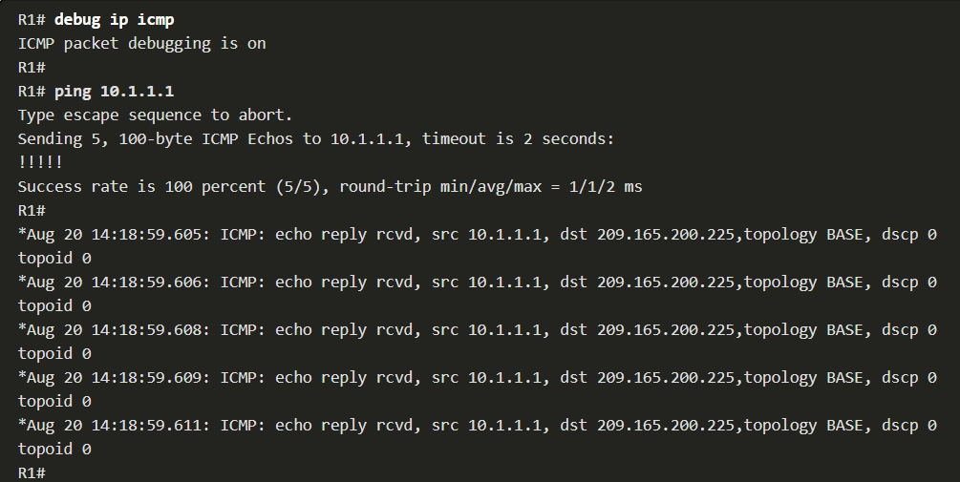

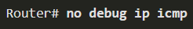

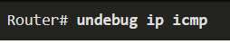

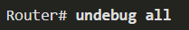

* debug  and certain other IOS message output is not automatically displayed on remote connections. This is because log messages are prevented from being displayed on vty lines.
* To display log messages on a terminal (virtual console), use the **terminal monitor** privileged EXEC command. To stop logging messages on a terminal, use the **terminal no monitor** privileged EXEC command.

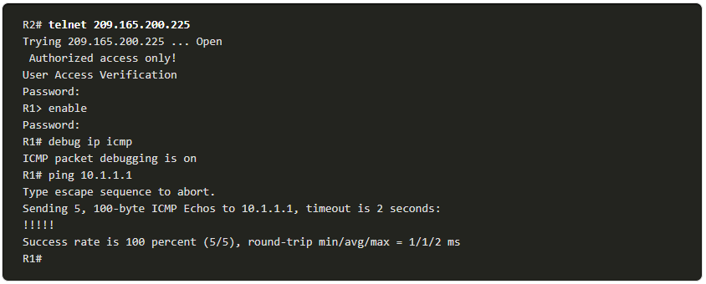

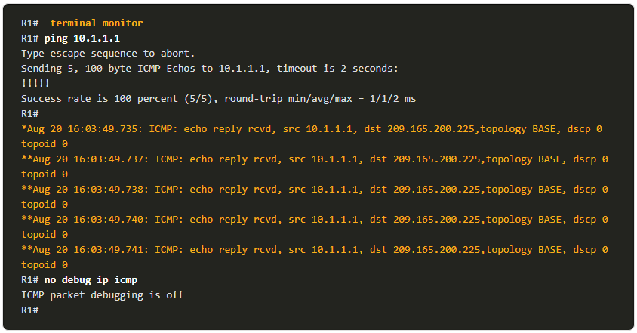

* 1. Troubleshooting Scenarios
* Interconnecting Ethernet interfaces must operate in the same duplex mode for best communication performance and to avoid inefficiency and latency on the link.
* The Ethernet autonegotiation feature facilitates configuration, minimizes problems and maximizes link performance between two interconnecting Ethernet links. The connected devices first announce their supported capabilities and then choose the highest performance mode supported by both ends.
* If one of the two connected devices is operating in full-duplex and the other is operating in half-duplex, a duplex mismatch occurs. While data communication will occur through a link with a duplex mismatch, link performance will be very poor.
* Duplex mismatches are typically caused by a misconfigured interface or in rare instances by a failed autonegotiation. Duplex mismatches may be difficult to troubleshoot as the communication between devices still occurs.
* Two common causes of incorrect IPv4 assignment are manual assignment mistakes or DHCP-related issues.
* Network administrators often have to manually assign IP addresses to devices such as servers and routers. If a mistake is made during the assignment, then communications issues with the device are very likely to occur.
* On an IOS device, use the **show ip interface** or **show ip interface brief** commands to verify what IPv4 addresses are assigned to the network interfaces.
* On Windows-based machines, when the device cannot contact a DHCP server, Windows will automatically assign an address belonging to the 169.254.0.0/16 range. This feature is called Automatic Private IP Addressing (APIPA). Think of it as Windows saying, “I will use this address from the 169.254.0.0/16 range because I could not get any other address”.
* A computer with an APIPA address will not be able to communicate with other devices in the network because those devices will most likely not belong to the 169.254.0.0/16 network.
* **Note**: Other operating systems, such Linux and OS X, do not use APIPA.
* If the device is unable to communicate with the DHCP server, then the server cannot assign an IPv4 address for the specific network and the device will not be able to communicate.
* To verify the IP addresses assigned to a Windows-based computer, use the **ipconfig** command.
* The default gateway for an end device is the closest networking device, belonging to the same network as the end device, that can forward traffic to other networks. If a device has an incorrect or nonexistent default gateway address, it will not be able to communicate with devices in remote networks.
* Similar to IPv4 addressing issues, default gateway problems can be related to misconfiguration (in the case of manual assignment) or DHCP problems (if automatic assignment is in use).
* To verify the default gateway on Windows-based computers, use the **ipconfig** command.
* On a router, use the **show ip route** command to list the routing table and verify that the default gateway, known as a default route, has been set. This route is used when the destination address of the packet does not match any other routes in its routing table.
* For example, the output verifies that R1 has a default gateway (i.e., Gateway of last resort) configured pointing to IP address 209.168.200.226.

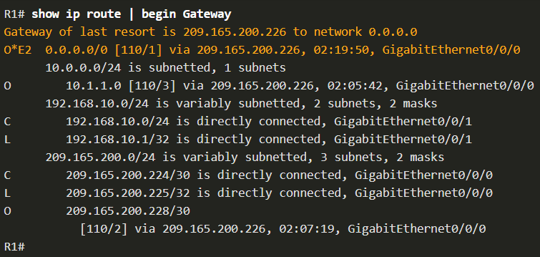

* The first highlighted line basically states that the gateway to any (i.e., 0.0.0.0) should be sent to IP address 209.165.200.226. The second highlighted displays how R1 learned about the default gateway. In this case, R1 received the information from another OSPF-enabled router.
* It is common for users to mistakenly relate the operation of an internet link to the availability of the DNS.
* DNS server addresses can be manually or automatically assigned via DHCP.
* Although it is common for companies and organizations to manage their own DNS servers, any reachable DNS server can be used to resolve names.
* Cisco offers OpenDNS which provides secure DNS service by filtering phishing and some malware sites. OpenDNS addresses are 208.67.222.222 and 208.67.220.220. Advanced features such as web content filtering and security are available to families and businesses.
* Use the **ipconfig /all** as shown to verify which DNS server is in use by the Windows computer.
* The **nslookup** command is another useful DNS troubleshooting tool for PCs. With **nslookup** a user can manually place DNS queries and analyze the DNS response.